BBRO PROJECT REPORT FORM
Please note the details on page 2 will be used to formulate our Annual Report.
Project Title: Maximising sugar yield via fungicides

BBRO project no: | 13/06
Project sponsor: | BBRO
Interim report / (delete as appropriate)

Project lead or student name: | Mark Stevens
Project mentor or supervisors: | Jon Knight
Report Date: | April 2017
Reporting period covered:  (e.g. 1/1/16 - 31/12/16) | 1/4/16 - 31/3/17
Timeline (e.g. Year 1 of 4) | Year 4* Extended for further year to provide necessary trials for the InnovateUK SPOREID project.
BBRO use only | Date assessed:
Assessors comments
Action required

Project summary (no more than 300 words)
Previous BBRO trials since 2010 have shown that a two-spray programme on a typical crop harvested in November provides an average 6% yield increase from the first spray and an additional 7% from the second. Benefits of a third spray, applied in September, have been observed by growers when delivering their beet late in the campaign. BBRO trials have seen an increase in sugar content of harvested roots by up to one percent, when trial plots were lifted after Christmas. These fungicide trials have enabled the industry to optimise disease control, green-leaf cover and, ultimately, yield depending on harvest date. These studies continue to fine-tune advice regarding application timing and lifting date and provide a more robust advisory system for communicating when to apply products to maximise profitability of the crop, linked to the InnovateUK SporeID project.

Main Objectives
- Clarify the impact of drilling date together with crop developmental stage and first application of fungicide.

- Comparison of products to include an assessment of the current triazole/strobilurin fungicides as well as any potential chemistry on current and future sugar beet genetics.

- Assess fungicide timings, the number of applications and impact of harvest date.

Insert picture/graph  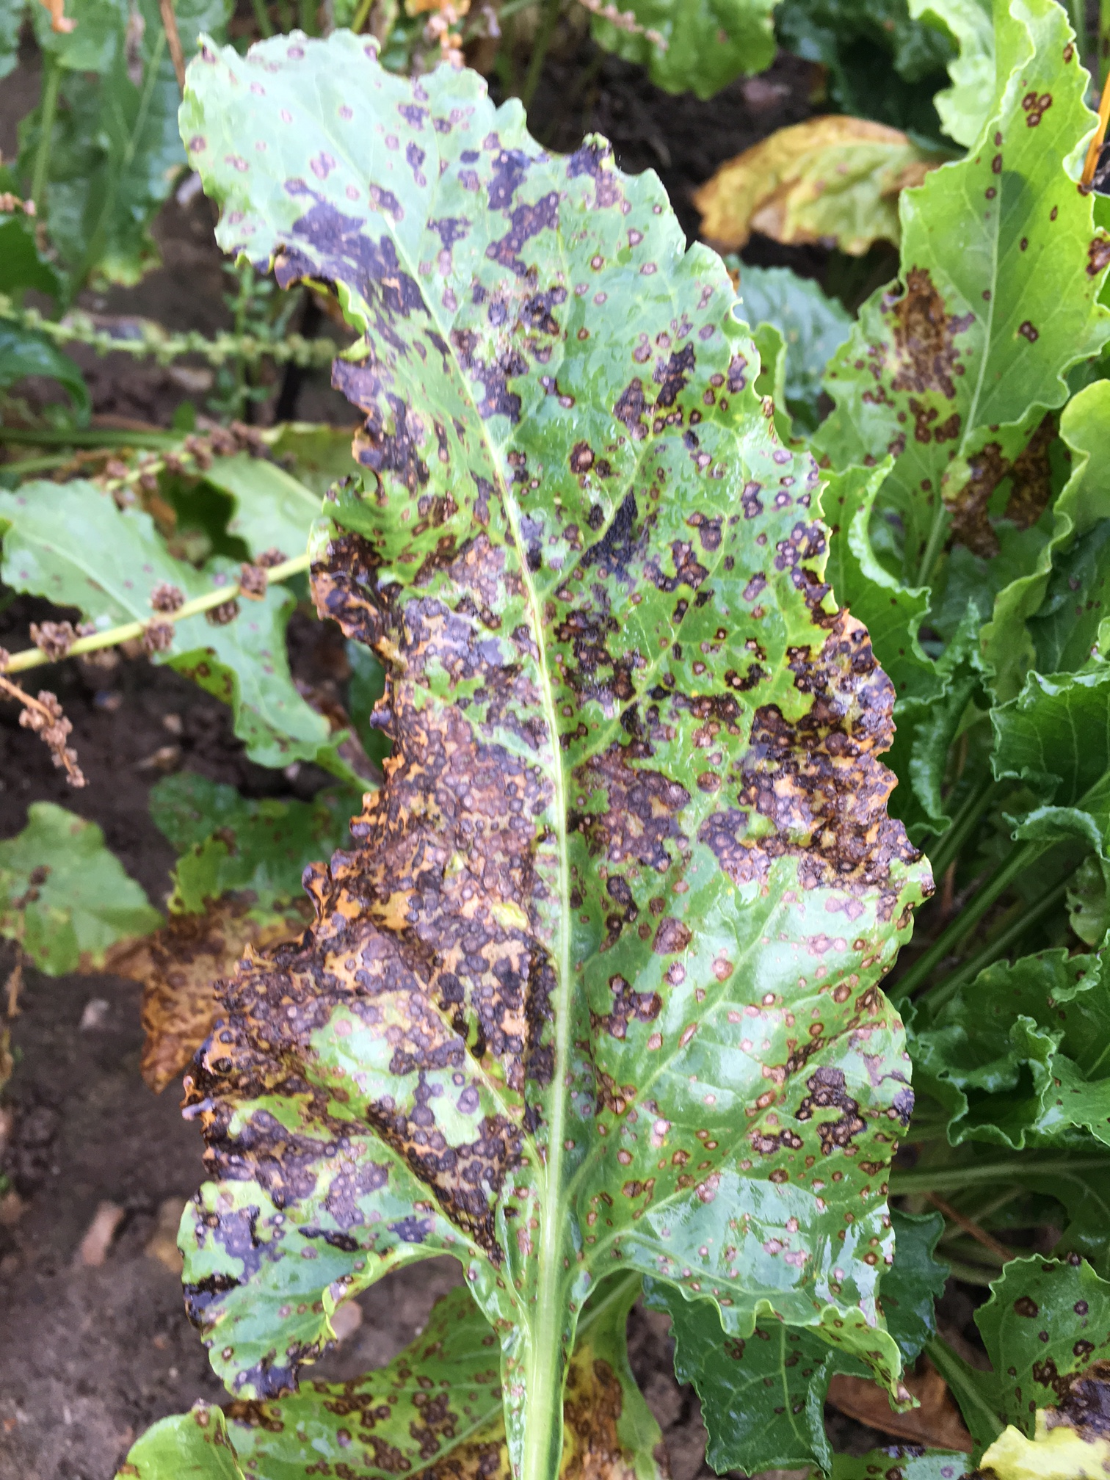  Symptoms of cercopsora leaf spot. Garboldisham, Norfolk October 2016. | Insert picture/graph  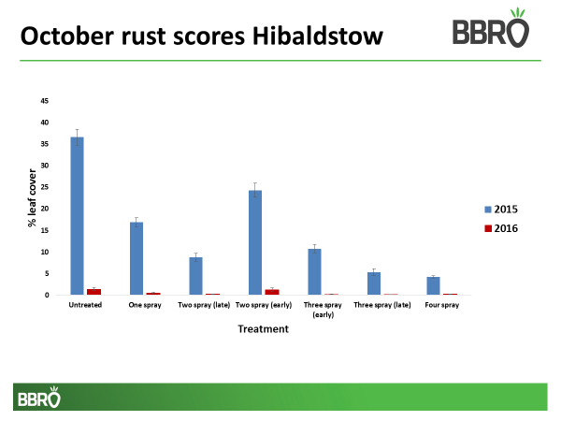
Main outcomes and achievements
- In 2016, two trials (based in Norfolk and Lincolnshire) evaluated the impact of sowing date and seven different fungicide timing programmes on the yield of sugar beet; at both sites plots were harvested in either October/November or the following January.

- At both sites, only 2% of the leaf area of untreated plots was found to be infected with rust by mid-October. In contrast, in 2015, 24% was found to be infected at Garboldisham, Norfolk and 37% at Hibaldstow, Lincolnshire in mid-October at the equivalent time point.

- In 2016, yield responses to fungicide application were more varied compared to recent years. The lack of disease development, impacted by weather extremes during the season (e.g. very wet in June and hot and dry in September) will have influenced these overall yield responses.

- Cercospora leaf spot was seen more widely during the autumn, and although normally a disease of mainland Europe, isolates collected from the UK were found to be resistant to strobilurin fungicides.

Key messages for growers and industry
Fungicides remain key to protecting the crop from foliar diseases whilst maintaining canopy cover for autumn growth, early frost protection and maximising overall yield potential. The trials in 2015 and 2016 continue to show good rust control, the most abundant disease during these two years, although yield responses were more variable and not all treatments provided significant yield increases as seen in previous years possibly reflecting the very variable weather and the impact this had on overall disease build-up, particularly during 2016.

Section 1: To be completed by Project Lead:
Other project objectives (not listed on previous page)

Monitoring cercospora leaf spot resistance with Adama and Bayer following the increase levels of this disease in the national crop during 2016.

Milestones for current period
Note: mentors will be asked to comment on the status of this project (yellow column) using the scoring system shown below

Status - Mentor’s scoring system for interim reports.
RED | “Major concern - escalate to the next level"  Slippage greater than 10% of remaining time or budget, or quality severely compromised. Corrective Action not in place, or not effective. Unlikely to deliver on time to budget or quality requirements.
AMBER | "Minor concern – being actively managed”  Slippage less than 10% of remaining time or budget, or quality impact is minor. Remedial plan in place.
GREEN | "Normal level of attention"  No material slippage. No additional attention needed
Milestones | Comments + Any Action required | Status R/A/G

Summary of results (including figures and tables)
Annual report: please provide a 2 page summary of key findings from the reporting year.
Final report: please provide a summary of project findings and outcomes with relevant supporting data.
2015 and 2016 BBRO fungicide trials

For each year, two trials were undertaken at sites in Lincolnshire and Norfolk. The main aim of these trials was to compare the impact of drilling date and the number of fungicide applications on disease control, ultimately measuring the impact of these decisions on yield at harvest. Each trial was designed so that appropriate plots could be lifted either in October/November or the following January to compare the impact of fungicides on later harvesting and yield. These data build on previous BBRO knowledge and findings, and also provide field data to support the current SPOREID InnovateUK project too.

Three drilling dates were used; these were between mid-March and late April (Table 1) to produce different canopy sizes when the first fungicides were applied. This was achieved in 2015 but the extremely wet conditions in 2016, particularly in Norfolk, affected the proposed drilling times and the final plots there were not sown until June. The actual fungicide timings are included in Table 2.

2015 | Garboldisham | Hibaldstow
Drill 1 | 16th March 2015 | 24th March 2015
Drill 2 | 30th March 2015 | 17th April 2015
Drill 3 | 17th April 2015 | 24th April 2015
Harvest 1 | 23rd October 2015 | 30th November 2015
Harvest 2 | 6th January 2016 | 22nd January 2016

2016 |  | Garboldisham |  |  | Hibaldstow
Drill 1 |  | 24th March 2016 |  |  | 22nd April 2016
Drill 2 |  | 13th May 2016 |  |  | 16th May 2016
Drill 3 |  | 13th June 2016 |  |  | 29th May 2016
Harvest 1 |  | 25th November 2016 |  |  | 11th October 2016
Harvest 2 |  | 11th January 2017 |  |  | 22nd January 2017
Treatment Number | End June |  | Disease Onset (July) | End August |  | End September | October
1 - Untreated
2 – Escolta |  |  | X
3 - Escolta/Escolta |  |  | X | X
4 - Escolta/Escolta | X |  | X
5 - Escolta/Priori Extra/Escolta | X |  | X | X
6 - Escolta/Priori Extra/Escolta |  |  | X | X |  | X
7 - Escolta/Priori Extra/Escolta/Priori Extra |  |  | X | X |  | X | X

Disease data

Once sprayed, trials were assessed for disease every four weeks until the end of the autumn. In both years, trace levels of powdery mildew were recorded in plots (data not shown); rust was the most important disease at both sites. However, these results highlight how different disease development can be between years and the importance of undertaking such trials over several years.

In 2016 at both sites, only 2% of the leaf area of untreated plots was found to be infected with rust by mid-October. In contrast, in 2015, 24 and 37% was found to be infected at Garboldisham, Norfolk and Hibaldstow, Lincolnshire respectively in mid-October at the equivalent time point. As expected, fungicide applications decreased the area of rust on the leaf surface but the actual sowing date of plots and timing of treatments were key. For example, later sown crops tended to have lower levels of disease early in the season. In 2015, when fungicides were applied before disease onset (the two-spray early treatment), there was a higher level of rust in these plots later in the season, as a consequence of treatments losing efficacy with time but with the disease still entering and infecting the plants during the autumn.

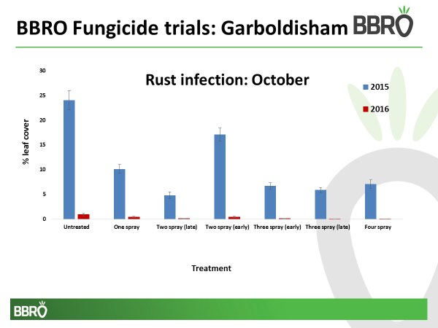

In 2016, cercospora leaf spot could be found in most UK fields by the end of September, possibly favoured by the very warm, or even hot conditions experienced in August and particularly September (for example, 32ºC in Cambridge on the 14th September). Although this disease is still not thought to have caused any significant yield losses during the 2016/17 season, particularly as most crops received at least one fungicide spray, it does serve as a timely reminder that disease threats can change. More worryingly, the latest analysis of three isolates collected by Bayer for resistance testing of cercospora leaf spot isolates across Europe, showed that all the UK isolates were resistant to strobilurin active ingredients. This resistance issue is similar to the threat already faced by other European countries, and an issue that will need to be closely monitored during 2017.

Yield data

Positive yield responses were observed from most fungicide treatments in 2015, although actual yield responses to equivalent treatments varied between the two sites (greater gains tended to be observed at Hibaldstow). Yields were also influenced by drilling date and the number and timing of treatments.
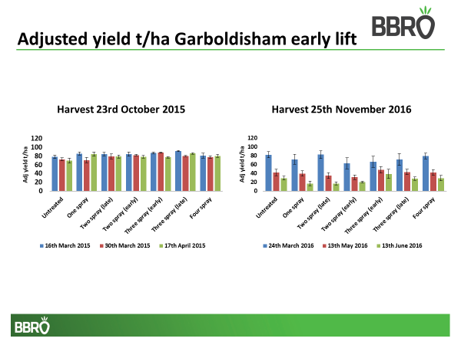

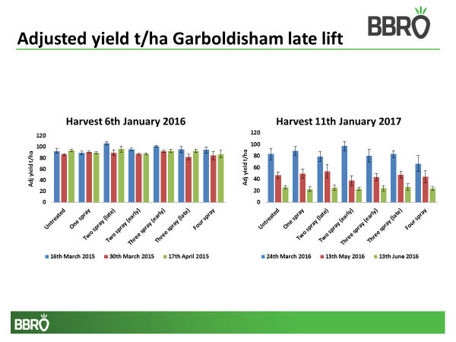

Later sown plots tended to have lower levels of disease earlier in the season. However, such delayed drilling impacted on canopy development leading to lower photosynthetic potential in the early part of the season and consequently these plots suffered yield penalties over earlier sown crops regardless of disease control. This emphasises the importance of sowing crops as soon as possible, when conditions allow, to maximise yield return.

In 2016, yield responses to fungicide application were more varied regardless of harvest date and were clearly influenced by sowing date too, especially as the last sowing at Garboldisham was in June. The lack of disease and the heavy rain events, particularly experienced at the Garboldisham site, also had an influence on soil structure (with some compaction) and overall yield.

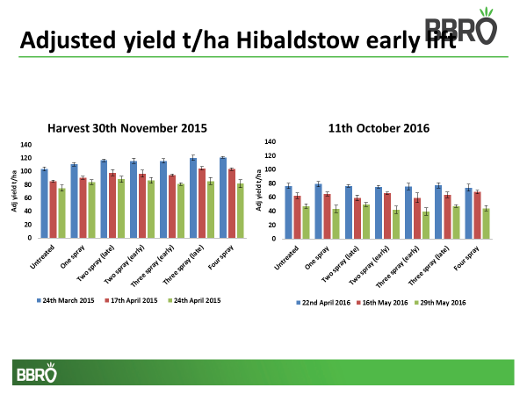

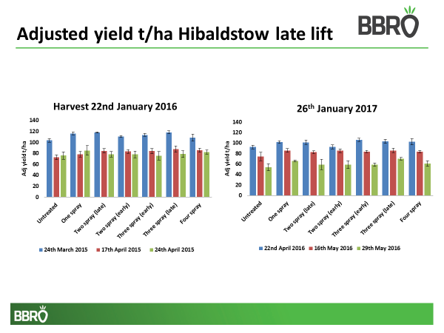

Analysis of the performance of fungicide programmes over the last three years (when compared to the untreated control) suggest that yield responses are decreasing. This will be re-evaluated after the 2017 trials to see if this trend continues.

Annual report: Key issues to be addressed next year:

The project will be extended for one further year to repeat the necessary field trials for the InnovateUK SPOREID project.

Publication of results to date/planned publications:
Section 2: To be completed by project mentor
Is the project on track to meet the stated objectives? (please comment in relation to milestones and the status score awarded in section 1).

Please comment on any proposed changes to milestones.
Are conclusions scientifically robust? (please comment on data analysis/interpretation)
For final reports only:
How would you rate the project against the following criteria (please give a score out of 10, with 10 being highest)
1 ) The project met its original objectives:

2) Contribution to scientific knowledge:

3) Direct relevance to growers:

