BBRO PROJECT REPORT FORM
Please note the details on page 2 will be used to formulate the BBRO printed Annual Report.
Project Title:
Understanding soil plant interactions to improve sugar beet productivity
BBRO project no: | 14/100
Project sponsor: | BBRO
Final report

Project lead or student name: | Prof. Debbie Sparkes
Project mentor or supervisors: | Tim Hess
Report Date: | 2020
Reporting period covered:  (e.g. 1/1/16 - 31/12/16) | 2014-2020
Timeline (e.g. Year 1 of 4) | Final report (year 5 of 5)
BBRO use only | Date assessed:
Assessors comments
Action required

Project summary (no more than 300 words)
Sugar beet seedbeds have been surveyed to identify which soil physical properties are important for establishment, including measurements of bulk density, shear strength, soil texture, organic matter and aggregate size. The data has been used to build models explaining which seedbed properties affect sugar beet establishment. Overall, a low shear strength (measurement of soil cohesion) and aggregates smaller than 2 mm, but larger than 0.1 mm have been found to increase emergence. Aggregate size is important, as a mix of small aggregates gives a soil structure with many interconnected pores, allowing air, water and root movement. X-ray C-T scanning was used on intact soil cores taken from the field to study aggregate sizes and pore space and connectivity. In addition to the original scope of the project, and in collaboration with BBRO, we also investigated the effect of cultivation on seedbed properties.

Results from the pore space analysis showed some links between aggregate size, and pore space connectivity, with increase in aggregates over 2 mm showing decreased pore connectivity, as larger aggregates pack together loosely leaving large but unconnected soil pores. This relationship was only seen in 2015, which was considered a more forgiving year for sugar beet establishment. There were no direct links between pore space, or pore connectivity and establishment, as this single measurement may not include enough detail on the complexity of soil properties affecting sugar beet establishment. Similarly, no relationship with soil pores and establishment were seen in the cultivation trials.

Within the cultivation trials a surprising result was the lack of relationship between crop establishment and final yield. Although soil structure is important for establishment and crop health, uniformity of establishment and rate of canopy closure are also important for final yield and these should be considered in further cultivation studies.

Main objectives
To improve understanding of optimum seedbed conditions for emergence and early canopy growth.

Main outcomes and achievements
- A model for establishment based on soil properties has been developed using three years of field survey data, collected from over 60 fields.
- Intact cores have been collected and scanned using X-Ray CT for analysis of soil pore space and soil pore connectivity.
- Cultivation trials highlighted how cultivation affects establishment rate, but that uniformity and rate of canopy closure are also important to consider to improve yield.

Key messages for growers and industry
- Aggregate size, bulk density and shear strength have been consistently found to be key soil properties that determine establishment.
- Pore space and pore connectivity have shown relationships with aggregate size, but not with sugar beet establishment. It is suggested that this is because pore space/connectivity is an oversimplification of all soil properties affecting establishment.

Section 1: To be completed by Project Lead:
Other project objectives (not listed on previous page)

Milestones for current period
Objective No./Milestone No. | Target date | Description
3.1/01  3.1/02  3.2/01  3.3/01  3.3/02  3.3/03 | 06/2014  02/2015  02/2017  12/2017  05/2018  11/2018 | Field survey of establishment and structural measurements completed.  Model developed to predict establishment.  Model evaluation and refinement complete.  Complete prototype of tool to predict establishment.  Complete testing of tool and refine if needed.  Publicise establishment tool for commercial use in 2019.

Summary of results (including figures and tables)
For Project Annual Report: please provide a 2 page summary of key findings from the reporting year.
For Project Final Report: please provide a summary of project findings and outcomes with relevant supporting data.
In 2015, 16 fields were surveyed for a number of soil physical properties directly after drilling, and then surveyed for emergence four weeks after drilling. A model was produced, which was able to explain 60% of the variation in sugar beet establishment (Fig 1) based on soil physical properties measured at drilling. The model highlighted shear strength as the most important factor, with other influential factors including bulk density and aggregate size. With this working model produced, the survey was expanded in the second and third years to include over 60 fields in total. The original plan was to expand the survey to include a wider range of soil conditions, to test and improve the original model. However once collected and tested, the further years of data did not fit the original model, but did group together to make a second model, which explained 69% of the variation in sugar beet establishment over those two years (Fig 1).
In 2015 the weather was favourable with drilling completed quickly, while in 2016 and 2017 we saw a protracted drilling season due to cold and wet weather. It is likely that the large difference in drilling date and weather conditions led to the difference in the 2016 and 2017 data sets. The clay and silt content were not important in the 2015 model, but came out as important factors in the 2016 / 17 model probably due to the wet weather causing capping in silty soils and waterlogging in clay soils. However, there were similarities between the two models, showing that bulk density, shear strength and aggregate size were consistently important properties for predicting establishment across all years measured (Fig 1).

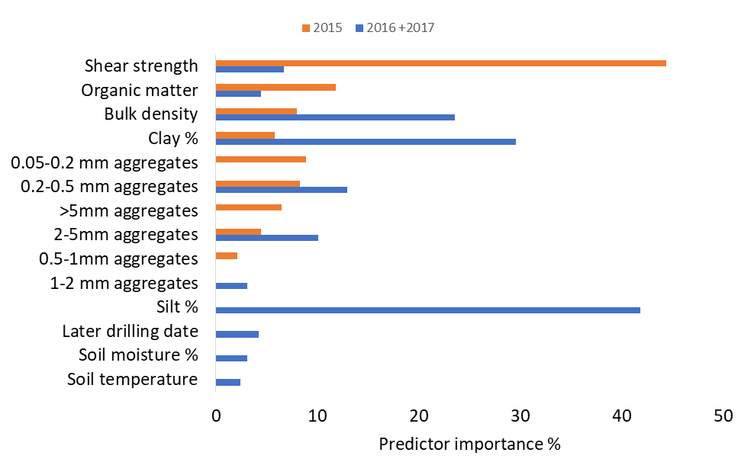
Figure 1: The predictor importance % for each soil property included in the 2015 and 2016+2017 models.

Alongside the measurements taken from the field survey, intact cores were collected from the field for analysis using the X-ray C-T scanner. The scanner produced 3D X-ray images and using image analysis the pore size and connectivity were calculated. The initial data showed trends towards smaller pore sizes in the better established plots (2a), and increased connectivity in these smaller pore size classes (Fig 2b).
Statistical analysis showed some significant relationships between aggregate size and pore space in the 2015 dataset; with aggregates in the class size 0.5- 1 mm showing a positive relationship with pore space (Fig 3). Pore space connectivity also showed a negative relationship with aggregates over 2 mm, but correlated positively with aggregates in the class size 0.2-0.5 mm. However, these relationships were not seen in the 2016 and 2017 datasets. Although aggregate size affects pore space, other factors such as water content, and cultivation decisions can also impact soil structure, influencing soil pore space and connectivity and these may have had a larger role in the unfavourable conditions of 2016 and 2017.

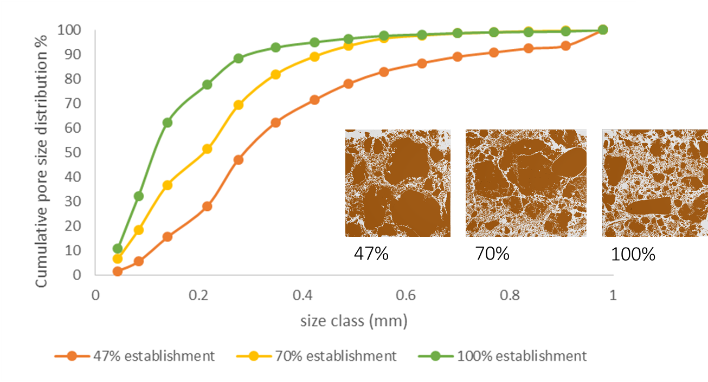
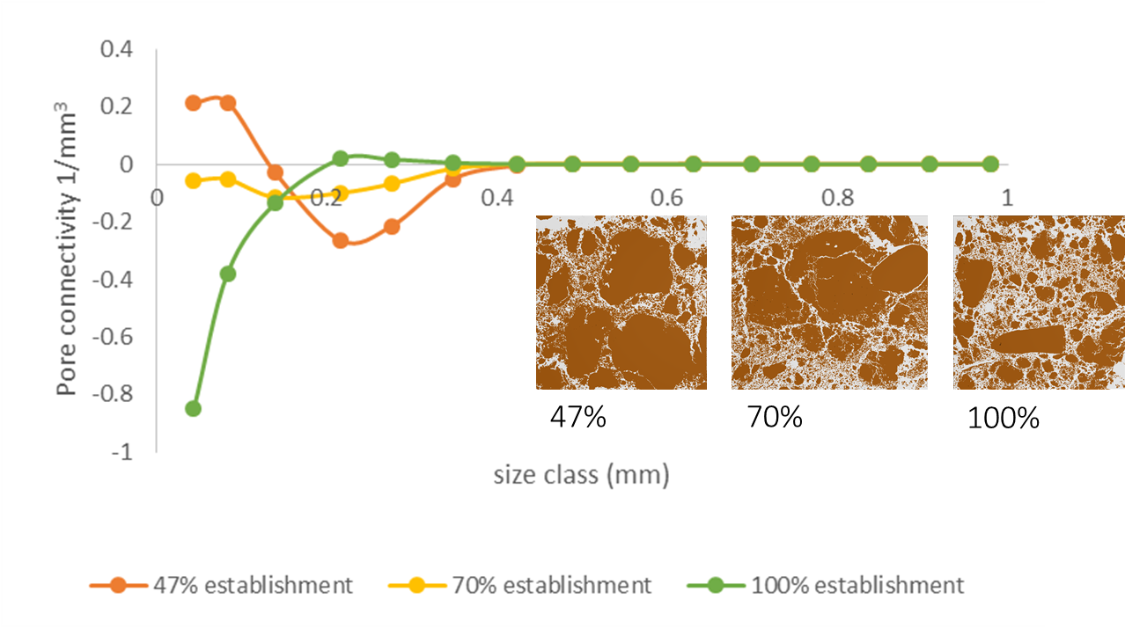
Figure 2: Three examples from a sandy clay loam show a low medium and high establishment. In figure 2a, image analysis has been used to calculate pore size, in figure 2b, pore connectivity has been calculated. Negative numbers show higher connectivity.

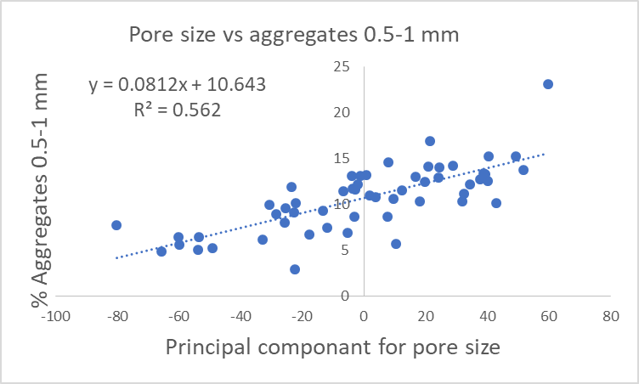
Fig 3: Regression between aggregates in the range 0.5 – 1 mm and pore size showing a positive relationship. As pore size is a multivariate dataset, a PCA was used to reduce this to one PC, which contained 87% of the variability from the original dataset.

The initial plan for the project was to develop an app to help farmers with decision making when drilling sugar beet, but after feedback from growers it was decided to focus instead on how cultivation affects establishment across different soil types, using the information gathered on soil properties which influence sugar beet establishment. Working with Stephen Aldis at BBRO, three on-farm strip trials were carried out using a range of seedbed preparation techniques. Soil properties were again measured at drilling, and establishment was counted four weeks later. Intact cores were taken for 3D X-ray CT scanning, and image analysis to determine pore space and pore connectivity. At the BBRO trial site in Rougham (loamy sand) three cultivation types were compared: plough, deep tine with power harrow and strip till. The plough plot surprisingly had poorer establishment at 60.9 %, followed by strip till at 63.5 %, and deep tine cultivation with power harrow at 72.6 %. Analysis of the X-ray CT data showed that although the ploughed plots had the greatest number of small pore spaces, it had the lowest number of connected pores. The strip till only cultivated the top two cm of soil, while the deep tine cultivation disturbed the soil deeper into the profile, with a clear transition from fine aggregates to larger ones (Fig 4). The low connected pore space in the plough seedbed may explain the poor establishment, while the larger aggregates at depth in the deep tine cultivation may explain why deep tine cultivation was also not very high.
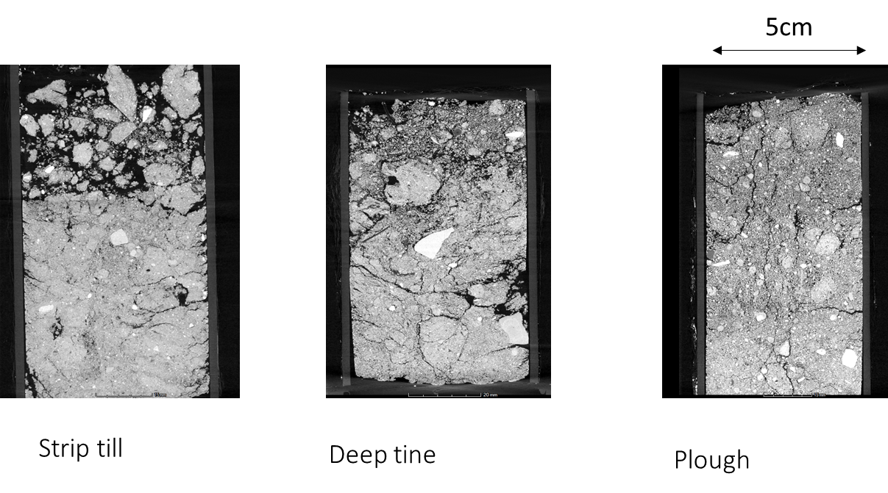
Fig 4: Examples of the X-ray C-T scans from the loamy sand site Rougham. These scans show 2D cross sections from the 3D scans.

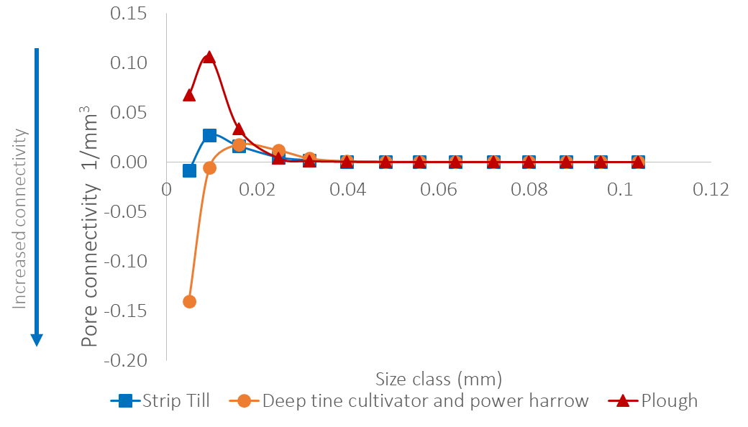

A cultivation trial at Morley (sandy clay loam) looking at 1, 2, and 3 passes with a spring tine showed very little difference in establishment (Table 1) and no differences seen in pore space or connectivity. A further trial at Morley comparing Vaderstad and Sumo trio cultivators to strip till once again showed small differences in establishment (Table 1). There was a slight decrease in small pore spaces in the strip till treatment, but no changes in pore connectivity. Sugar yield was also measured and did not always reflect crop establishment, with higher sugar yield in the ploughed plot in Rougham, despite the lowest establishment (Table 1). It is clear that uniformity of establishment and early canopy closure are also important for yield, as well percentage establishment.

Table 1: Cultivation trials carried out at Morley and Rougham in 2018 and 2019.
 | Primary Cultivation | Secondary cultivation | Establishment (%) | Sugar yield (t/ha)
Rougham 2018 | Strip till | N/A | 65.3 +/- 12.1 | 14.4
Loamy sand | Deep tine min till | Power harrow | 72.6 +/- 2.6 | 17.7
 | Plough | Power harrow | 60.9 +/- 7.8 | 18.7
Morley 2018 | Plough | 1 x combination harrow | 68.3 +/- 7.7 | 16.3
Sandy clay loam | Plough | 2 x combination harrow | 75.9 +/- 2.7 | 17.6
 | Plough | 3 x combination harrow | 71.1 +/- 4.0 | 17.3
Morley 2019 | Strip till | N/A | 78.3 +/- 1.5 | 11.4
Sandy clay loam | Shallow tine min till | Spring tine | 80.0 +/- 4.6 | 12.1
 | Deep tine min till | Spring tine | 85.8 +/- 1.4 | 14.2

Soil surveys across three years and over 60 fields showed consistent soil properties linked with better establishment. These included bulk density, shear strength and aggregate size, with aggregates too large (>2mm) or too small (<0.2 mm) having negative impacts while aggregates in the middle range showed positive impacts on establishment. Analysis using X-ray CT scanning suggest that aggregates in these size ranges can form a good network of small connected pore spaces, which allow air, water and root movement in the seedbed, and enough seed soil contact to allow the seed to take up water and emerge. Surveying over three years of contrasting weather showed that environmental impacts coupled with different cultivation methods can also affect soil structure and establishment. Initial cultivation trials carried out during this project showed that differences in establishment could be better explained by pore space connectivity, than number of small pore spaces. It also demonstrated that establishment alone does not improve yield; uniformity of establishment is also important along with canopy expansion. In future establishment trials uniformity of establishment should also be measured, and the crop monitored for canopy expansion to better link establishment with final yield.

Annual report: Key issues to be addressed next year:

FINAL REPORT

Publication of results to date/planned publications:
A poster was presented on this work package at the BBRO 2016 and 2019 open days.
An article for the British Sugar Beet Review was published in the May 2018 issue, focusing on this work package.
A paper was presented to the IIRB conference in June 2018, and an update was presented in at the IIRB congress in 2020.
Two papers have been published in high quality refereed journals in collaboration with Sebastian Blunk, using the X-ray CT scanner to understand seed soil contact in cores taken from cultivation trials during 2018 sampling.
A further publication is planned using the models for establishment generated in the three survey years.

Blunk, S, Bussell, J, Sparkes, DL, de Heer, Sturrock, CJ and Mooney, SJ (2021) Tillage significantly affects seed-soil contact but not necessarily seedling establishment for sugar beet (Beta vulgaris). Soil and Tillage Research. 206: https://doi.org/10.1016/j.still.2020.104757

Blunk, S, Malik, AH, de Heer, MI, Ekblad, T, Bussell, J, Sparkes, DL, Fredlund, K, Sturrock, CJ and Mooney, SJ (2017) Quantification of seed–soil contact of sugar beet (Beta vulgaris) using X-ray Computed Tomography. Plant Methods, 13:71 DOI 10.1186/s13007-017-0220-4

Section 2: To be completed by project mentor
Status - Mentor’s scoring system for interim reports.
Red | “Major concern - escalate to the next level"  Slippage greater than 10% of remaining time or budget, or quality severely compromised. Corrective Action not in place, or not effective. Unlikely to deliver on time to budget or quality requirements.
Amber | "Minor concern – being actively managed”  Slippage less than 10% of remaining time or budget, or quality impact is minor. Remedial plan in place
Green | "Normal level of attention"  No material slippage. No additional attention needed
Milestone | Comments + action required | Status  R/A/G
Is the project on track to meet the stated objectives? (please comment in relation to milestones and the status score awarded in section 1).

Are conclusions scientifically robust? (please comment on data analysis/interpretation)
For final reports only:
How would you rate the project against the following criteria (please give a score out of 10, with 10 being highest)
1 ) The project met its original objectives:

2) Contribution to scientific knowledge:

3) Direct relevance to growers:

