BBRO PROJECT REPORT FORM
Please note the details on page 2 will be used to formulate the BBRO printed Annual Report.
Project Title:
Understanding soil plant interactions to improve sugar beet productivity
BBRO project no: | 14/100 (WP 1: water uptake)
Project sponsor: | BBRO
Final report

Project lead or student name: | Prof. Debbie Sparkes
Project mentor or supervisors: | Tim Hess
Report Date: | 2020
Reporting period covered:  (e.g. 1/1/16 - 31/12/16) | 2014-2020
Timeline (e.g. Year 1 of 4) | Final report (year 5 of 5)
BBRO use only | Date assessed:
Assessors comments
Action required

Project summary (no more than 300 words)
The aim of this work package was to identify what limitations there are to the rooting depth of sugar beet and how that influences water uptake in the field. Through work conducted as part Tamara Fitter’s PhD the rooting constraints of sugar beet have been investigated. Roots were shown to preferentially take up water in the top layers of soil, and only begin to take water up in lower layers when it was limiting in the upper layers. Tamara’s work also demonstrated that roots are able to quickly reach depths of 1m and beyond, but there is a lag of approximately 3 weeks between roots arriving at these deeper layers and extracting water from them. This was attributed to the lack of secondary xylem in young roots, which are required to extract water from depth.

Field surveys across UK sugar beet fields highlighted that there are compaction issues in a number of UK sugar beet fields. Deep root cores were taken and analysed using X-ray CT scanning to quantify the pore space at depth. Field trials at Nottingham were set up to investigate how to alleviate compaction issues. They used deep rooting cover crops; cocksfoot, red clover and cocksfoot mix, lucerne and chicory, which were grown for either 6 months or 18 months before a sugar beet crop. Soil bulk density measurements from the top 10 cm were significantly lower in the cover crop plots compared to the bare soil controls. There was also evidence that the overall crop health was improved in the crop following the long term cover crops. The sugar beet plants had significantly higher SPAD scores; used as a proxy for nitrogen uptake, and lower thermal temperature, suggesting improved water uptake. However, this did not result in a higher yield, possibly due to good water availability throughout the growth of the sugar beet crop.

Short summary of key objectives
Identify the limitations to water uptake by the sugar beet crop and how these can be mitigated.

Main outcomes and achievements
- Methodology was developed to investigate sugar beet root growth in non-limiting conditions – initially in 1m columns and subsequently in ‘mini-plots’ using large potato boxes (1.8 x 1.2 x 1.2m)
- Use of minirhizotrons, alongside moisture sensors, demonstrated the delay of c. 21 days between roots arriving at deep soil layers and extracting water from those layers
  - Detailed root anatomy work demonstrated that it takes c.21 days for secondary xylem to develop in roots which we believe is the reason for this delay
- Field experiments showed that varieties differ in their rooting patterns but that there is also a strong GxE interaction in root growth
- A survey of farmers’ field found limitations to root growth, typically at 30-40 cm depth.
- A long term cover crop experiment demonstrated the ability of cover crops to improve soil structure (and potentially water uptake) of the subsequent sugar beet crop

Key messages for growers and industry
- Sugar beet roots can quickly grow to 1m depth, in unconstrained conditions, but there is a delay of approximately 3 weeks before they can extract water from these layers
  - This was explained by the need for secondary xylem to develop before water could be extracted from depth
- Sugar beet varieties differ in their rooting patterns, and there is strong interaction between genetic potential and environmental conditions which needs further exploration
- Our results indicate the potential to select for varieties of sugar beet that can extract more water from deeper soil layers: either through more optimal distribution of roots or more rapid development of secondary xylem
- Compaction is an issue across 74% of areas sampled in UK fields, which is likely to limit the growth of sugar beet roots and thereby water uptake
  - Long term cover crops could potentially improve soil structure and hence water uptake by subsequent beet crops. Further research is required, with water limitation imposed, to explore whether this leads to benefits in yield

Section 1: To be completed by Project Lead:
Other project objectives (not listed on previous page)

Milestones for current period
Objective No./Milestone No. | Target date | Description
1.1/01  1.1/02  1.2/01  1.3/01  1.3/02  1.3/03  1.3/04  1.3/05 | 12/2014  05/2015  01/2016  02/2016  04/2016  04/2017  04/2018  12/2018 | Methodology development for column work complete.  Completion of experiments to define maximum rooting depth/water uptake in ideal conditions.  Completion of experiments to identify the most important constraints to root growth/water uptake in the field.  Design of field experiments to evaluate methods to alleviate rooting constraints based on outcome of 1.2.  First field experiments on rooting constraints established across a range of soils.  Second field experiments on rooting constraints established.  Final field experiments on rooting constraints established.  Recommendations for growers published.

Summary of results (including figures and tables)
For Project Annual Report: please provide a 2 page summary of key findings from the reporting year.
For Project Final Report: please provide a summary of project findings and outcomes with relevant supporting data.
The aim of this work package was to gain a better understanding of the maximum rooting depth of sugar beet, and the capacity of these roots to obtain water from depth. This work package included work by PhD student Tamara Fitters, whose work developed most of the methodology for measuring rooting depth in column and box experiments and extensive microscopy work to understand how xylem maturity in sugar beet roots influenced water uptake. These results will be summarised below, but for more details on this work please see Tamara’s final PhD report, published thesis, or the three journal papers detailed below.

Tamara’s work using columns has shown that under unconstrained conditions, sugar beet roots will quickly grow to depths of 1 metre, but that there was a delay before moisture sensors at this depth showed any water depletion. Root staining and microscopy was used to study the maturity of the xylem (Fig 1). It showed there was a delay of around 21 days between the roots growing to depth and the xylem being sufficiently mature for water uptake, which could explain the delay of water uptake at depth. Tamara’s work has also looked at the effects of drought on sugar beet growth. Following on from the column experiments, potato boxes were used to simulate drought conditions and allow monitoring of roots using rhizotron cameras, but without the edge effects seen in column studies (Fig 2). An experiment investigating the impact of early or late drought on water uptake found that, after a period of early drought, sugar beet appear to recover with stomatal conductance and water uptake both increasing when water is replenished (Fig 3 and 4). The rhizotron cameras also showed that after a period of drought sugar beet roots started to proliferate at depth where moisture was still present in the soil (Fig 5). A field experiment using irrigation vs rain-fed conditions showed that there are varietal differences in root proliferation, with strong interactions between genotype and the environment, with all varieties showing similar rooting at depth under rainfed systems, but much larger differences under irrigated systems (Fig 6).

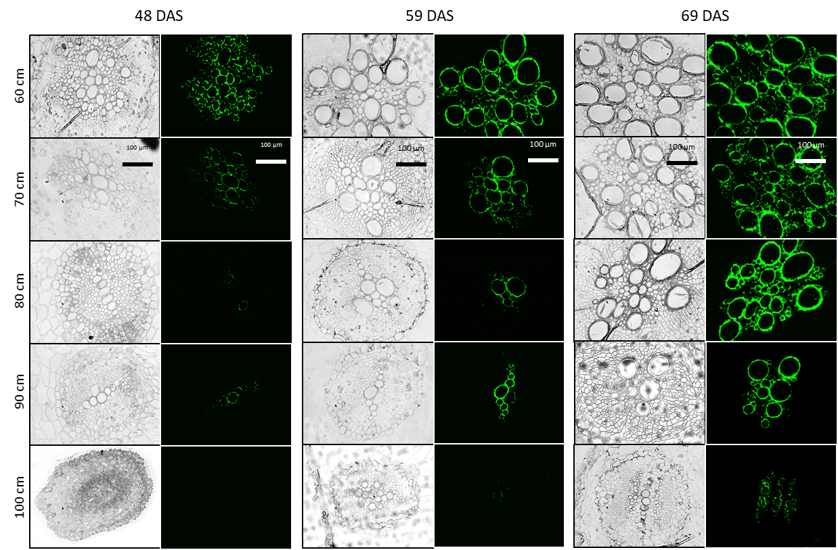
Figure 1: Root staining to show up mature xylem; root cross sections shown under a light microscope on left, and using luminescent staining, showing up mature xylem in green on the right. There is a delay between roots reaching depth, and roots exhibiting enough mature xylem for water uptake.

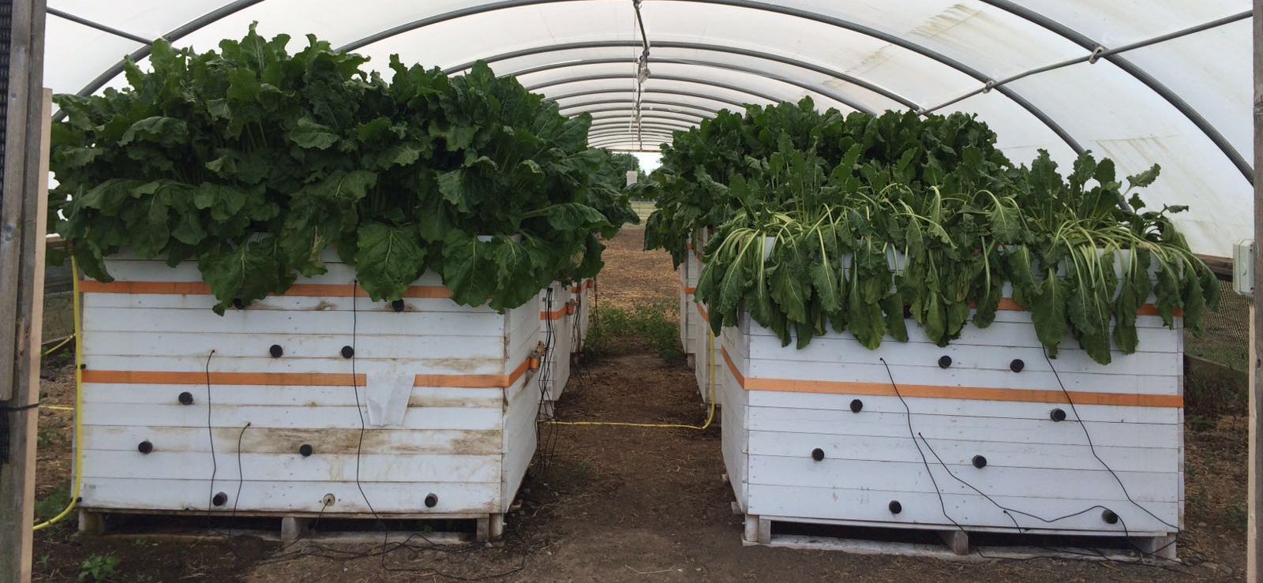
Figure 2: Sugar beet grown in boxes, irrigated on left, and droughted on right. The black marks on the side of the boxes show the rhizotron cameras and the wires going to the boxes show the moisture sensors at different depths.

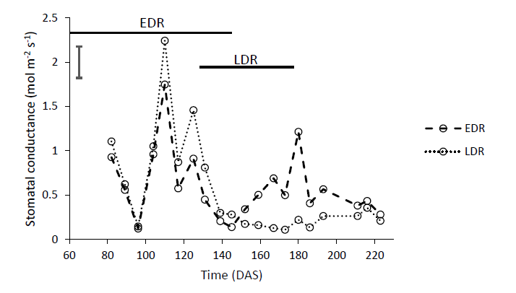
Figure 3: Stomatal conductance over time for each early drought (EDR) and late drought (LDR) treatment. The solid horizontal bars show the timing of drought treatments. The error bar shows least significant difference.
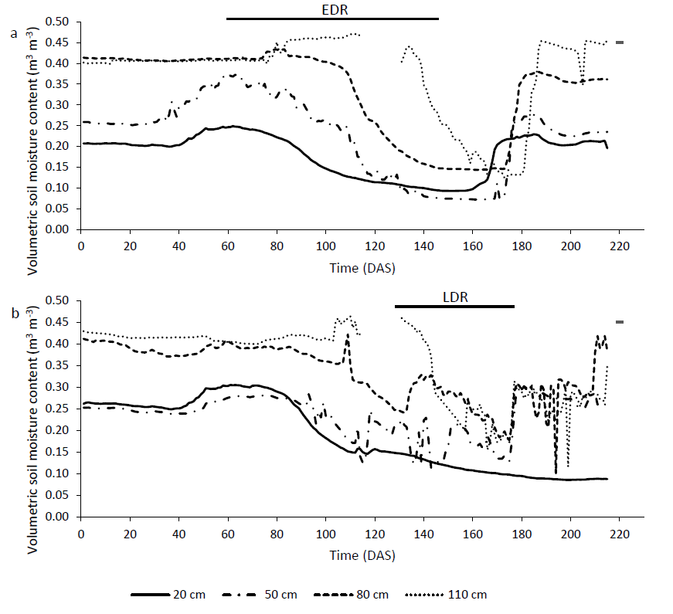
Figure 4: Volumetric soil moisture content over time at four different depths within the box experiment, showing (a) early drought (EDR) and (b) late drought (LDR) treatments. The solid horizontal bar shows the timing of the drought treatments.

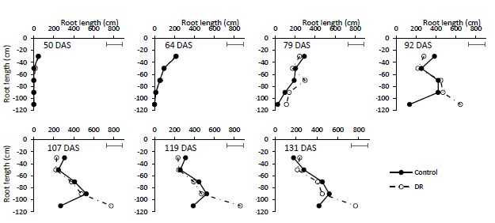
Figure 5: Root length (cm) at five different depths at consecutive time points in the box experiment. The error bars show least significant difference (time*treatment*depth).

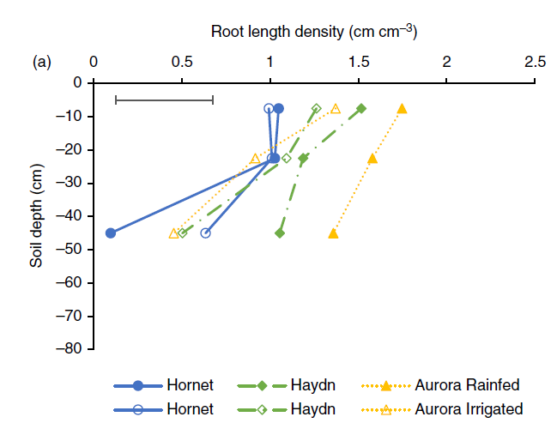
Figure 6: Root length density at 170 DAS at four depths in a rainfed and irrigated field experiment. Error bar shows the least significant difference (treatment*variety*depth).

To further understand the restrictions to rooting depth in the field three years worth of field surveys were carried out across beet growers’ fields. Penetration resistance was measured to a depth of 70 cm surveying 16 fields in year one, 35 fields in year two and a further 32 fields in year three. A penetration resistance score of over 1500 kPa can restrict rooting depth, so this was used to calculate the percentage of sampled areas with compaction problems. Overall, 74% of sampled areas had an area of compaction within the 70 cm profile measured. Table 1 shows the breakdown of rooting restriction within the different soil textures measured, which was slightly higher in sandy soils, which can be prone to slumping, but much lower in peat soils as expected due to the high organic matter content in these soils. Overall, there was little difference in the depths at which the compaction was found, with most of the compaction issues being found between 30 and 40 cm depth (Fig 7).

In addition to this, intact soil cores to a depth of one metre were sampled from a total of 15 fields in 2016 and 13 fields in 2017, across 6 different sites, which varied in soil texture. These were scanned using the X-ray CT scanner, to visualise the pore space at depths of 5cm, 20cm, 40cm and 60cm. Using image analysis the size and connectivity of the soil pores can be visualised to help explain the rooting restrictions seen at depth in sugar beet fields across the UK growing area (Fig 8). Analysis showed that pore size did not differ significantly between the different sites or depths, despite the different soil textures. Pore connectivity did differ with a significant interaction between site and depth (P=0.021). Connectivity is higher at depth in some sites, particularly at Rougham where a number of cores showed a large increase in connectivity at depth. This could be due to the soil at depth being less disturbed by cultivations, so rooting and worm channels have time to build up a connected network of pores. Connected pores are important for water and air movement through the soil, and also aid root growth. The large variation between the cores suggest that improvements in pore space could be made throughout the soil profile in many of the fields tested.

Table 1: Percentage of samples that showed some rooting restriction (readings above 1500 kPa) separated into the different soil texture classes measured.
Soil texture | % of samples with rooting restrictions
Clay loam | 75.0
Loam | 84.0
Loamy sand | 81.7
Peat (>20% OM) | 32.2
Sand | 90.0
Sandy clay | 83.3
Sandy loam | 84.7
Silt loam | 73.4

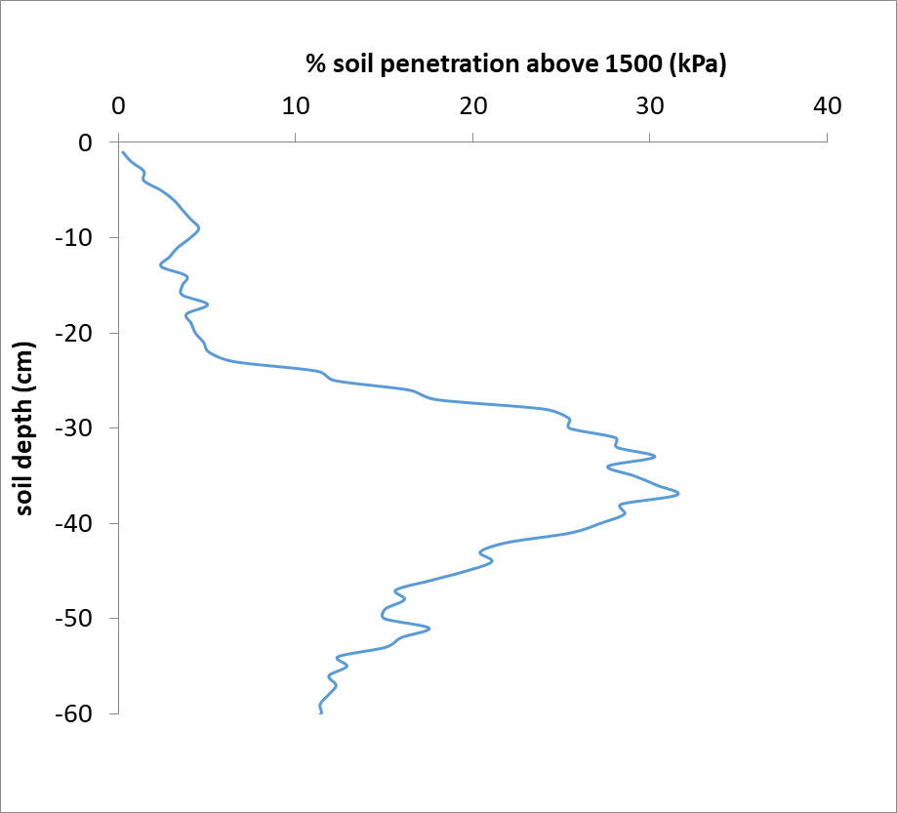
Figure 7: Percentage of samples above 1500 kPa at each depth measured, indicating that most compaction problems in sugar beet fields occur around 30-40cm.

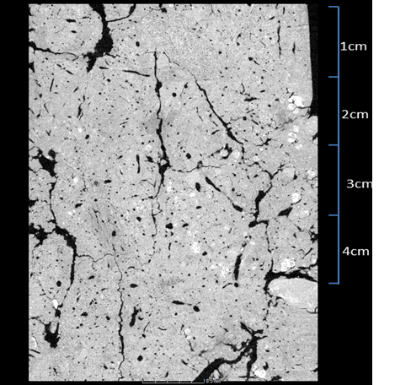
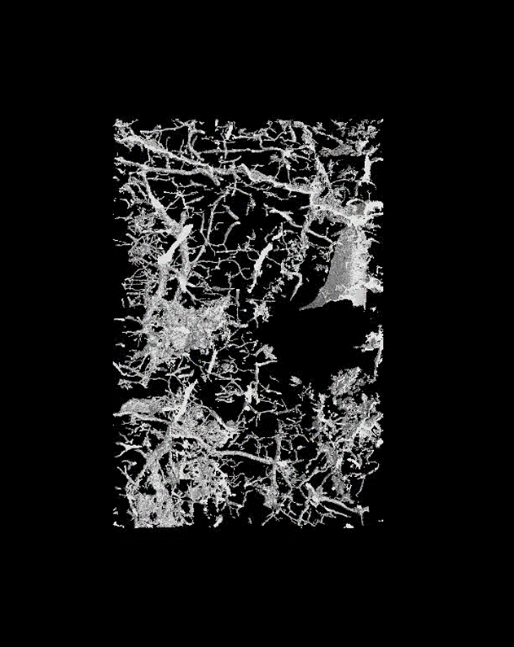
Figure 8: a) A cross section of an x-ray CT scan showing porosity at 60 cm depth in a clay loam beet field. Grey is the soil and black represents the air filled pores and old rooting channels.
b) Showing the pore spaces and rooting channels from the cross section above. In this image grey represents the air filled pores and soil, stones and organic matter have been removed.

Figure 9: a)The pore size (mm) of different sites at 0-30 and 30-60 cm depth. b) The connectivity (Eulian number) of the different sites at 0-30 and 30-60 cm depths. Despite showing no difference in pore size, some of the sites showed higher pore space connectivity at depth.

This work package also used field experiments to investigate if cover crops could be used to alleviate some of the compaction issues seen in sugar beet fields across the UK, to aid deeper rooting in a following sugar beet crop. The aim was to see if deep rooting species could be used to improve the soil structure, allowing improved water uptake by the subsequent beet crop. The deep rooting species chosen were cocksfoot, red clover and cocksfoot mix, lucerne and chicory. These species were also chosen for their ability to be grown over multiple seasons, with the potential to be used as part of a ley treatment before sugar beet for fields with compaction issues. The experiment not only compared these different species, but also the effect of long term (autumn to spring in the following cropping year; referred to as 2 year cover crop treatment) and short term (autumn to spring; referred to as one year cover crop treatment) cover crops ley on the subsequent sugar beet crop.

Bulk density cores showed significant (P<0.001) differences in the top 10 cm of soil. With the bare soil control having the highest bulk density, and cocksfoot having the lowest bulk density (Fig 10). Measurements were also taken of sugar beet health, including SPAD, which is a leaf measurement taken in the field often used as a proxy for nitrogen content. The SPAD results showed a significant difference between sampling time points (P=0.007) and a near significant difference between treatments (P=0.056) with bare soil having the lowest SPAD results and lucerne showing the highest. This trend breaks down in the last few readings, which could be due to the canopy senescence towards the end of the season (Fig 11).

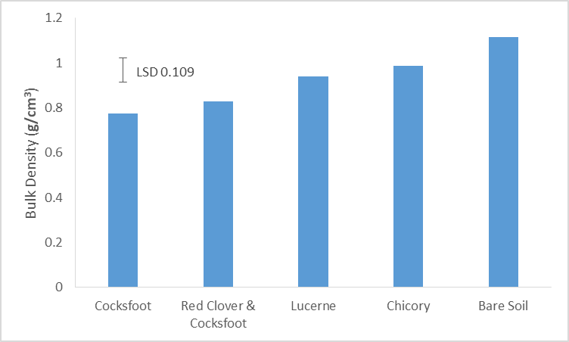
Figure 10: Bulk density measured in the seedbed (10 cm depth) before the sugar beet crop.

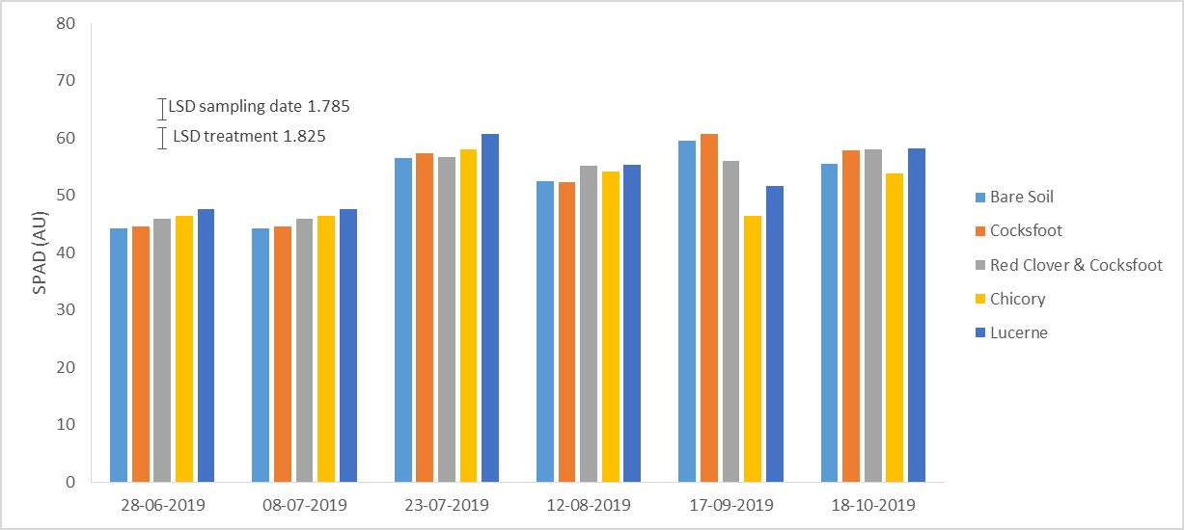
Figure 11: Repeated SPAD measurements taken from the leaves of the sugar beet crop. A close to significant (P=0.056) difference was seen between treatments, with the same trend is seen in the first 4 sampling points.

Thermal imaging was used as an indicator of water stress in the crop (Fig 12). A high canopy temperature measured can indicate closed stomata due to water stress, which could be a sign of poor root growth/water uptake. Canopy temperature was measured throughout the sugar beet growing season, and although there was no significant difference seen between the different cover crops, canopy temperature was significantly lower in plots where cover crops had previously been grown for 2 years, compared to the 1 year plots (Fig 13). This suggests that the longer cover crop treatment improved water uptake in the following beet crop, allowing them to keep their stomata open for longer and maintain a lower leaf temperature through increased transpiration. Despite the differences seen in bulk density, SPAD and canopy temperature, the final harvest showed no significant treatment differences in yield for root mass or sugar content.

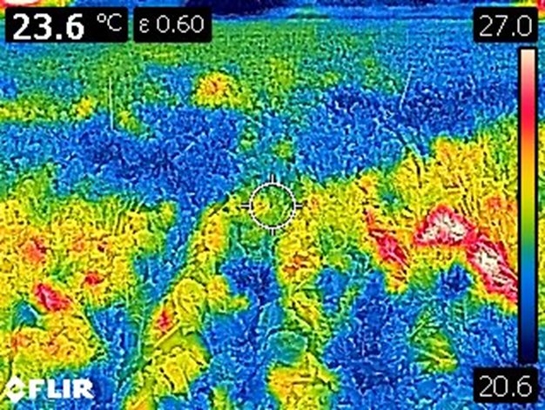
Figure 12: Example of a thermal imaging picture taken of a sugar beet plot following a cover crop, in the long term cover crop trial.

Figure 13: Average plot thermal temperature was taken every two weeks. It was significantly lower in plots that had previously had cover crops in for more than one season (2 year).

In conclusion, the column experiments conducted as part of Tamara’s PhD have shown that in unconstrained conditions sugar beet roots can grow to 1 m depth, and beyond, and will take up water from depth, when water at the surface is limiting. However, there is a delay of around 21 days before the roots at depth have the secondary xylem needed for water uptake. Field surveys have highlighted that there are compaction issues in 74% of the surveyed areas within UK sugar beet fields. Field trials at Nottingham have shown that the use of long term cover crops for more than one season seem to improve the health of the crop, with a higher SPAD and lower canopy temperature suggesting better nitrogen and water uptake, however this did not result in a higher yield. The lack of difference in yield may be due to sufficient water being available to the sugar beet crop in the test year. Hence it would be useful to repeat this experiment in a system where drought can reliably be imposed on the crop.

Annual report: Key issues to be addressed next year:

FINAL REPORT

Publication of results to date/planned publications:
Three papers have been published in high quality refereed journals from this work package:

Fitters, TFJ, Mooney, SJ and Sparkes, DL (2020) Impact of water availability on sugar beet root growth. Soil Use and Management. https://doi.org/10.1111/sum.12664

Fitters, T.F., Bussell, J.S., Mooney, S.J. and Sparkes, D.L., 2017. Assessing water uptake in sugar beet (Beta vulgaris) under different watering regimes. Environmental and Experimental Botany, 144, pp.61-67.

Fitters, T.F., Mooney, S.J. and Sparkes, D.L., 2018. Sugar beet root growth under different watering regimes: A minirhizotron study. Environmental and Experimental Botany, 155, pp.79-86.

In addition, Tamara Fitters presented a paper at the IIRB congress in June 2018.

Posters were presented by Tamara Fitters at BBRO open days and winter technical meetings 2016-2019.

Section 2: To be completed by project mentor
Status - Mentor’s scoring system for interim reports.
Red | “Major concern - escalate to the next level"  Slippage greater than 10% of remaining time or budget, or quality severely compromised. Corrective Action not in place, or not effective. Unlikely to deliver on time to budget or quality requirements.
Amber | "Minor concern – being actively managed”  Slippage less than 10% of remaining time or budget, or quality impact is minor. Remedial plan in place
Green | "Normal level of attention"  No material slippage. No additional attention needed
Milestone | Comments + action required | Status  R/A/G
Is the project on track to meet the stated objectives? (please comment in relation to milestones and the status score awarded in section 1).

Are conclusions scientifically robust? (please comment on data analysis/interpretation)
For final reports only:
How would you rate the project against the following criteria (please give a score out of 10, with 10 being highest)
1 ) The project met its original objectives:

2) Contribution to scientific knowledge:

3) Direct relevance to growers:

