**BBRO 11/19: Increased plant populations and N rates on high-fertility soils**

**By**

**E Burks, C Walters & G Milford**

Final report

March 2013

**Increased plant populations and N rates on high-fertility soils**

**Introduction**

A recent review of past work on plant populations from the 1970s, 1980s and early 1990s concluded that the optimum population density for maximum yield lies between 80 and 100,000 plants/ha, and that little yield is lost above this optimum[1]. This is now the general commercial recommendation for UK sugar beet grown on most types of soil.

In his recent address to the BBRO 2013 Grower Conference, Robert Olssen of Nordic Beet Research made the point that grower generated knowledge is often ahead of R & D advice. There are indications many UK growers are adapting these generally-recommended plant populations to their own particular circumstances. Recent British Sugar surveys of grower practice, for instance, show that, whereas many growers on sand, loamy sand, and sandy and clay loam soils may achieve their maximum yield with 80-100,000 plants/ha, many growers on fertile silt and fen-peat soils are obtaining increasingly greater yields with plant populations beyond 120-140,000/ha (Fig.1). It is not known whether these increased yields are due to increased dry matter production or to the greater partitioning of crop’s dry matter to the storage root and to sugar.

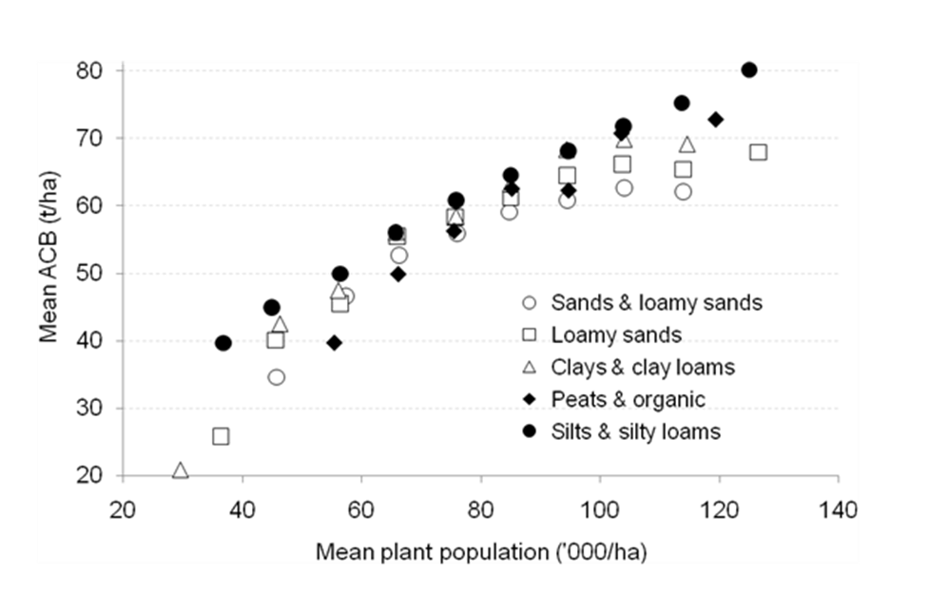

Fig. 1. *Relation between yield and plant population density on different soil types derived from 2008-11 British Sugar surveys of grower practice.*

The practices used by French sugar-beet growers - who are among the most productive in Europe - support the use of high plant populations on a fertile soil. Growers around the Paris basin consistently achieve yields of 100-120 t ACB/ha helped, in part, by the use of much higher plant populations of 110-120,000/ha and the use of more nitrogen (150 kg/ha). This contrasts with UK practice on our fertile silt soils, for instance, on which the average plant population is around 90,000/ha, and to which an average of 88 kg N/ha is applied producing an average yield of 73 t ACB/ha[2].

The BBRO commissioned a single experiment in 2012 to test how far yields on a fertile silt soil could be increased by the use of higher than recommended plant populations supplemented with an application of extra N.

**The experiment**

The experiment tested the factorial combination of six plant population densities (100-140,000/ha) with and without an extra 50 kg N/ha in a 4-block, randomised split plot design on a fertile silt at Holbeach in Lincolnshire. Plant population treatments were allocated to the main plots and the N treatments to the sub-plots in a split-plot design. Plots were 6 rows by 9 m from which a 13.5 m2 area was lifted from the central 3 rows. Clean beet yield, dirt tare and sugar, amino-N, Na and K contents were measured in the Wissington-factory tare-house. The trial was drilled on the 20th March 2012. 120 kgN/ha had already been applied to the entire seedbed in liquid form. The trial was lifted on the 5th November 2012.

|  |  |  |  |  |
| --- | --- | --- | --- | --- |
| Target Seed Rates - Holbeach Hurn | | | | |
|  |  |  |  |  |
| **20 tooth master drive socket** | | |  |  |
| **Cell wheel code K** |  |  |  |  |
| **50cm rows** |  |  |  |  |
|  |  |  |  |  |
| **Gear** |  | **Spacing (inches)** | **Spacing (cm)** | **seeds/ha** |
| Red | 33/22 | 4.75 | 12.1 | 166,000 |
| Gold | 32/23 | 5.2 | 13.2 | 151,000 |
| Green | 31/24 | 5.5 | 14.0 | 143,000 |
| Grey | 30/25 | 6 | 15.2 | 131,000 |
| Black | 29/26 | 6.5 | 16.5 | 121,000 |
| Brown | 28/27 | 7 | 17.8 | 112,000 |

**Results**

There were problems with establishment within the trial: three plots had missing plants in two guard rows and a further seven plots had missing plants in one guard. Although not satisfactory, the trial was taken to harvest. The data were statistically analysed in two ways: firstly by a straightforward analysis of variance (ANOVA) that included all plots (coefficient of variation for adjusted clean beet yield = 17.4%), and secondly by an ANOVA that treated plots with missing guard rows as missing plots (coefficient of variation = 7.9%). The results of the second analysis are used in this report.

Very high plant populations, ranging from 100-150,000 plants/ha, were established in the trial and yields of over 120 t of adjusted clean beet/ha obtained. The responses of clean beet yield and beet quality to increased plant population and extra fertiliser N are given in Table 1. Figure 1 shows the effects on the yield of adjusted clean beet. There were yield responses to increases in plant population from 100,000 to 150,000 plants/ha without extra N, or to an increase from 100,000 to 125,000 plants/ha when extra N was given. The highest plant populations of 125,000 to 150,000 plants/ha did appear to increase yields when the crops were given an extra 50 kg N/ha. In this form of the analysis, however, the responses were not statistically significant because of the confounding effects of the large number of missing plots without sufficient guard rows.

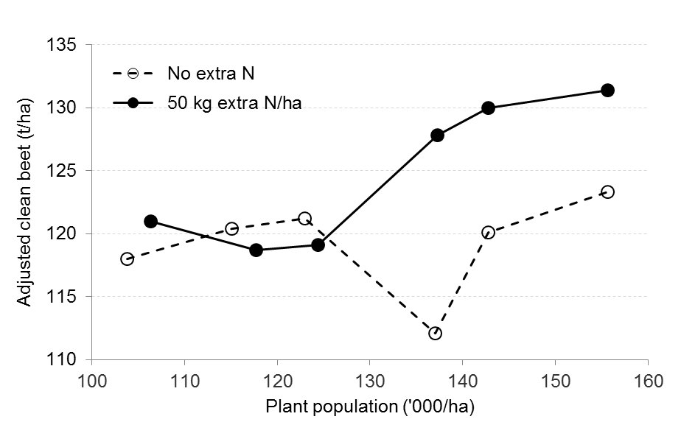

Fig.1. *The effects of increasing plant population and extra N fertiliser on the yield of adjusted clean beet on a fertile silt soil.*

Better statistical discrimination between responsive and non-responsive treatments was obtained by comparing the pooled variances of the highest three plant populations that received extra N with the remaining treatments (i.e. the lowest three plant populations given extra N plus the six plant populations given no extra N), omitting the missing plots. This pooled analysis showed that an extra 9.1 t of adjusted clean beet/ha populations were obtained in a 120 t/ha crop, when plant populations were increased above 125,000 plants/ha and given an extra 50 kg N/ha More importantly, the increase was statistically significant (Fig. 2).

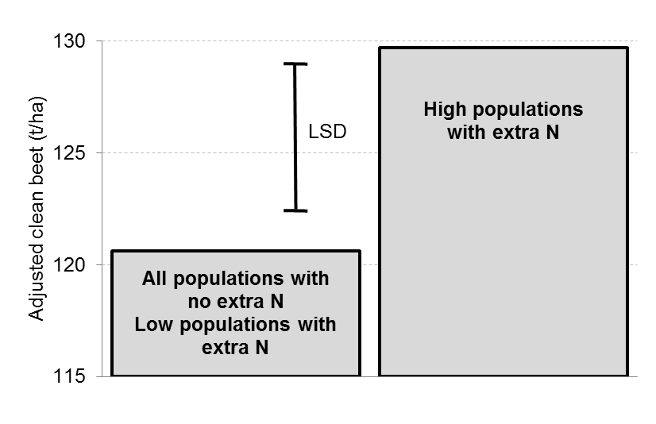

Fig.2. *Pooled statistical analysis of the effects of plant population and extra N on sugar-beet yield on a fertile silt soil.*

**Conclusions and recommendations for further work**

The current recommended populations for sugar beet are based on experiments done in the 1970s, 1980s and early 1990s. Few of these tested populations above 120,000 plants/ha, and even fewer tested whether high plant densities require extra nitrogen. However, many commercial sugar-beet growers on those on fertile soils (many in France but some in the UK) claim yield gains from higher than recommended populations supplemented with extra N.

The results of the single experiment reported here support this grower-driven approach. The experiment was not as clear cut as intended - illustrating the risk of relying on single experiments to produce clear-cut decisions on agronomic practice. Even so, we were able to show that extra yield could be obtained from high-yielding crops on fertile silt soils by establishing more than 125,000 plants/ha and supplying them with an extra 50 kg N/ha. The response to increased plant numbers in this trial are in line with those of the previous 2010 BBRO seed rate and spatial arrangement trial[3]. Obviously, more trials are needed to confirm the findings of this initial trial.

Recent British Sugar grower surveys indicate ample opportunities for using higher than recommended seed rates and extra N on some of the UK’s more fertile sugar-beet soils. For example, although over 60% of sugar-beet growers on silt soils succeed in establishing the recommended populations of 85-100,000 plants/ha, very few establish populations greater than 125,000 plants/ha (Fig. 1) or apply extra N.

There are also reasons to believe the crops grown use of some of the organic soils might benefit from much higher plant densities with the aim of constraining shoot growth and shifting the partitioning of dry matter more toward the root. However, Crops grown on N-rich organic soils will not require any extra N.



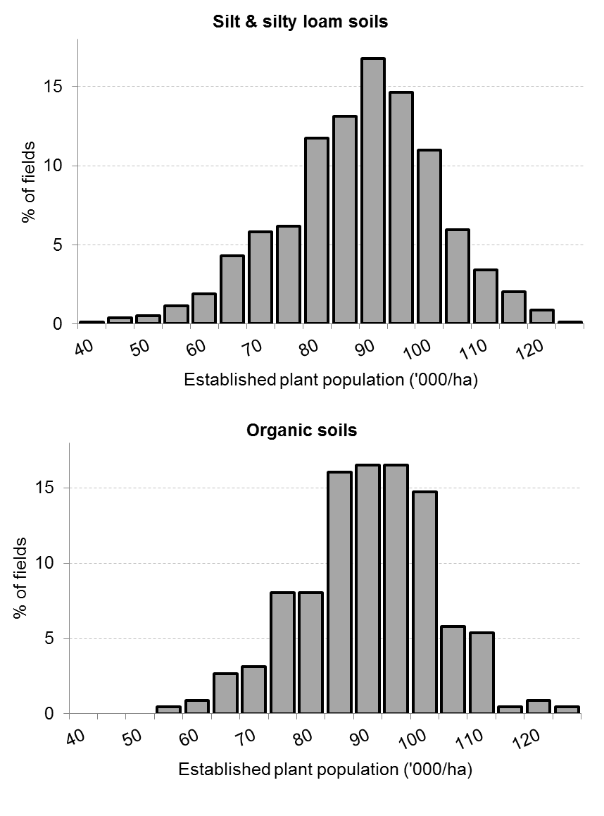

Fig. 3. *Established plant population densities for sugar beet grown on silt and organic soils (from British Sugar’s 2006-10 surveys of grower-practice).*

1. BBRO 10/24: Seed rates and optimal spatial arrangement of seeds for maximum yield and profitability. Final report, May 2011.
2. British Sugar surveys of grower practice 2008-11.
3. BBRO 10/04: Seed rates and optimal spatial arrangement of seeds for maximum yield and profitability. Final report, May 2011.