Project title | Monitoring and managing insecticide resistance in UK pests
Project number | 21510015
Start date | 1 April 2012 |  | End date | Since 2015, the project has been annually reviewed and awarded one-year extensions.
Project aim and objectives
This long-term project monitors for reduced sensitivity sensitivity (a potential precursor for full resistance) and resistance to insecticides in key UK crop pests.
It provides an early warning of the potential evolution/selection of full-blown resistance that may lead to pest control failures.
Monitoring is primarily through insecticide screening bioassays on live insect samples. This approach is independent of the need to know the genetic mechanism (metabolic, target site or other) of the resistance. All samples are screened with compounds at diagnostic doses (determined in past research).
New forms of resistance can be followed up to identify the genetic mechanism(s) involved. With subsequent molecular-based work, it is possible to develop assays to rapidly test multiple insect samples.
Samples are provided by a stakeholder network, which includes project sub-contractors (ADAS and Dewar Crop Protection), and agronomy and agrochemical companies (particularly Agrii).
The work focuses on aphids, primarily virus-transmitting peach-potato aphids (Myzus persicae).
Samples are reared in the lab (to ensure good health) and routinely bioassayed for their response to relevant insecticides.
We also identify the known underlying target site mutations using established DNA-based diagnostics and any new diagnostics (identified in other Rothamsted Research projects).
Screens are also conducted on other important UK aphid pests, including grain aphids (Sitobion avenae), bird cherry-oat aphids (Rhopalosiphum padi), rose-grain aphids (Metopolophium dirhodum), willow-carrot aphids (Cavariella aegopodii), and black bean aphids (Aphis fabae). We have established susceptible baseline bioassay data for each insecticide to allow the selection of appropriate screening doses to test for resistance.
The project also monitors non-aphid pests, including cabbage stem flea beetles (Psylliodes chrysocephala), striped flea beetles (Phyllotreta striolata), pollen beetles (Meligethes aeneus), pea and bean weevils (Sitona lineatus), diamondback moths (Plutella xylostella), silver Y moths (Autographa gamma), asparagus beetles (Crioceris asparagi) and onion thrips (Thrips tabaci).
The project findings guide agronomists, growers and the scientific community on the availability of effective insecticides, and inform the development of insect management strategies (Insecticide Resistance Action Group (IRAG-UK). The results also provide robust scientific support to the regulatory decision-making process via Defra/CRD and inform AHDB crop management guidelines.
The data also provides a valuable resource for determining long-term trends in resistance and modelling future occurrences.

Key messages emerging from the project
Peach-potato aphids
The long-term screening of peach-potato aphid samples has helped monitor insecticide resistance.

Figure 1 provides an example of plotted bioassay data (flonicamid), which compares field and protected sample responses with the fully-susceptible insecticide baselines.

A traffic light system helps show samples that are susceptible (green box) or have reduced sensitivity (amber box) and resistance (red box).

In the UK, there have been no significant changes in sensitivity to neonicotinoids, cyantraniliprole, flonicamid, spirotetramat or sulfoxaflor.

However, there has been strong resistance to pyrethroids over many years, although this may now be falling in frequency.

Figure 1. Response of UK peach-potato aphid nymphs to flonicamid
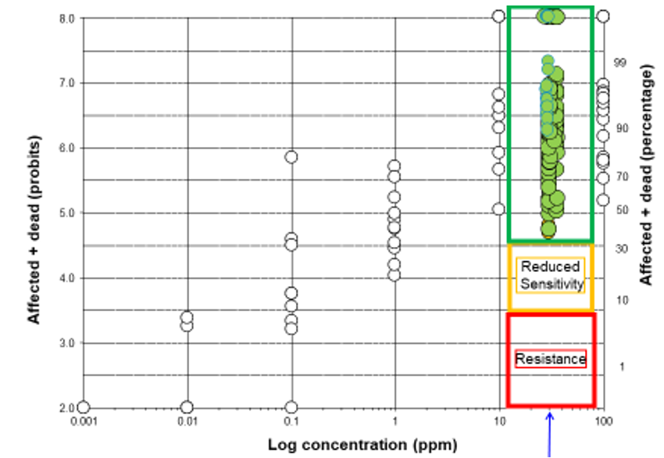

Clear circles = susceptible baselines. Green circles = responses (field and protected samples) to the 30-ppm screening dose. Samples collected from protected environments are shifted slightly to the right to allow distinction.

Screening bioassays have been supported by DNA tests for target site resistance to carbamates (MACE) and pyrethroids (kdr and super-kdr), with results shown in Figure 2.

Figure 2. Presence of resistance mechanisms in peach-potato aphid field samples

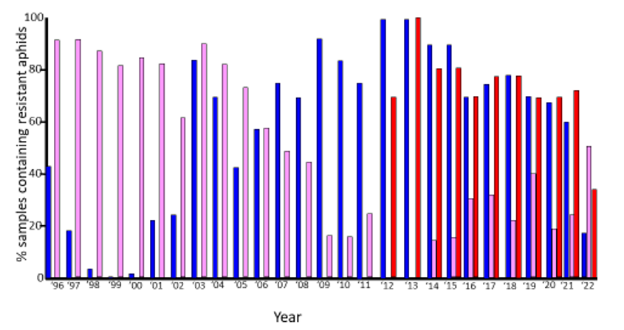
Results of DNA tests for target site resistance to carbamates, MACE (blue) and pyrethroids, kdr (pink) and super-kdr (red)

The relatively new form of super-kdr (North European: Ne) is nearly always found in the heterozygous form (conferring strong resistance to pyrethroids) and has remained relatively common in the UK.

Kdr, which is also primarily found in the heterozygous form (conferring moderate resistance to pyrethroids), has also been found in higher frequencies in recent years.

MACE resistance (to the dimethyl carbamate, pirimicarb) is falling in frequency.

Some field samples contain aphids that were susceptible to lambda-cyhalothrin but resistant to esfenvalerate (both pyrethroid insecticides), probably as the result of a new (unidentified) mechanism.

Peach-potato aphids carrying strong (Nic-R⁺⁺) neonicotinoid resistance, commonly found in southern mainland Europe, north Africa and recently in Belgium on sugar beet, have not been detected in the UK. Continued monitoring is important.

Some peach-potato aphids in protected crops are from more genetically-diverse, sexually-reproducing populations, that have entered the UK on imported plant material. Such samples tend to carry rarer combinations of resistance genotypes and could carry new resistance mechanisms.

Cereal aphids
Bioassay susceptible baselines have been established for many other important aphid pests.

Although moderate pyrethroid resistance is present in grain aphids, it should not compromise control (if sprays are applied at the full recommended field rate with good contact).

Tests on thousands of grain aphids, over the course of the project, have found no kdr-RR (homozygote) genotypes (which are potentially associated with greater pyrethroid resistance). There may be a fitness cost associated with this genotype (as postulated in other insect pests), or the inability of kdr-SR (heterozygotes; mainly thought to be a super-clone: Sav3) to produce both males and females (which could mate and produce RRs).

There is no evidence of pyrethroid resistance in the bird cherry-oat aphid and the rose-grain aphid, although reduced sensitivity (with a response ratio of 5) has been recorded. However, live aphid samples have not been tested since 2020.

Non-aphid pests
Pyrethroid resistance has been detected in other UK pests, including willow-carrot aphids, cabbage stem flea beetles, striped flea beetles, pollen beetles, pea and bean weevils, diamondback moths, silver Y moths, asparagus beetles and onion thrips. Onion thrips have also been found to carry resistance to spinosad.

Leafhoppers (Psammotetix alienus) from barley in the east of England in 2020 were screened for Wheat Dwarf Virus (WDV). WDV was found in all individuals tested. Unfortunately, the hoppers were not healthy enough to be screened for pyrethroid resistance. Interestingly, the sampler, Alan Dewar, has observed WDV symptoms in current cereal crops on the Norfolk/Suffolk border (Breckland).
Summary of results from the reporting year
Peach-potato aphids
Screens on several peach-potato aphid samples collected in 2022 (13, 12 from oilseed rape) show, once more, no reduced sensitivity or resistance (that may compromise control) to many key compounds: acetamiprid, cyantraniliprole, flonicamid, spirotetramat and sulfoxaflor. Furthermore, there was no evidence of any significant shifts towards reduced sensitivity in these insecticides. In 2021, some reduced sensitivity to neonicotinoids and sulfoxaflor was detected. However, this was not detected in the 2022 samples.

In contrast, strong pyrethroid resistance (esfenvalerate and lambda-cyhalothrin) continues to be detected in the screening bioassays (primarily conferred by the super-kdr target site mechanism). In 2022, the frequency was below 40% – the lowest frequency in the decade since the Ne mutation was discovered. Interestingly, the other pyrethroid mechanism, kdr (conferring moderate resistance), was seen in over 50% of the samples (Figure 2). These changes may be due to new aphid clones in the UK population.

Peach-potato aphids continue to carry MACE resistance (specifically, to pirimicarb), although at a much lower frequency compared to previous years (Figure 2). The use of pirimicarb was lost in most UK crops several years ago. This project continues to monitor this mechanism to assess changes (now selection pressures have reduced).

Some samples (3) contained extreme (R₃) esterase levels, conferring strong metabolic-based resistance to organophosphates (OPs), which are now rarely used in UK fields. This resistance was in an otherwise fully-susceptible resistance background – forms that had not been seen in samples collected from UK open-field crops since 2018. These forms may have originated from countries where OPs are more commonly used. One sample carried kdr, old super-kdr and the new super-kdr, all in the heterozygous form, a resistance-genotype combination never detected before in the UK.

In-kind micro-satellite testing, by Gaynor Malloch at the James Hutton Institute, on peach-potato aphids caught in Scottish suction traps in 2022, showed a prevalence of the super clone (P and V) genotypes. However, the O genotype (commonly seen in the past) was not present.

This micro-satellite genotyping method supports the live aphid bioassay and molecular monitoring approach. The monitoring work highlights the volatility of the UK peach-potato aphid population, with super-clones potentially ‘coming and going’ over time.

Cereal aphids
We continue to develop and validate bioassay methods for various aphid species and many insecticides.

As in previous years, greater pyrethroid resistance (than conferred by heterozygous kdr), was not found in three UK samples of grain aphids collected in April and May 2023. Two of the samples were associated with moderate resistance (from winter wheat in Suffolk and winter barley in Hertfordshire). This should not cause control failures when pyrethroid sprays are applied at the full recommended rate (with good aphid contact). All three samples showed no mobile aphids in bioassays at the equivalent of double (200%) field rate. If these forms were detected, it would probably lead to pyrethroid control failures in the field.

In an in-kind contribution from another AHDB-funded project, virus-detecting assays were used to record BYDV and CYDV levels in samples of bird cherry-oat aphids from three suction traps in 2022. The highest levels were seen at the Starcross (17%) and Hereford (13%) sites.

Non-aphid pests
Pyrethroid-coated glass vial bioassays (Figure 3, right) were used to screen 15 cabbage stem flea beetle samples from England and 4 from Scotland (all collected from oilseed rape in 2022).

Figure 3. Bioassay techniques used for resistance monitoring at Rothamsted Research

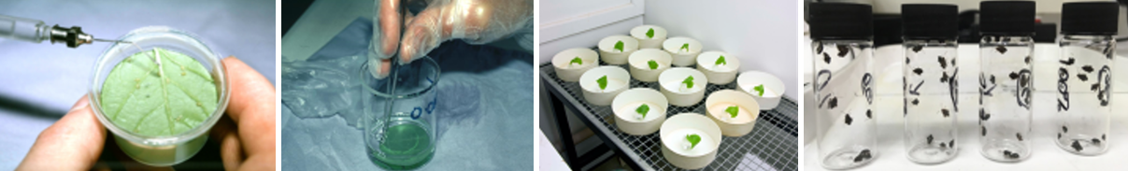

Pyrethroid resistance (at equivalent to full-label application rate) was detected in all samples from England (ranging from 37% at St Albans in Hertfordshire up to 100% at Sancton in Yorkshire). Once again, pyrethroid resistance was not detected in the samples from Scotland. Although the reason for this north-south divide is unclear, it may relate to lower pyrethroid selection pressures or differences weather severity in Scotland.

Three pollen beetle samples (collected from oilseed rape at Rothamsted Research in Hertfordshire in 2022) contained pyrethroid-resistant beetles at the 100% field rate.

Key issues to be addressed in the next year
A further one-year extension would permit focus on insect pests of cereals and oilseeds. This would include providing samplers with collection kits to increase the number of peach-potato aphid samples.
Lead partner |  | Rothamsted Research
Scientific partners |  | James Hutton Institute (‘in kind’ contribution)
Industry partners (for reporting year) |  | Agrii, AHDB, AICC, BASF, Bayer, BBRO, Certis-Belchim, Corteva, FMC Agro, Frontier, Hutchinsons, NuFarm, Procam, Sumitomo and Syngenta
Government sponsor |  | Defra/CRD ‘in kind’ contribution
Has your project featured in any of the following in the last year?
Events | Press articles
IRAG-UK Meetings
S Foster. Monitoring and managing insecticide resistance in UK pests. IRAG-UK Meeting, York. April, 2023.

S Foster. Monitoring and managing insecticide resistance in UK pests. IRAG-UK Meeting, Stoneleigh Park. December, 2022.

S Foster. Monitoring and managing insecticide resistance in UK pests. IRAG-UK Meeting, Virtual Meeting via Teams, April 2022.

Other Meetings
S Foster. Trends in the last decade: insecticide resistance. AHDB Agronomists Conference. Kenilworth, December 2022.

S Foster. Monitoring and Managing Insecticide Resistance in UK Pests. AIC Meeting. Peterborough, April 2022.

S Foster. Update on Aphids and Resistance. ADAS Aphid Workshop, Virtual Meeting, March 2022.
Conference presentations, papers or posters | Scientific papers
See Above | LE Walsh, O Schmidt, SP Foster, C Varis, J Grant, GL Malloch & MT Gaffney. Evaluating the impact of pyrethroid insecticide resistance on fitness in Sitobion avenae. Annals of Applied Biology. Open Access Article.
Other
Resistance Management Guidelines and Resistance Alerts (in last year)
IRAG-UK guidance is due to be updated in 2023.

