Advanced Sugar Beet Technology Course 2016

The Advanced Sugar Beet Technology Course was established with funding from the BBSRC’s Modular Training Partnerships, with support from BBRO and British Sugar. Now in its fourth year, it has been incorporated within the Agrifood Advanced Training Partnership, providing links with other advanced training courses in agronomy and crop physiology though to food science and animal production (www.agrifoodatp.ac.uk). The course is recognised by BASIS as an advanced module (worth 30 CPD points) and can be applied towards the BASIS Diploma in Agronomy.

The course comprises six days of training, divided into three, two-day units. There is also a fourth, optional unit, on water management and irrigation, delivered by Cranfield University. There were 14 delegates on the course this year, including growers, agronomists, British Sugar Area Managers and colleagues from across the wider industry (e.g. plant breeding, the agrochemical industry). The first unit ‘Foundation in Sugar Beet’ was held at the University of Nottingham’s Sutton Bonington Campus on 2-3 November. It set the scene for the rest of the course by covering topics such as the global sugar market and UK sugar beet industry, physiology and agronomy of the crop and soil management. Delegates also heard about current BBRO-funded research on water and nutrient uptake by the crop and visited a field experiment comparing the effect of a range of cover crops on soil structure and yield of the subsequent beet crop (Pic 1).

The second unit ‘Crop Protection’ was held at BBRO in Norwich on 23-24 November and covered the wide range of pests and diseases that can affect the crop, plus the principles of weed control. Alongside the talks, there were lots of hands-on opportunities for the delegates such as analysing plant clinic samples and identifying different aphid species (Pic 2-4). Delegates also heard about the new ALS technology being developed for sugar beet, current research on beet cyst nematodes and the latest on the Spore ID project (REF?).

Eight of the delegates on the course elected to take the ‘Water Management and Irrigation’ module held at Cranfield University on 6-7 December. Topics included estimating the seasonal and peak irrigation requirements for given soil and climate, evaluating different types of irrigation systems and selecting appropriate irrigation scheduling methods.

The final unit of the course was divided between ‘Plant Breeding, Seed Production and Seed Technology’ (13 December) and ‘Harvest, Storage and Processing’ (14 December). Delegates learned about the history of plant breeding and seed production and how breeders select for disease resistance. This was followed by a visit to Germains where the focus was on the technology of priming and seed treatment, including tours of the priming and pelleting factories. The final morning of the course was largely in the field with practical demonstrations of harvester management. Delegates worked through a harvester loss assessment and how to trace back losses to possible problems with the harvester (Pic 5/6). We then moved inside for a discussion on minimising losses in storage and a tour of Wissington Sugar Factory and the trials tare house (Pic 7).

I would like to thank the many contributors to the course, too numerous to name individually, who together provide a unique training course in sugar beet production. I would also like to thank Germains who kindly hosted a dinner for delegates on 13th December.

If you would be interested in attending the course in 2017, please contact Debbie Sparkes (Debbie.Sparkes@nottingham.ac.uk).
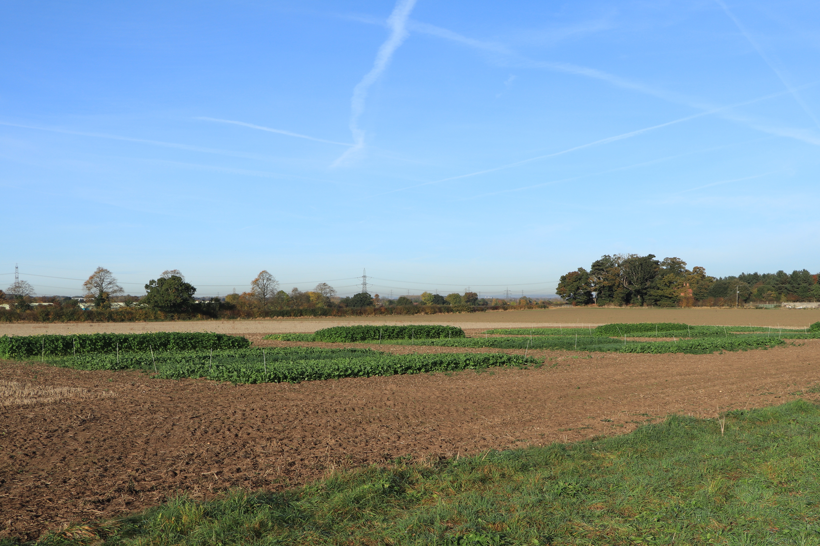
Pic 1. The cover crop experiment at Sutton Bonington.
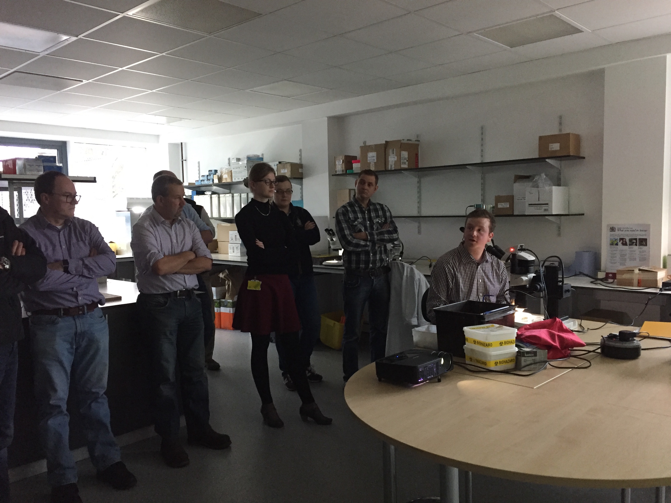
Pic 2. BBRO-funded PhD student Alistair Wright demonstrating how to assess beet cyst nematode infestation.

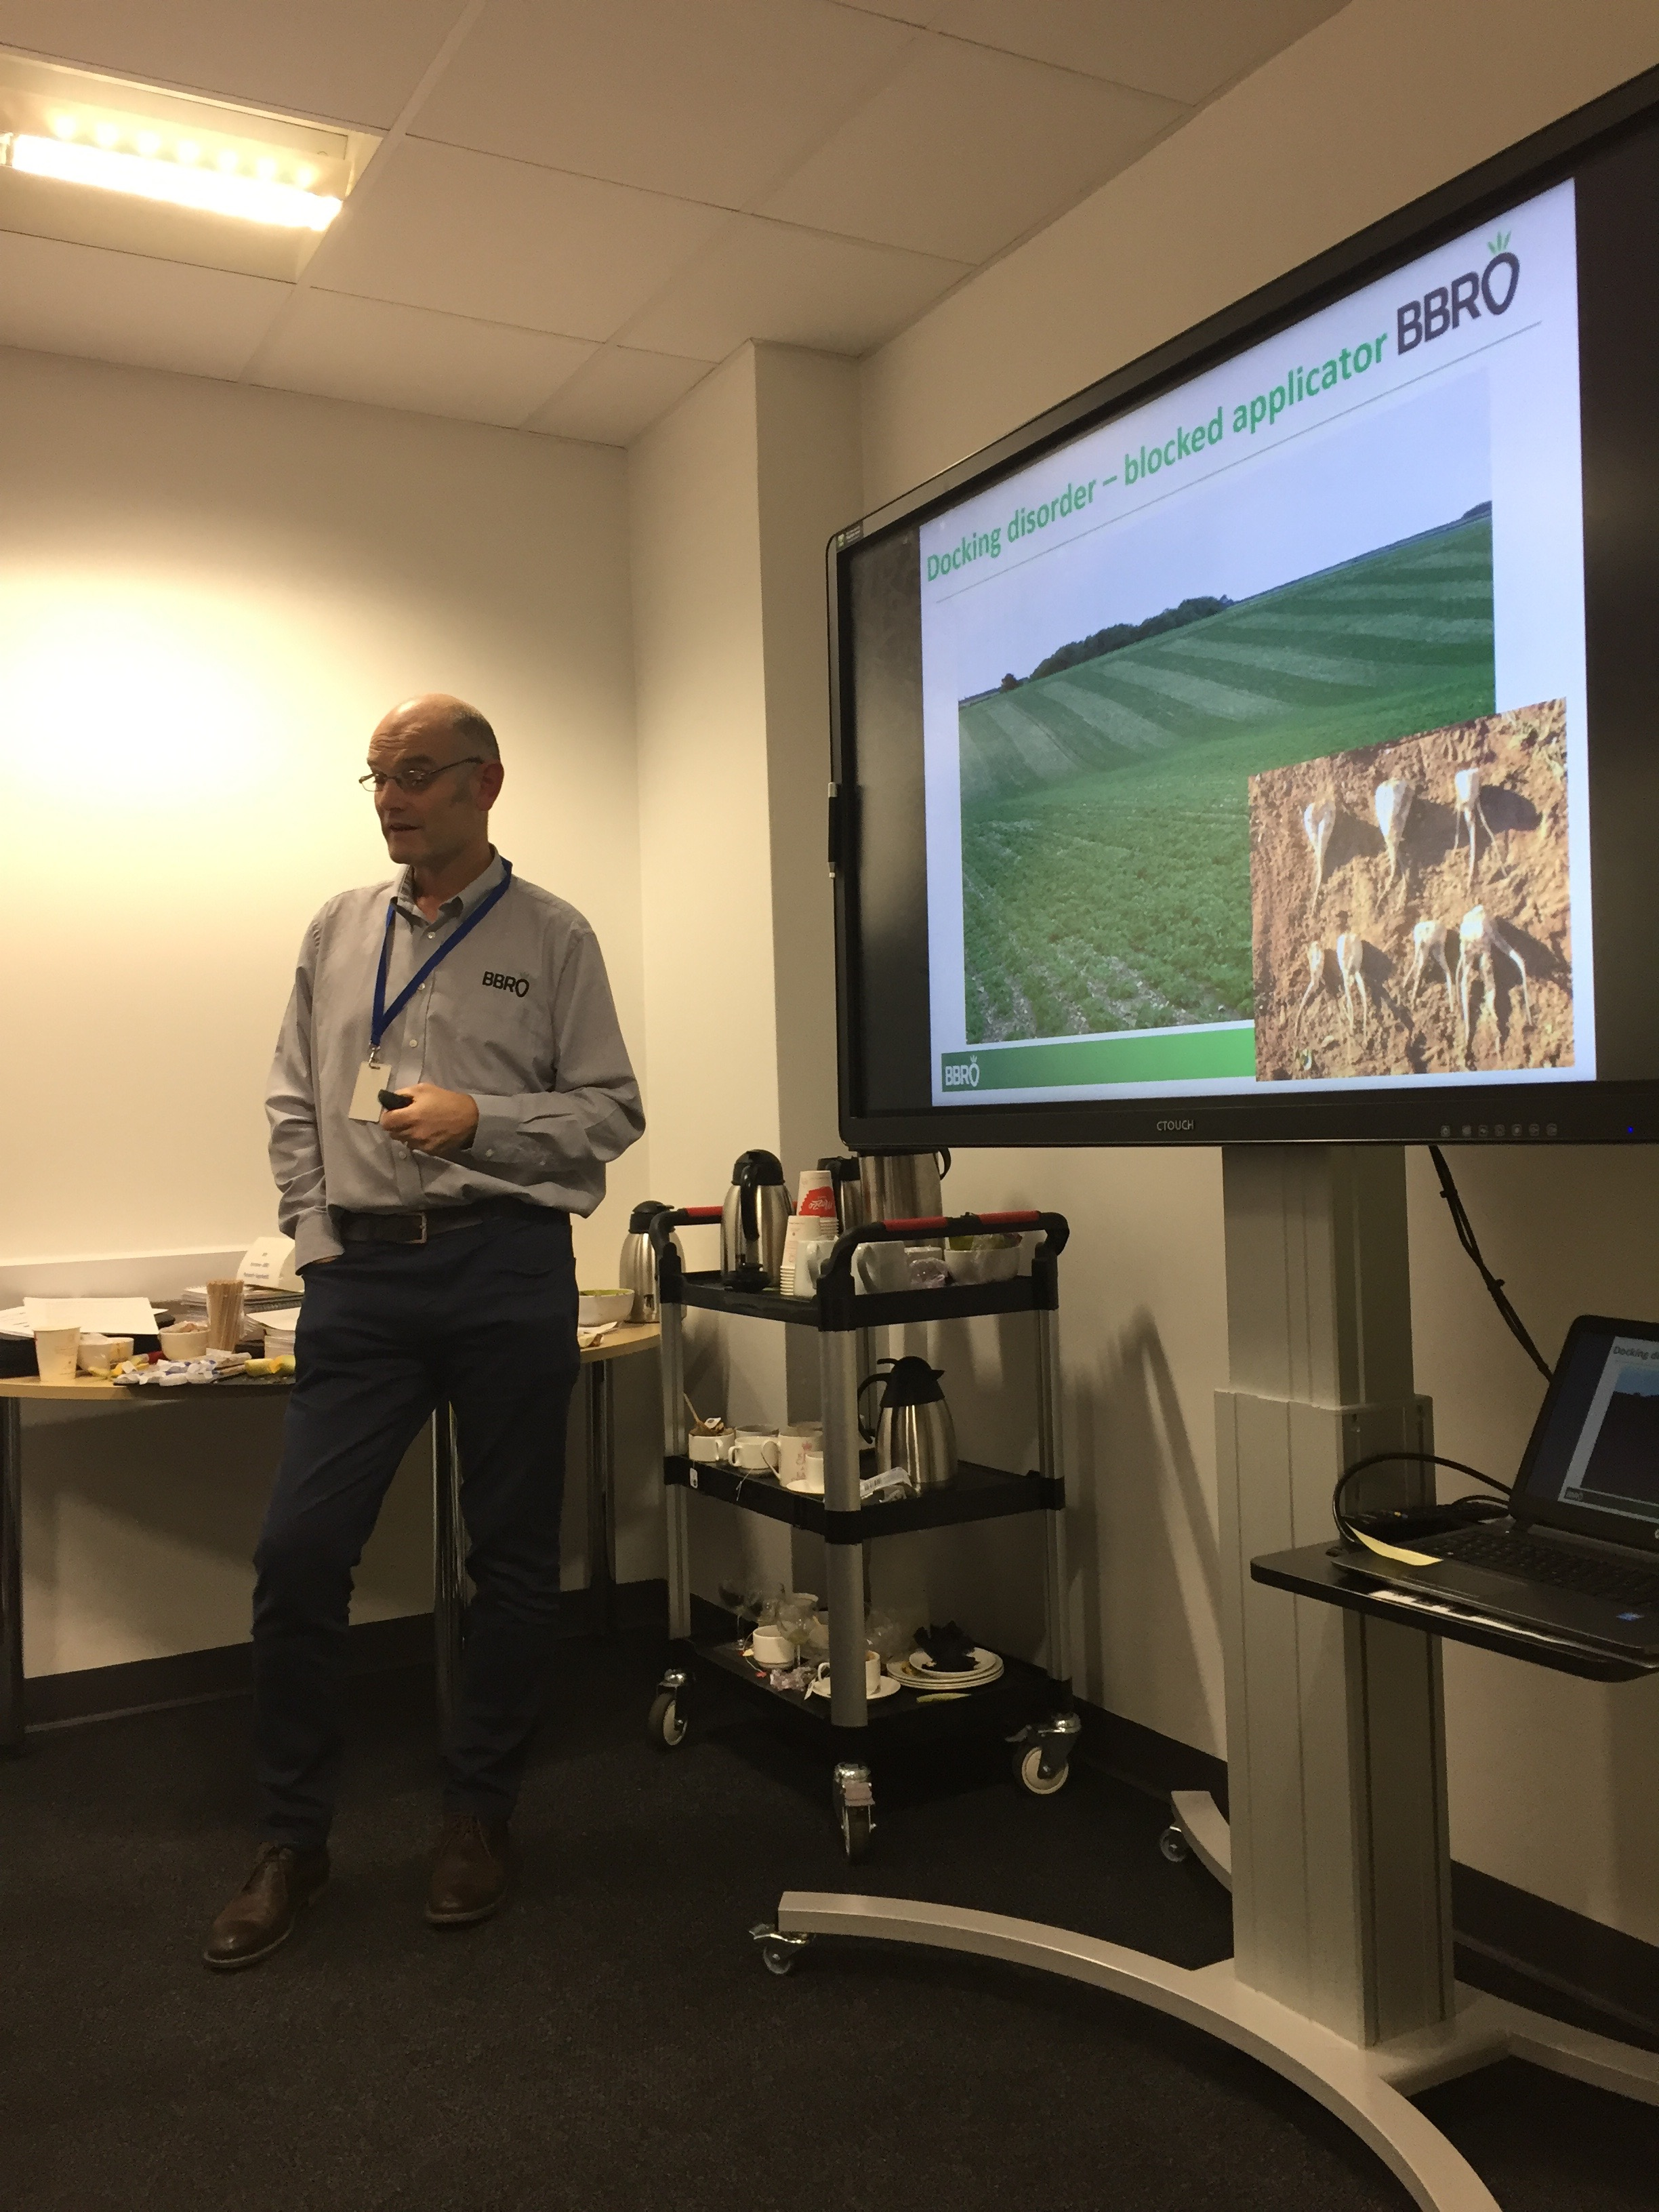
Pic 3. Mark Stevens leading the discussion of pathogens of sugar beet

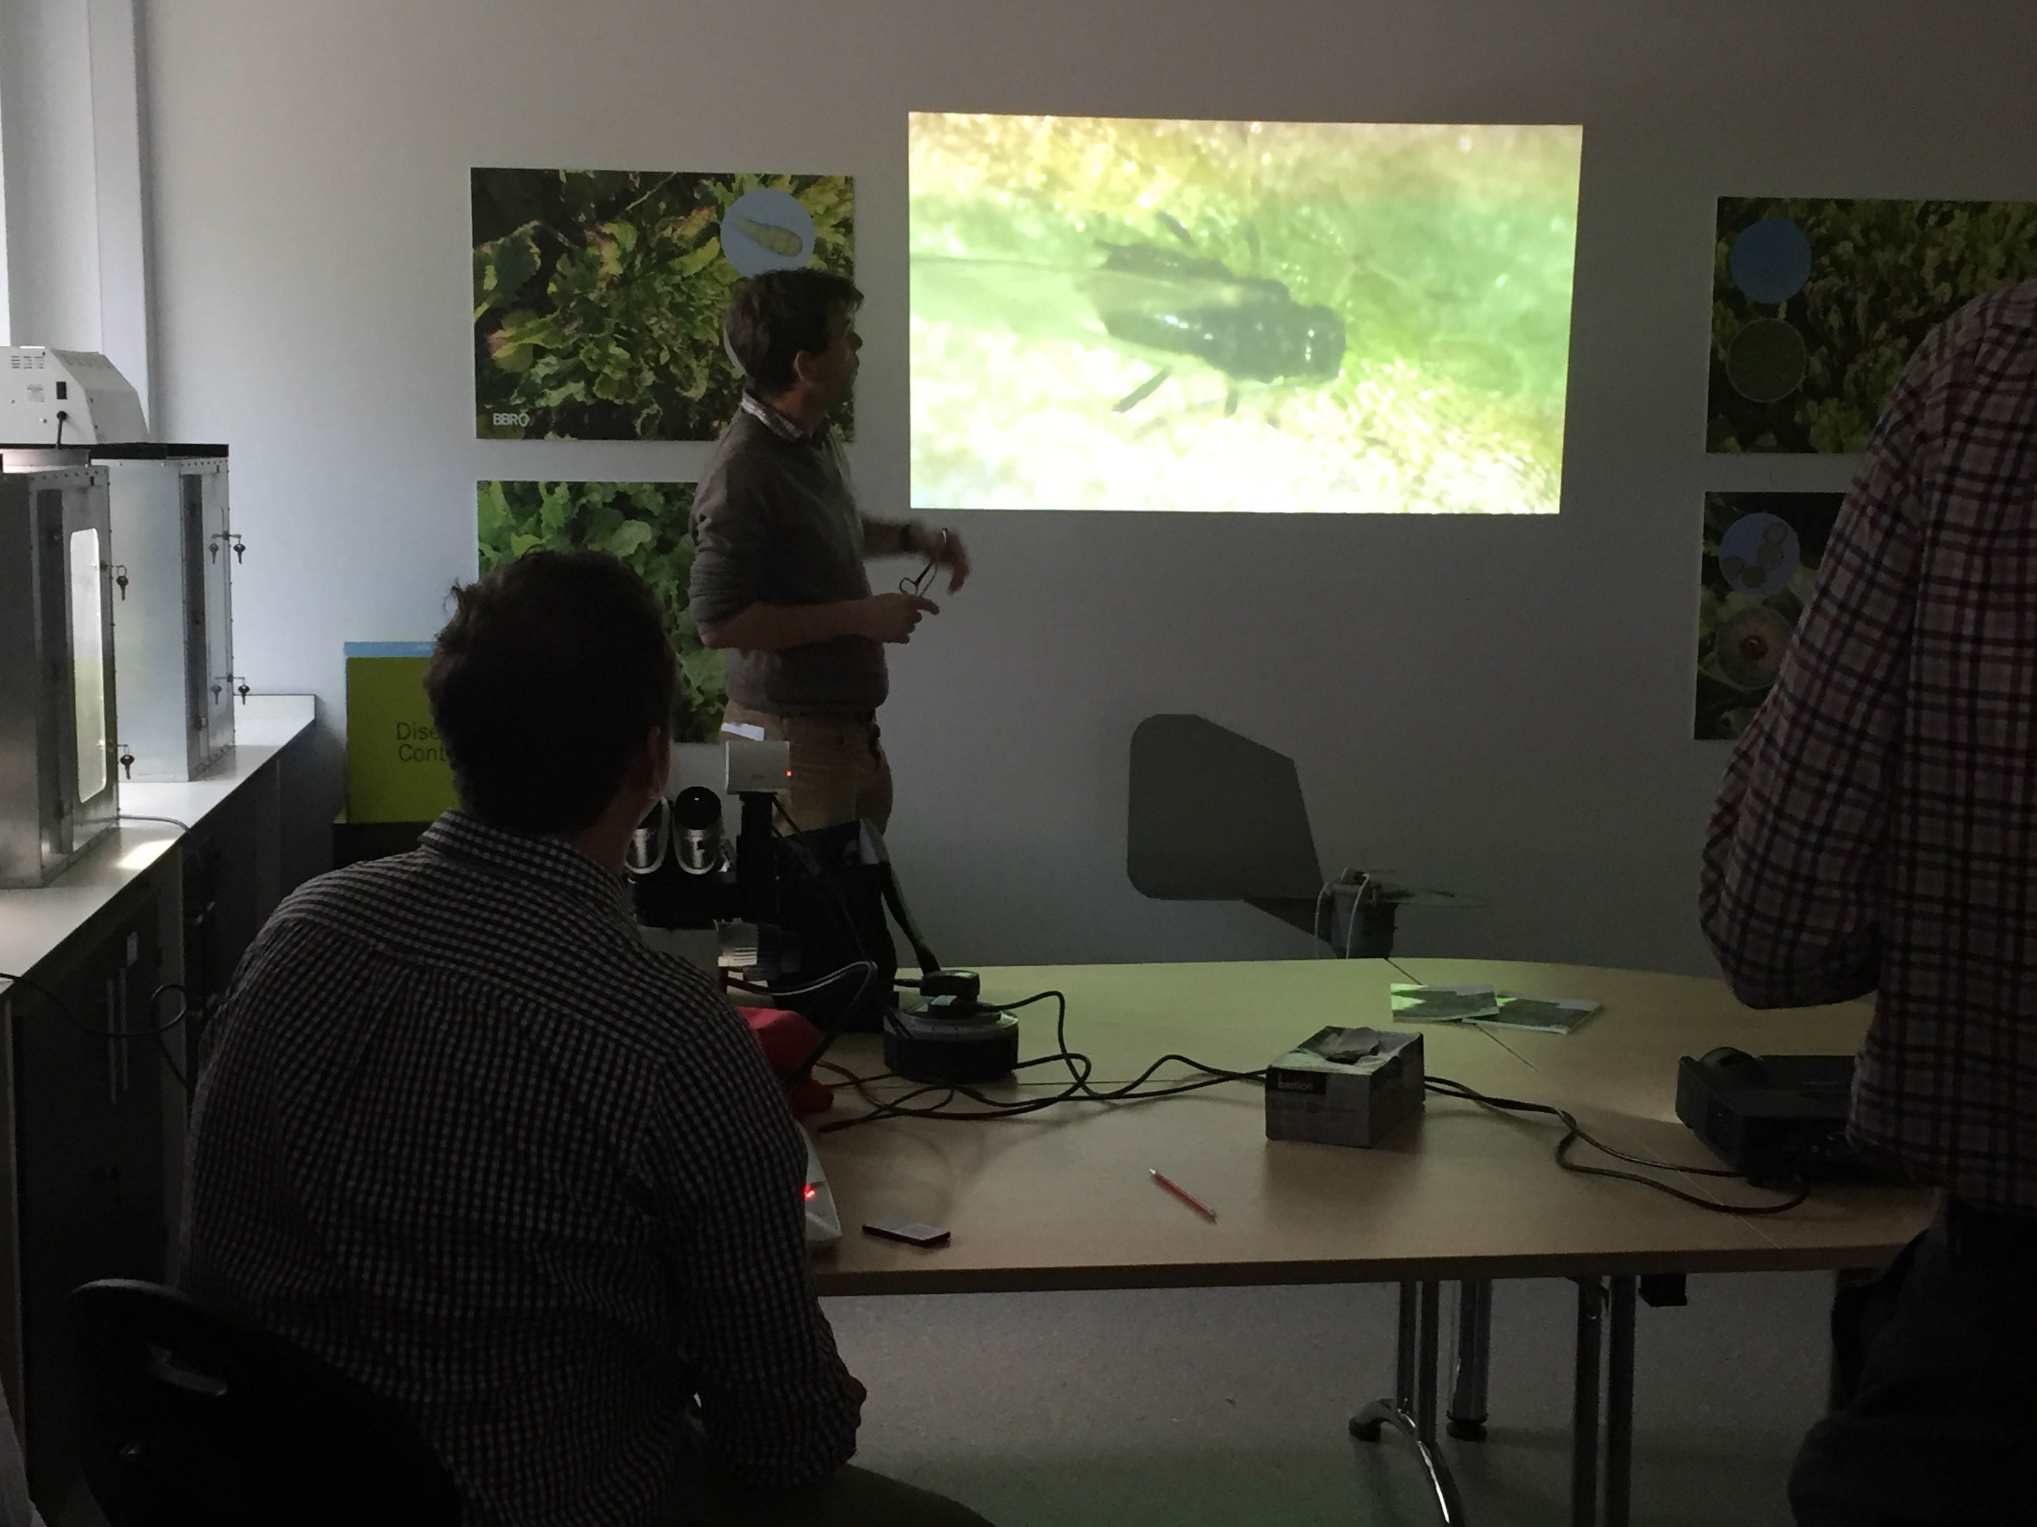
Pic 4. James Bell (Rothamsted Research) with a live demonstration of aphid identification
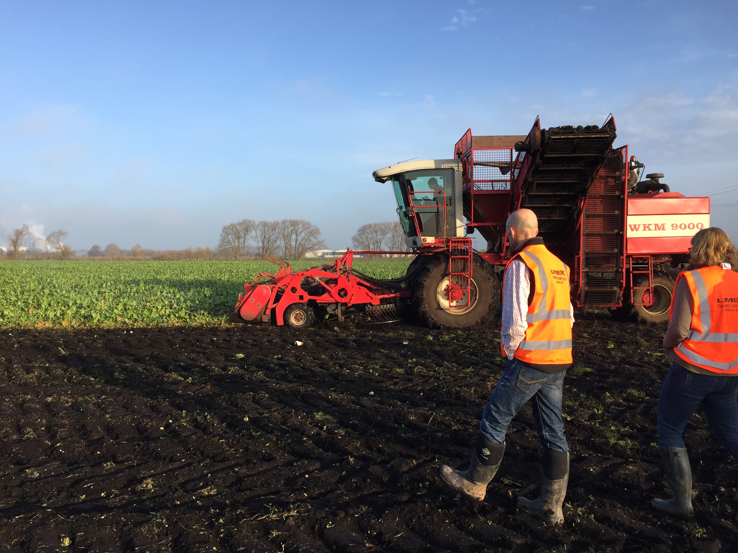
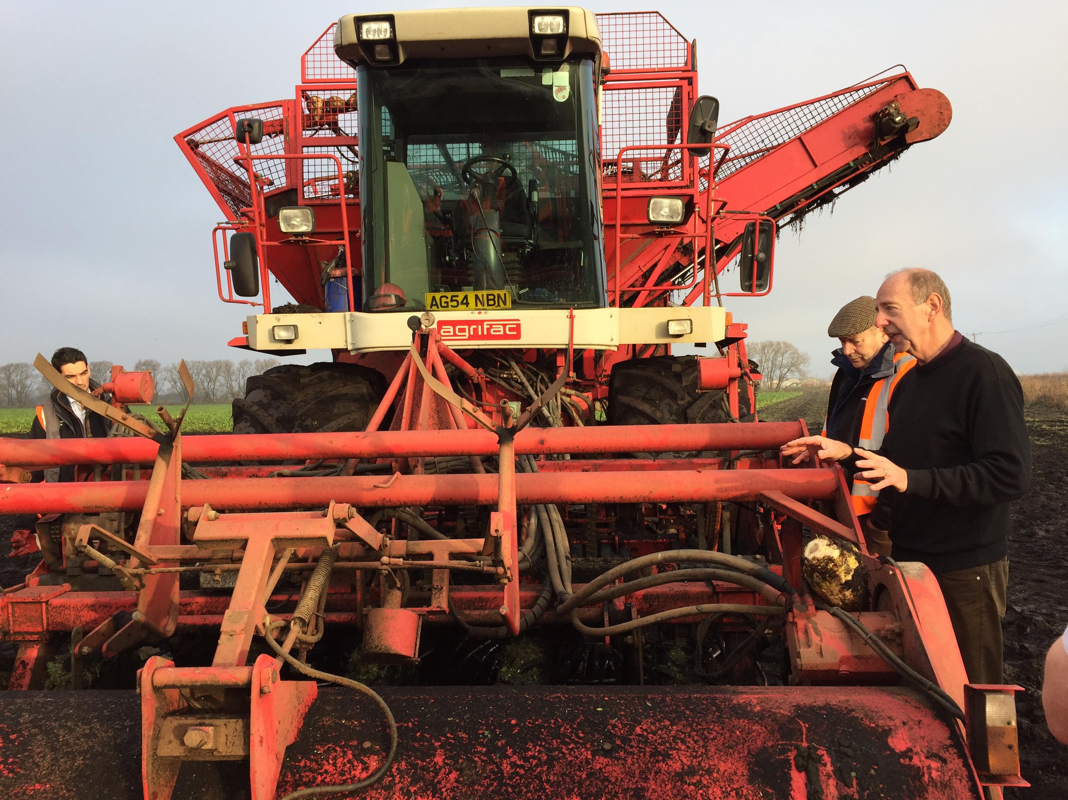
Pic 5/6. Discussing how to improve harvesting efficiency in the field, led by Stephen Brown, British Sugar
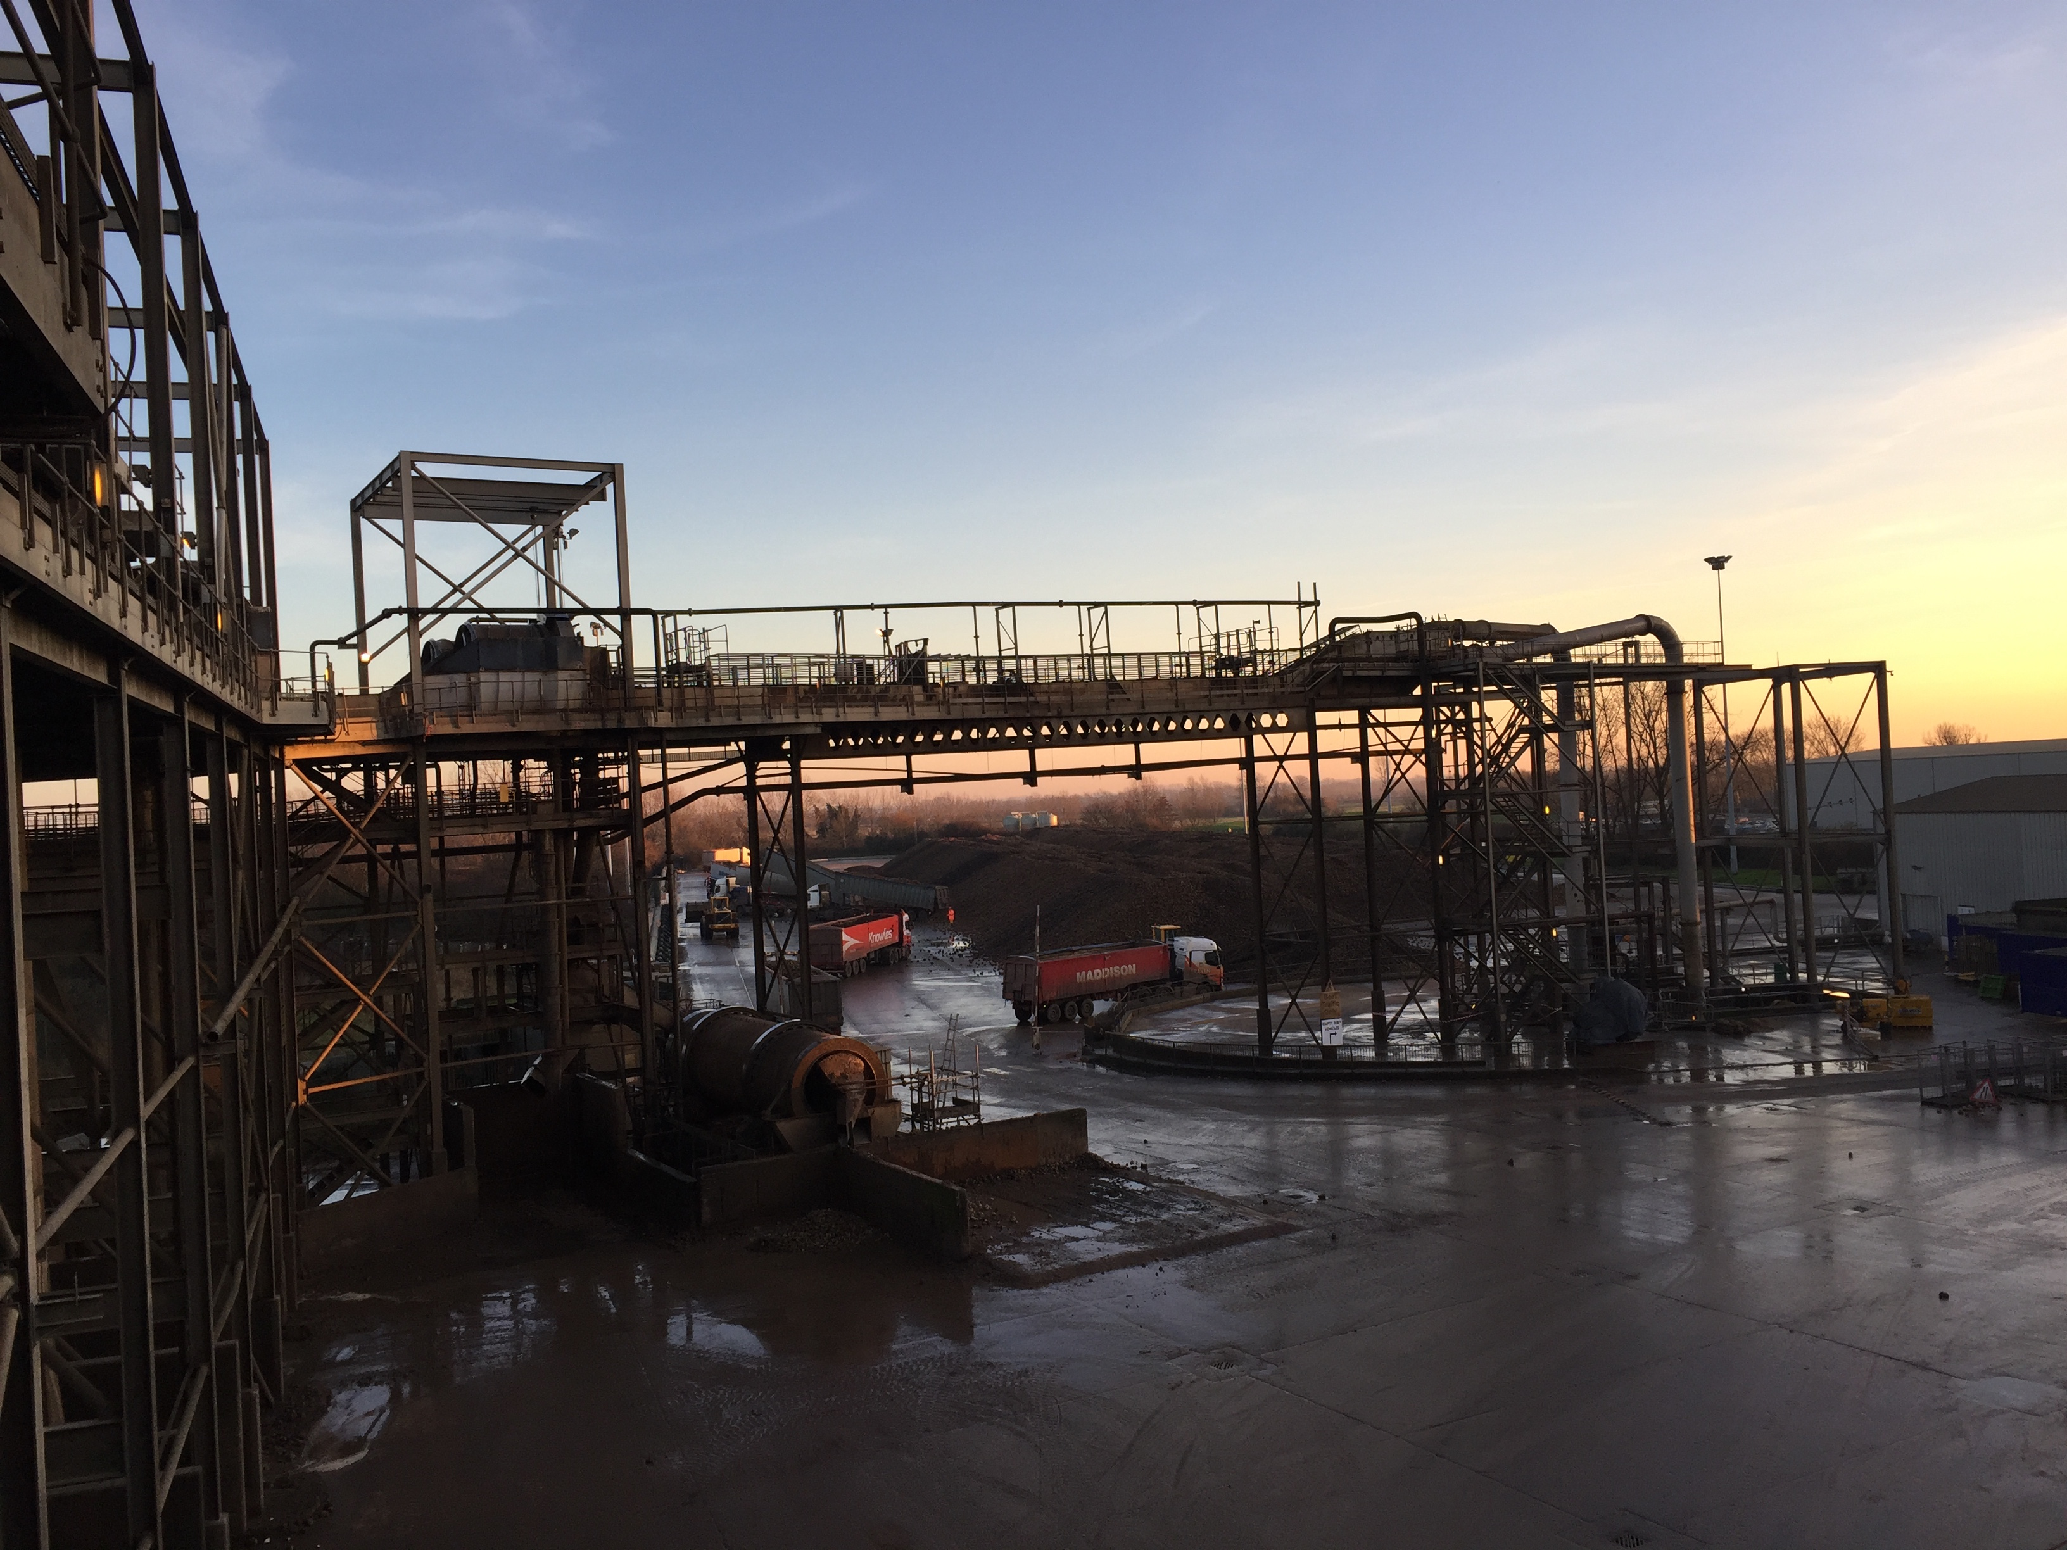

Pic 7. The course finished with a tour of Wissington Factory.

