- Good progress with drilling over the last week but some rapid drying of soils is causing concerns
- If drilling into fields with a poor seedbed or areas of poor seedbeds such as headlands, consider using a higher seed rate.
- Some rapid emergence from earlier drilled crops under the warm conditions. Weeds are also beginning to emerge, and these early crops will reach the window for herbicides very soon
- Keep an eye out for differences between seed treatments where used and don’t forget to mark up where different varieties are drilled as you go.
Adjusting seed rates and drilling depth
Rapidly drying soils are causing some concerns although this may be alleviated by forecasted rain this week. Targeting the placement of seed into moist soil is the key to quick and uniform emergence. Normally, the target drilling depth is 2-3cm but in very dry soils, drilling a bit deeper into moist soil will encourage germination. Check your drilling depth and that seed is fully covered regularly in order to make any adjustments. Remember this may change across the field, especially where the soil type changes.
Also, remember to check your seed spacing regularly. The BBRO drill testing program is currently assessing drill performance, identifying seed population, distribution and placement. Current results have shown actual seed rates can range from 0.5% -7% from the target population!

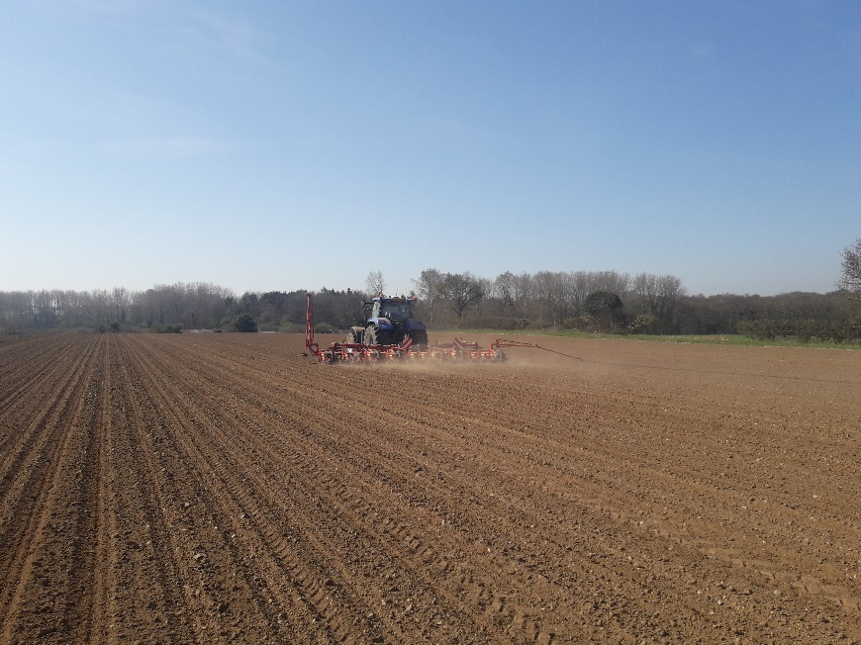
In general, seedbed have been produced with good tilth (see photo) but as some of the heavier soils dry, seedbeds are becoming cloddy with less seed to soil contact and more variable depth.
Consider increasing the seed rate in areas where the seedbed is poor, and establishment is likely to be lower. This is frequently the case on headlands but also on some of the heavier land which has produced very cloddy seedbed.
We have had a couple of queries about the merits of reducing seed rates for later drilled crops. Our view is that the warm temperatures will lead to faster emergence but not necessarily better numbers of established plants. As some seedbeds are less than idea, it is a false economy to think that saving can be made by reducing seed rates. The target of 100,000 plants per hectare remains the figure to aim for.
A full range of seed rates and spacings based on different expected establishment values were published in the last BBRO Advisory Bulletin and can also be found in the BBRO Reference Book (www.bbro.co.uk/publications).
BBRO drill testing is a service available to you. This will help monitor:

- Seed population
- Drilling depth and moisture levels
- Monitor and benchmark row unit performance

The test will not interrupt or slow your normal drilling operation, but it will give you confidence that the right amount of seed is being drilled in the right place. Those interested should contact their British Sugar Area Manager to organise a test.

Rolling
It is difficult to provide a general recommnedation for rolling as it depends very much in individual field conditions and every field is different, especially where land continues to dries daily. However, it is worth considering this as an option if seedbeds on heavy soils are poor and cloddy and seed to soil contact is poor. Also if planting depth is poor and seed is being left on the surface. However, don’t roll if heavy rain is forecast.
Planting records and variety identification
Ensure you have got good traceability and records of where and when different varieties have been planted. This will allow you know where to look for any differences in their performance but also when deciding when to apply herbicides. Growth stages may be slightly different, and this is important to ensure you work within the minimum growth stages for application and don’t set the crop back. A list of these are available can be found in the BBRO Reference Book (www.bbro.co.uk/publications).
The same applied to any different seed treatments you have used. Any differences are more likely to be apparent between emergence and the 6-leaf stage and these may be a matter of a few days so regular observation may be required. It is also useful to know where any BCN tolerant varieties are located as this help with future soil sampling and interpretation of results.
Nutrition
As early drilled crops reach full emergence don’t delay with your second application of nitrogen. Crops are likely to develop canopies rapidly and will need adequate nutrients. Sufficient nitrogen is essential for leaf growth. We expect canopies grow rapidly this season so don’t also delay in applying manganese. There were a lot symptoms of manganese deficiency seen in crops last year when the canopy grew rapidly. Don’t wait until you see symptoms. Many products can be mixed with herbicides and this will be a good opportunity to apply for many crops.

Beet Yield Competition.
Applications are now invited for the 2018 BYC competition. For further info please visit our website https://bbro.co.uk/on-farm/beet-yield-competition/

Summer Open Days.
Plans are proceeding for the BBRO Summer Open Days, with lots of opportunities to see our trials in progress, speak directly to the research team and view the RL varieties for 2019.
Invites will be released in May.

British Beet Research Organisation, Innovation Centre, Norwich Research Park, Colney Lane, Norwich, NR4 7GJ
Dr Mark Stevens mark.stevens@bbro.co.uk 07712 822194
Dr Simon Bowen simon.bowen@bbro.co.uk 07718 422717
General Enquiries info@bbro.co.uk

Two BASIS points in total (not per bulletin) have been allocated for the period between 01/06/17 and 31/05/18 reference CP/59324/1718/g. To claim these points please email michele@basis-reg.co.uk

