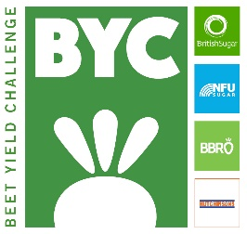
Beet Yield Challenge 2018
Application form
Grower name

Contract number

British Sugar Contract Manager

Factory

Contact details
Email address

Contact tel. no.

Farm business name

Address

Competition field
Field name (if applicable)

Field location (IACS number)

Size of field (inclusive of headlands)

Soil type

Previous cropping

Use of organic manures, etc. (type, amount and application date)

Straw use from previous crop (e.g. baled or chopped and incorporated)

Was a cover crop used? If so, what type, and when was it drilled? How was the cover crop growth stopped (e.g. sprayed, flailed, grazed, etc.)?

Cultivations prior to sugar beet

When was it last planted with sugar beet?

Variety/Varieties

Drilling date

Type of drill

Please return to: byc@bbro.co.uk or toby.townsend@bbro.co.uk

