BBRO PROJECT REPORT FORM
Please note the details on page 2 will be used to formulate our Annual Report.
- Project Title:

NPPI Optimising plant populations and N rates for modern, high-yielding sugar-beet crops

BBRO project no: | 14/11
Project sponsor:
Interim report / Final report (delete as appropriate)

Project lead or student name: | Colin Walters  Simon Bowen (inherited lead May 2016)
Project mentor or supervisors:

Report Date: | July 2016
Reporting period covered:  (e.g. 1/1/16 - 31/12/16) | 1/1/16 – 31/12/16
Timeline (e.g. Year 1 of 4) | Year  3 (final)
BBRO use only | Date assessed:
Assessors comments
Action required

Project summary (no more than 300 words)
There is circumstantial evidence to suggest that some UK high-yielding sugar-beet crops grown under modern conditions would benefit from higher-than-recommended plant populations and more N. An extensive 3-year programme of experiments has been testing factorial combinations of 7 rates of N (0-200 kg/ha) and six plant population densities (50,000–150,000/ha) on three different soil types.

Of the three 2016 trials sites, the Garboldisham site was abandoned and not taken to yield due to high population of weed beet. SMN tests which were undertaken post-drilling revealed higher than expected soil N levels. This placed both the Bracebridge and Hibbaldstow sites in Soil N Index 2. The recommended nitrogen rate for these soils is 100 kg N/ha.
The recommended plant population is 100,000/ha but this was not selected as one of the population densities treatments and 90,000 & 110,000 plants/ha were the nearest comparative treatments to this.
The 2016 data shows very little interaction between nitrogen rates and plant population and provide little evidence that higher plant population require higher nitrogen rates. At both sites, the 50,00 population density was clearly, as expected, sub optimal. At Bracebridge, there were few significant differences between the 90,000 and higher (110,000, 130,000 & 150,000,) population densities whereas as at the Hibbaldstow site the 90,000 population density was poorer than the higher population densities. There was a consistent reduction in root sugar content (%) above 90 kg N/ha at both sites albeit this effect was more variable at Hibbaldstow. This effect was not significantly influenced by plant population.
It is not possible to conclude from the 2016 trials that different soil types have different optimal plant population densities and nitrogen rates. Unfortunately, this is in part due to the small number of sites tested and the high soil nitrogen levels on these sites.

Main Objectives:

- To assess the interactions of nitrogen rates and plant populations on crop performance
- To assess this interaction across different sites (soil types)
- To understand the basis for any interaction in terms of crop partitioning of dry matter.

Outcomes and key messages

The effect on nitrogen rate and plant population on crop yield

Bracebridge 2016

Hibbaldstow 2016

- The 2016 data shows very little interaction between nitrogen rates and plant population and provide little evidence that higher plant population require higher nitrogen rates.

- At both sites, the 50,00 population density was clearly sub optimal and this was expected given the current recommended population density of 100,000 /ha. At Bracebridge, there were few significant differences between the 90,000 and higher (110,000, 130,000 & 150,000,) population densities

- At the Hibbaldstow site, the 90,000 population density was resulted in lower yields than at the higher population densities. This was the higher yielding of the two sites and reinforces the need to establish the recommended population densities especially to realise the potential of higher yielding sites.

- There was a consistent reduction in root sugar content (%) above 90 kg N/ha at both sites albeit this effect was more variable at Hibbaldstow. This effect was not significantly influenced by plant population

- The two sites in 2016 had higher than expected soil nitrogen levels at drilling and the recommended rate of nitrogen was 100kg N/ha. This is reflected in the relatively shallow response curve about 90 kg N/ha and reinforced the current recommendations.

Short summary of key objectives
- To establish a range of plant populations and nitrogen fertiliser rates on contrasting soil types
- To more precisely establish optimal plant numbers and N rates for individual soils.
- To assess the effect of interactions between plant population and nitrogen rate on dry matter partitioning

Insert picture/graph  Severe weed beet populati on at Garboldisham in 2016 led to abandomant of trial.  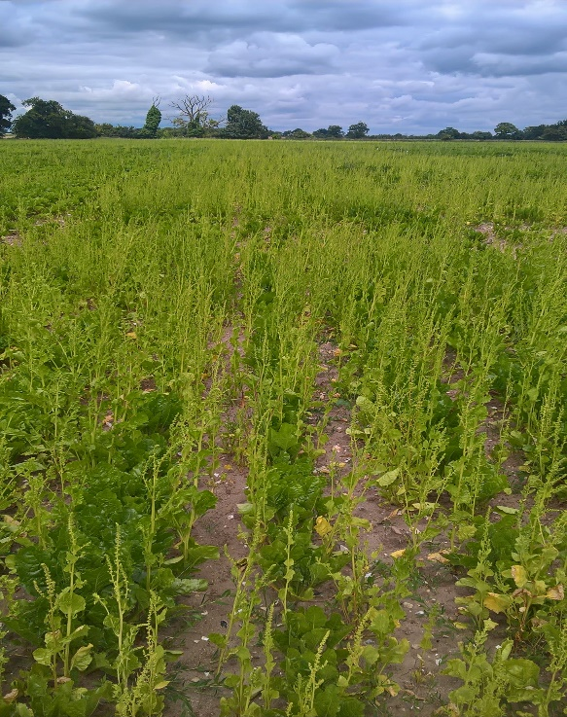 | Insert picture/graph  Emerging plots at Bracebridge trial in 2016  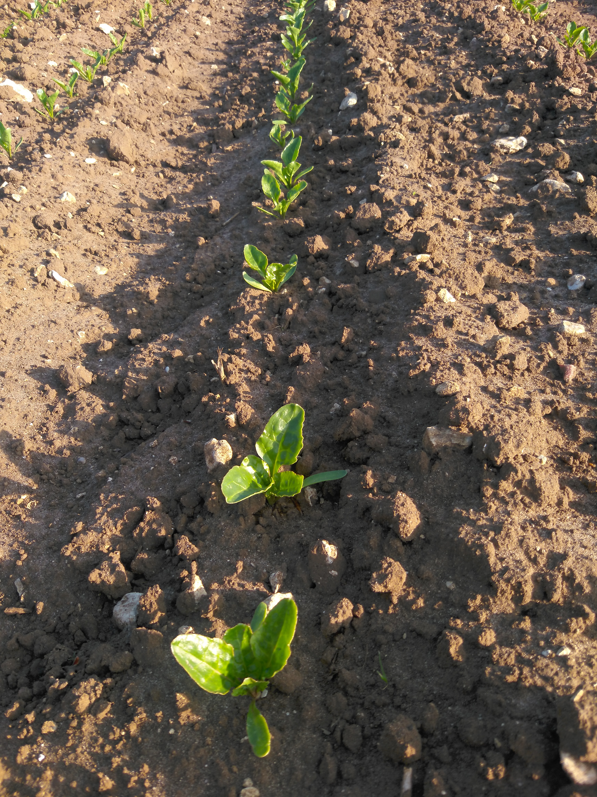
Outcomes/Key messages for growers and industry
The 2016 trials complete a series of trials assessing interactions between nitrogen rates and plant populations and whether higher plant populations require more nitrogen and that different soils have different optimal plant populations and nitrogen requirement to improve crop yield.

The trials have reinforced the current optimal plant population of 100,000 plants/ha showing that there was no consistent improvement in yields by increasing plant populations from 90,000 to 110,000, 130,0000 or 150,000 per hectare. The trials showed the yield penalty of being below the optimal level. This appeared to be have more effect at the Hibbaldstow site where the overall yield level was higher, indicating that where there is potential for higher yield it is more critical to ensure the optimal population is established to realise the potential.

Trials were drilled and manged to ensure accurate plant populations were established and it should be remembered that in commercial practice establishment is 70-80%. The UK average plant population in 2016 was & 90,000 plants/ha.

The trials have showed very few consistent interactions between plant populations and nitrogen rates and do not indicate a need to increases nitrogen rates with higher plant populations or indeed that yields can be improved by increasing nitrogen rates and plant populations.

The trials also demonstrated the potential depression of sugar content of roots at high nitrogen rates reinforcing the need to select nitrogen rates carefully on the basis of soil nitrogen levels.

Section 1: To be completed by Project Lead:
Other project objectives (not listed on previous page)

None

Milestones for current period
Note: mentors will be asked to comment on the status of this project (yellow column) using the scoring system shown below

Status - Mentor’s scoring system for interim reports.
RED | “Major concern - escalate to the next level"  Slippage greater than 10% of remaining time or budget, or quality severely compromised. Corrective Action not in place, or not effective. Unlikely to deliver on time to budget or quality requirements.
AMBER | "Minor concern – being actively managed”  Slippage less than 10% of remaining time or budget, or quality impact is minor. Remedial plan in place.
GREEN | "Normal level of attention"  No material slippage. No additional attention needed
Milestones | Comments + Any Action required | Status R/A/G

Summary of results (including figures and tables)
Annual report: please provide a 2 page summary of key findings from the reporting year.
Final report: please provide a summary of project findings and outcomes with relevant supporting data.
Final Report

NPPI Optimising plant populations and N rates for modern, high-yielding sugar-beet crops
It was proposed that there was circumstantial evidence to suggest that some UK high-yielding sugar-beet crops grown under modern conditions would benefit from higher-than-recommended plant populations and more nitrogen. An extensive 3-year programme of experiments has examined this by testing factorial combinations of 7 rates of N (0-200 kg/ha) and six plant population densities (50,000–150,000/ha) on different soil types. The data provided by this series of trials has not been able to substantiate this theory and does not provide evidence for consistent interactions between plant populations and nitrogen rates and do not indicate a need to increases nitrogen rates with higher plant populations or indeed that yields can be improved by increasing nitrogen rates and plant populations

The levels of soil nitrogen of the trials sites in both 2015 & 2016 indicated higher levels than expected and placed soils in Indices 1 &2 as opposed to Index 0 which is often the case of fields going from cereals into sugar beet on lighter land. This has skewed the results to being more relevant to these types of soils. It was also decided in both the 2015 & 2016 trials that the detailed and expensive analysis of dry matter partitioning was not undertaken as it would not be able to test this across a sufficiently wide enough range of soil nitrogen levels.

Specific 2016 results and commentary

2016 Treatment List

N kg/ha |  | Population
1 | 0 | 1 | 50000
2 | 30 | 2 | 70000
3 | 60 | 3 | 90000
4 | 90 | 4 | 110000
5 | 120 | 5 | 130000
6 | 150 | 6 | 150000
7 | 180
8 | 210

Bracebridge

Table 1 Full treatment effects on clean yield levels

Clean Yield t/ha
Kg N/ha | 50,000 | 70,000 | 90,000 | 110,000 | 130,000 | 150,000
0 | 57.69 | 61.13 | 69.13 | 61.71 | 66.87 | 66.58
30 | 70.18 | 70.6 | 71.71 | 76.73 | 76.51 | 77.53
60 | 74.31 | 76.91 | 78.13 | 76.51 | 79.33 | 76.8
90 | 72.91 | 74.8 | 78.33 | 78.13 | 76.07 | 75.58
120 | 72.31 | 76.07 | 74.56 | 77.64 | 76.49 | 76.82
150 | 71.16 | 77.29 | 75.27 | 77.69 | 73.96 | 75.13
180 | 73.87 | 75.24 | 76.47 | 77.4 | 75.87 | 77.87
210 | 74.82 | 78.07 | 77.64 | 76.64 | 74.4 | 75.04

Hibbaldstow

Table 2 Full treatment effect on clean yield levels

Clean Yield t/ha
Kg N/ha | 50,000 | 70,000 | 90,000 | 110,000 | 130,000 | 150,000
0 | 64.89 | 64.58 | 73.11 | 68.62 | 82.09 | 76.62
30 | 70.8 | 77.73 | 81.87 | 80.89 | 85.11 | 87.82
60 | 73.38 | 83.78 | 82.98 | 92.18 | 87.11 | 89.64
90 | 79.2 | 79.33 | 85.87 | 84.31 | 90.67 | 93.73
120 | 77.73 | 82 | 81.42 | 85.07 | 84.15 | 86.76
150 | 75.82 | 81.29 | 79.02 | 83.42 | 85.87 | 88.71
180 | 74.98 | 78.04 | 82.84 | 85.2 | 86.76 | 72.44
210 | 76.49 | 70.93 | 81.91 | 85.96 | 85.56 | 87.47

Table 3 Significance and P values for different treatments

 | Bracebridge |  |  | Hibaldstow
P-values | Population | Kg N/ha | Popn.Kg N/ha | Population | Kg N/ha | Popn.Kg N/ha
Yield | 0.018 | <0.001 | 0.157 | <0.001 | <0.001 | 0.572
Sugar % | 0.382 | <0.001 | 0.952 | 0.594 | <0.001 | 0.783
Sugar Yield | 0.014 | <0.001 | 0.269 | <0.001 | <0.001 | 0.699
AN | 0.228 | <0.001 | 0.688 | 0.103 | <0.001 | 0.429
Na | 0.815 | <0.001 | 0.174 | 0.101 | <0.001 | 0.741
K | <0.001 | 0.165 | 0.914 | 0.003 | <0.001 | 0.230
- The Garboldisham site was severely affected by weed beet and was abandoned.
- The SMN tests were undertaken post-drilling as opposed to pre-drilling and showed high soil N levels which should have resulted in amending the range of applied fertiliser levels.
- The graphs below show effects on clean yield and root sugar content (%). These do not include all the plant populations to make the charts slightly easier to review.
- No results are shown for Amino -N, Na & K levels in the roots as there were significant effects.
- Table 1 & 2 show the full range of treatment effects on clean yield levels at each site for reference
- Table 3 shows the P values for the different factors.
- The decision was made to only take the two sites to yield and not to undertake the extensive (and expensive elements of soil and plant sampling and analysis
- For reference, the currently recommended plant population is 100,000/ha
- The data shows very little interaction between nitrogen rates and plant population and provide little evidence that higher plant population require higher nitrogen rates
- The 90,000-population level resulted in slightly lower yields at the Hibbaldstow site highlighting this population level is sub-optimal. A fuller analysis of the complete data sets (including 70,000 & 110,00 densities) will be undertaken
- Clearly, the 50,000-population density is sub-optimal and at this level there is a greater response to N rate compared to the higher population levels
- Remember that the optimum N level for this site is between 60-90 kg N/ha because of the high soil N levels.
- This project is now finished. Any further work on plant populations will be undertaken on the Demo Farms as demonstration trials as opposed to research trials.

Annual report: Key issues to be addressed next year:

This is the final year of the project. No further work on nitrogen, plant populations interactions is planned.

Publication of results to date/planned publications:
BBRO Annual Report
BBRO Technical Conference/meetings

Section 2: To be completed by project mentor
Is the project on track to meet the stated objectives? (please comment in relation to milestones and the status score awarded in section 1).

Please comment on any proposed changes to milestones.
Are conclusions scientifically robust? (please comment on data analysis/interpretation)
For final reports only:
How would you rate the project against the following criteria (please give a score out of 10, with 10 being highest)
1 ) The project met its original objectives:

2) Contribution to scientific knowledge:

3) Direct relevance to growers:

