The effects of cover crops on soil structure and sugar beet growth

Summarised findings

August 2019

PhD Project

Jake Richards

Supervisors: Professor Debbie Sparkes (UoN), Professor Sacha Mooney (UoN) & Dr Mark Stevens (BBRO)

Project funded by the British Beet Research Organisation and The University of Nottingham



Table of Contents

Controlled environment work: 3

Glasshouse experiment 1: 3

Introduction 3

Results and Discussion 4

Conclusions 5

Glasshouse experiment 2 6

Introduction 6

Results and discussion 6

Conclusions 10

Glasshouse experiment 3 – understanding the effects of combining species on root growth 11

Introduction 11

Results and Discussion 12

Conclusions 14

Field experiments and related work 15

Replicated field experiments at the University of Nottingham 15

Introduction 15

Results and Discussion 16

Conclusions 23

Findings from field experiments on commercial farms in Norfolk and Suffolk 24

Introduction 24

Results and Discussion 24

Conclusions 32

Overall conclusions and useful points for sugar beet farmers 33

Selected References 34

# Controlled environment work:

## Glasshouse experiment 1:

### Introduction

To understand the effects of cover crops on soil aggregation we looked at the effect of tillage radish, rye and Phacelia on soil aggregation in clay loam soil in five litre pots. A number of different cover crop species are available on the market for growers to choose from each with slight differences in root growth – it is often assumed that tillage radish will produce a tap root that can break through compaction whereas rye has lateral roots that will cause soil aggregation and Phacelia is thought to be ‘strong rooting’.

The behaviour of different soil textures means broadly that that greater the clay content of a soil the more affected by aggregation and the production the soil will be (Keller and Dexter, 2012). This is also dependent on soil organic matter content and soil moisture (Kay, 1998).

In field conditions plant growth is associated with soil stability as a result of the enmeshing effect of roots in addition to the production of ‘sticky’ root mucilage (Gyssels et al., 2005). Generally, soils with greater organic matter content will have a more friable structure as organic matter allows soil particles to adhere to it to form the crumb structure (Angers and Chenu, 1998). Plant growth will also affect the wetting & drying cycles that occur particularly during the autumn (Linsler et al., 2016). It is thought that if we can increase the frequency and intensity of wetting and drying cycles then the soil profile will have a greater proportion of small aggregates which are useful for seed germination and are associated with less restrictive conditions for crop root growth (Goss, 1977).

### Results and Discussion

Tillage radish and rye produced very similar amounts of above ground biomass in all treatments whereas Phacelia produced significantly less above ground biomass. Figure 1 shows that as above ground biomass increased soil moisture content decreased. This suggests that treatments that had the greatest leaf biomass were using the greatest quantity of water.

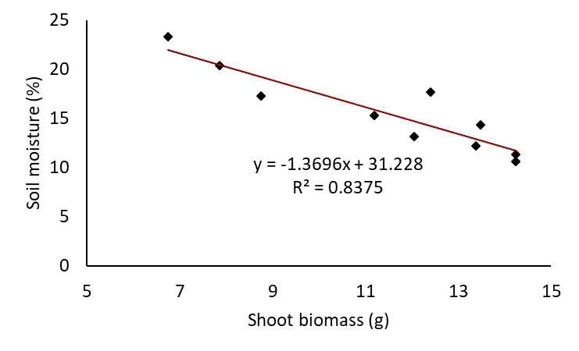

Figure 1. Linear regression between above ground and soil moisture (P=0.004).

We found that there was a relationship with soil moisture and soil aggregation. As soil moisture decreased the mean weight diameter size decreased (Fig.2). This suggests that the treatments that used the most water and dried the soil out caused a reduction in aggregate size. It’s possible that the plants with the greatest above ground biomass may also have had the largest root system and therefore had enmeshed the soil the most resulting in smaller aggregates (Gyssels et al., 2005). It is also likely that the more intense drying effect of the larger cover crops also resulted in smaller aggregates due to the more intense wetting and drying effect (Linsler et al., 2016).

Figure 2. Significant regression between soil moisture and mean weight diameter of the aggregate size distribution (P<.001, d.f. 26, R2 0.511).

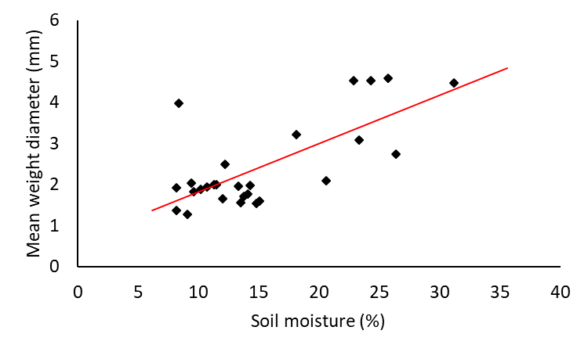

### Conclusions

* Radish and rye produced similar amounts of above ground biomass
* Greater above ground biomass production resulted in lower soil moisture
* Lower soil moisture was related with a greater proportion of smaller aggregates
* This may be sue to the effect of roots directly on the soil or through wetting and drying cycles.

## Glasshouse experiment 2

### Introduction

The first glasshouse experiment explored the effects of cover crops on soil aggregation in small scale pots. It’s unclear whether the differences we saw in such small volumes of soil would occur when cover crop root growth was not restricted. To understand this we set up a second similar experiment using metre tall soil columns filled with the same clay loam soil and growing tillage radish and forage rye prior to sugar beet to look at cover crop root growth, the effect on the soil structure and the direct effect on sugar beet growth.

In addition to the points made in the first experiment we aimed to understand whether there were any other effects of cover crops on sugar beet growth other than their effect on the soil structure. As a result we included measurements of sugar beet nitrogen content and X-ray Computed Tomography imaging in the experimental process.

### Results and discussion

At the point of cover crop destruction soil moisture content was significantly greater in bare soil columns showing that cover crops had taken up water from the soil profile. There were no differences between cover crop treatments suggesting that the species had not had a significant effect on the soil moisture content throughout the growing period (Fig.3).

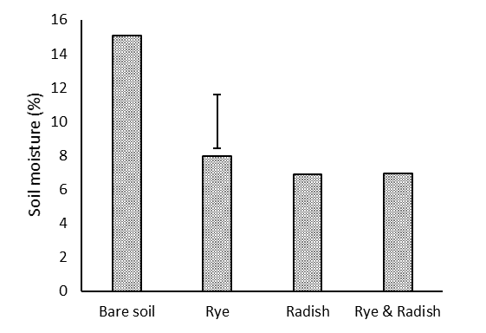

Figure 3. Soil moisture content of columns at harvest of cover crops (P<.001, 39 d.f.) Error bars depict LSD of 3.14.

There was no difference in soil aggregation between the cover crop treatments. However, when all cover crop treatments were combined and compared to bare soil they showed that cover crops had resulted in a slight, but significant reduction in mean aggregate size (Fig.4)

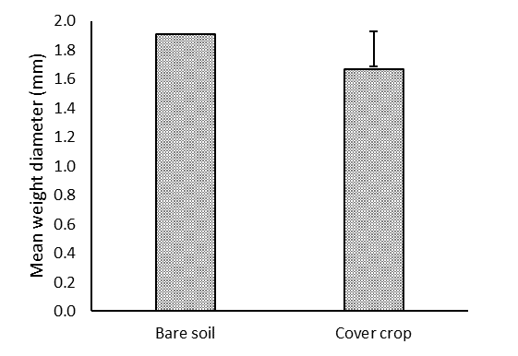

Figure 4. Mean weight diameter of aggregate size distribution where cover crop treatments have been combined. Repeated measures ANOVA of all depths (P=0.05, d.f 14. Error bar LSD of 0.239.

We found that radish produced the most roots throughout the soil profile however in all treatments root production increased with soil depth which would not normally be expected. It is possible that this reflected roots growing where water was most available and they were preferentially growing at the bottom of the column where water content was greatest as the surface irrigation was not enough to sustain growth. It appeared that when rye and radish was combined there may have been some negative effect on root growth (Fig.5).

Figure 5. Root length density of cover crops at each depth. (P=0.008, d.f. 39).

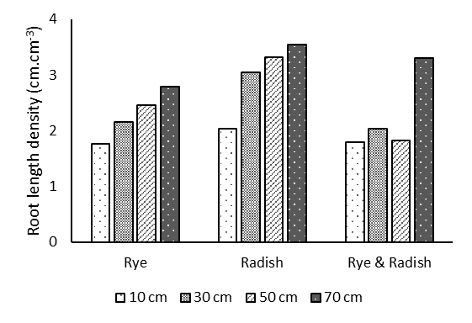

No overall differences in soil porosity were measured. X-ray CT images suggest that where a tillage radish was grown the distribution of pores becomes more restricted and the porosity of the soil changes from being many small pores to having a greater proportion of large cracks as a result of lateral fracturing due to the large tap roots (Fig.6).

Figure 6. Cross sections at 10 cm depth of soil columns before termination. A) Bare soil B) Rye C) Tillage radish D) Rye & tillage radish. White shows soil, red shows pore space and coloured areas show radish roots.

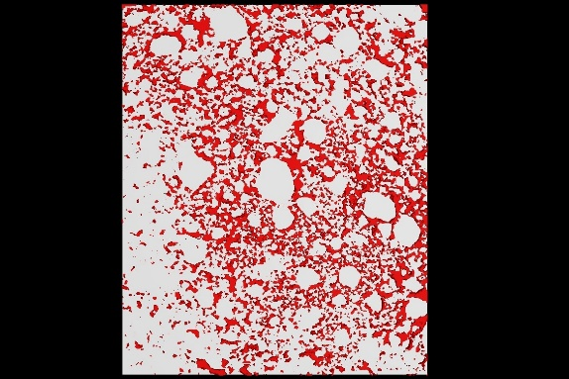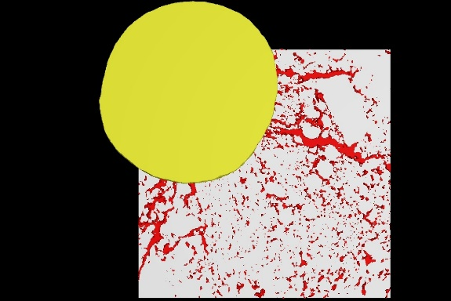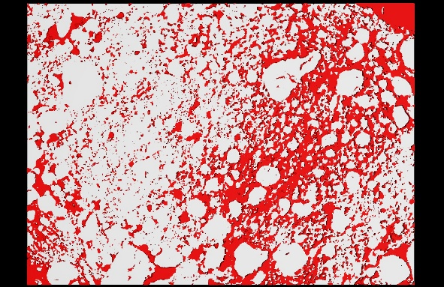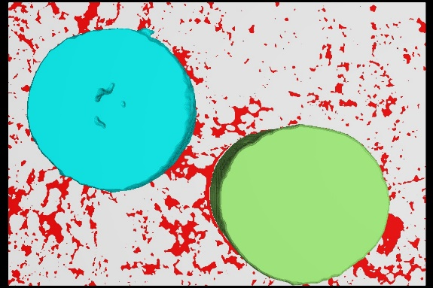

A

D

C

B

6 cm

It appeared that sugar beet growth in treatments containing radishes may have been restricted as seen by the differences in leaf area and storage root size (Fig.7&8)

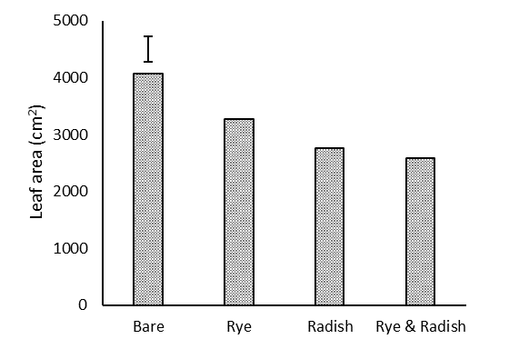

Figure 7. Sugar beet leaf area at harvest following different cover crop treatments (P<.001, d.f. 16) error bar shows LSD of 440.

It is unclear why produced the smallest taproot compared to all other cover crop treatments particularly as the CT scans suggest that the soil porosity had not changed and the leaf area was second greatest after bare soil (Fig.8)

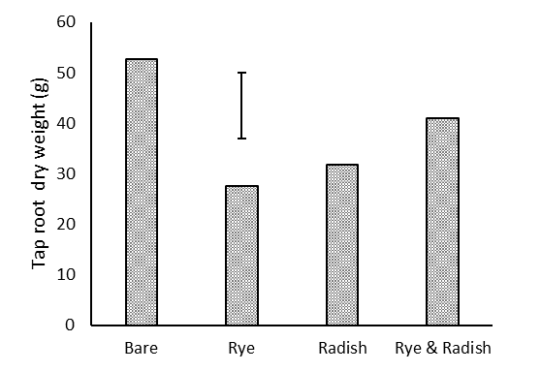

Figure 8. Taproot dry weight of sugar beet following different cover crop species(P=0.005, d.f. 16) Error bars showing LSD of 11.92.

CT Scans of the sugar beet following cover crops show that the beet following radish appear to be far more restricted resulting in malformed taproots as seen in Figure 9B particularly. It is unlikely that in UK field conditions we would see tillage radish having sufficient thermal time in the autumn to produce such large taproots. Furthermore, field conditions are likely to be far more conducive to decomposition of cover crop roots so it unlikely that this effect would be seen in sugar beet crops.

### Conclusions

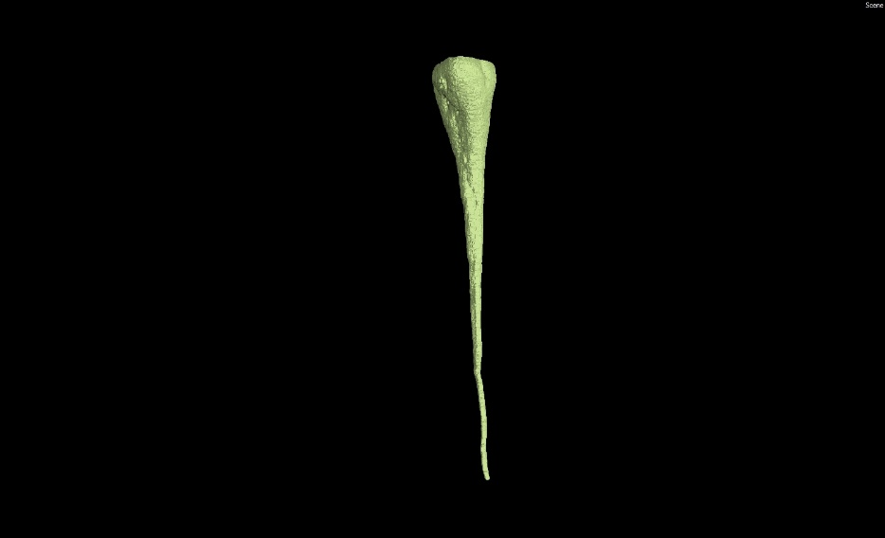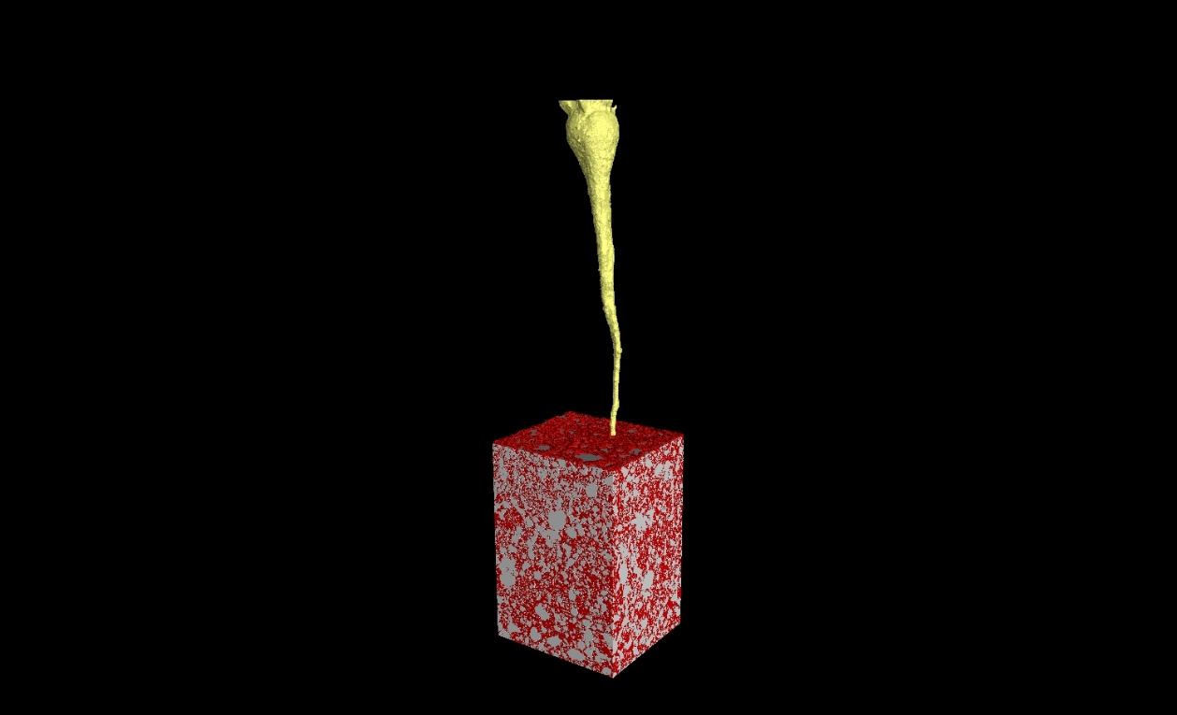

B

A

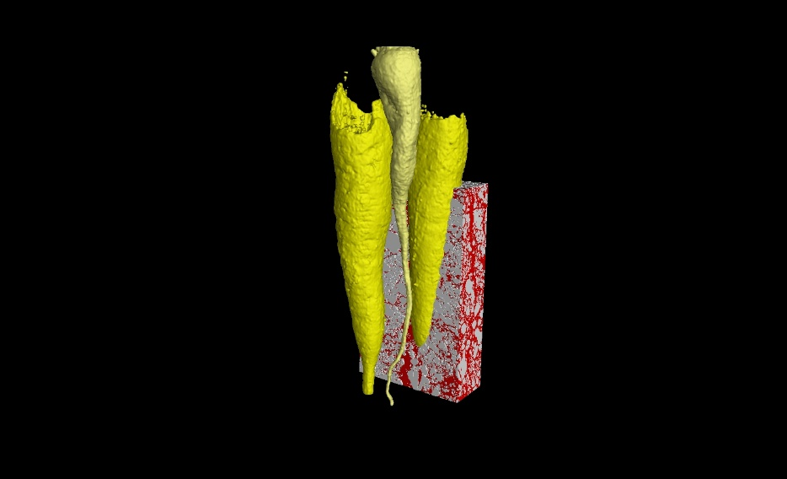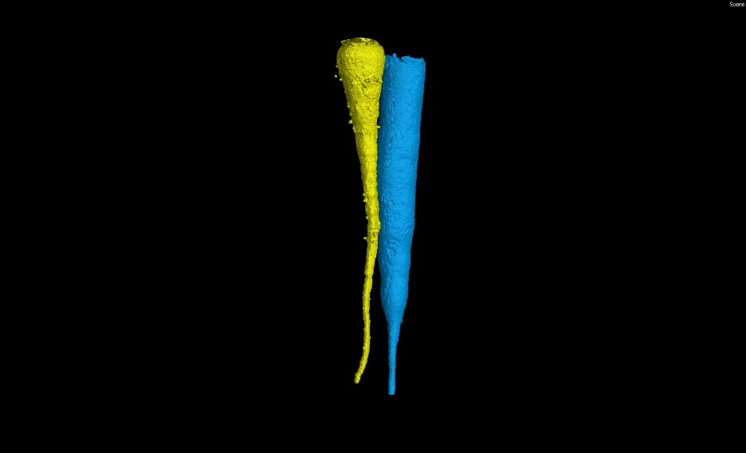

D

C

Figure 9. X-ray CT reconstructions of sugar beet growing following each cover crop treatment. A) Bare soil B) Rye C) Radish D) Rye & radish.

50 cm

* Cover crops had a significant but lesser effect on soil aggregation which is likely to be due to both lower root density and less intense wetting & drying cycles
* Tillage radish roots reduced the proportion of small pore space in the soil but this is likely to be less severe in field conditions
* Sugar beet root growth was restricted by cover crop growth, particularly tillage radish.
* In controlled conditions sugar beet were larger following bare soil

## Glasshouse experiment 3 – understanding the effects of combining species on root growth

### Introduction

In the previous glasshouse experiment it appeared that there was a negative effect of combining tillage radish and rye on overall root growth. Changes to the Common Agricultural Policy (CAP) require cover crops that are part of environmental schemes, to consist of two or more species containing at least one cereal plant and one non-cereal plant (DEFRA, 2018). In addition to this, many of the commercially available cover crops are combinations of five or more species which are being sold as beneficial to growers as a result of combining species with for a ‘hybrid vigour’ effect of their root structures.

The previous work from this project suggests that there may actually be a negative effect of combining two species and therefore it is important to investigate further. It is suggested that in some cases there may be benefits to growing multiple species as one crop (Bonkowski et al., 2009). This can be demonstrated in agroforestry, companion cropping and in grass leys. However, there is also considerable evidence to suggest that this is not always the case and that interspecies competition and allelopathy may have negative effects on growth of cover crops (Ohno et al., 2000).

From a practical aspect it is possible that combining species may spread the risk of one not establishing well as a result of poor moisture availability or low thermal receipts in the autumn – both of which are important factors in the UK.

It I well-regarded that in long term ecosystem management, greater plant species diversity will have positive effects on overall biodiversity. It is likely that this will be the case where cover crops are used in long term situations to encourage pollinators (Bonkowski et al., 2009). However, due to the cool autumn temperatures experienced in the UK it is likely that the aim for getting a successful cover crop is rapid and maximum autumn growth. As a result is may be beneficial to avoid complicated cover crop mixtures in favour of single species cover crops.

|  |  |  |
| --- | --- | --- |
| Species 1 | Species 2 | Treatment name |
| White mustard | White mustard | MM |
| Tillage radish | Tillage radish | TT |
| Black oat | Black oat | OO |
| Forage rye | Forage rye | RR |
| White mustard | Tillage radish | MT |
| White mustard | Black oat | MO |
| White mustard | Forage rye | WR |
| Forage rye | Tillage radish | RT |
| Forage rye | Black oat | RO |
| Black oat | Tillage radish | OT |

### Results and Discussion

Brassica cover crops produced the greatest quantity of above ground biomass when in combination with other brassica cover crops (Fig10). When cereal cover crops were in monoculture or in combinations they produced the least amount of biomass. When a brassica was combined with a cereal the biomass production was intermediate of the two groups. The same relationship was seen in root production and there was a strong linear relationship between root production and above ground biomass (Fig.11 & 12). Tillage radish produced significantly more roots with a diameter of greater than 3mm although the total length of roots at this diameter remained small.

The linear relationship between above ground biomass and root growth suggests that if the aim is to produce the largest quantity of roots then a brassica cover crop would be preferential. However, in other experiments within this project and other’s findings, cereal cover crops have produced more biomass than brassicas. This is likely to be related to the conditions at cover crop establishment as brassicas are highly sensitive to soil moisture at drilling whereas in the UK cereal cover crop growth is more limited by thermal time accumulated during growth (Allison et al., 1998).

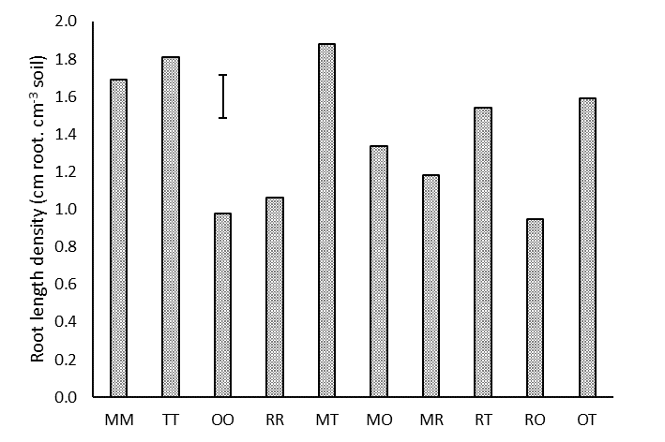

Figure 11. Total root length density of cover crop species. P<.001 d.f. 58, error bars showing LSD of 0.2292.

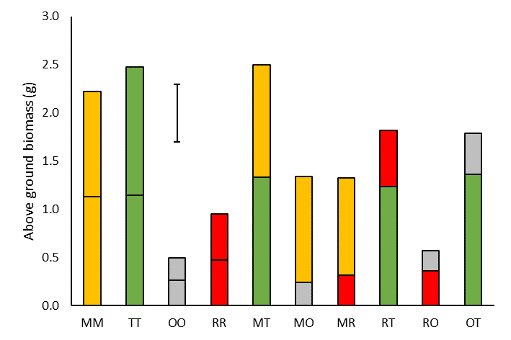

Figure 10. Above ground biomass of cover crop species. Bars represent total of both plants in each pot. Colours denote the species: yellow, green, grey and red being white mustard, tillage radish, and black oat and forage rye respectively. P<.001 d.f.58 error bars showing LSD 0.0968.

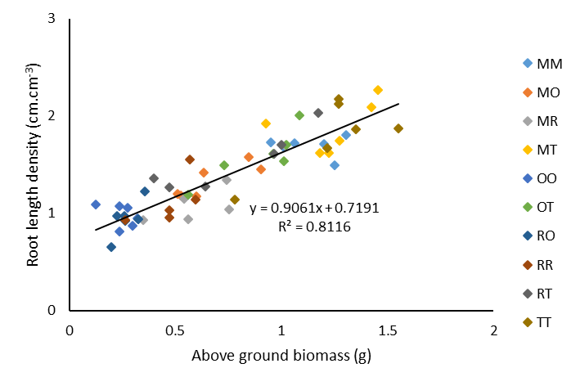

Figure 12. Regression of above ground biomass on total root length density. P<.0001 d.f. 58

There was no evidence of negative effects of combining cover crop species on above ground biomass production or root growth however there was also no positive effect either. As a result we can suggest that there was no competitive effect nor an allelopathic effect of the species tested. It is possible that species such as Egyptian clover or vetch may benefit from being combined with other species in terms of the success of individual plants however, overall it appears that maximum growth of the cover crop will lead to maximum root growth and influence on the soil.

### Conclusions

* There was a strong relationship between above ground growth and root growth of cover crops
* Brassica cover crops had the greatest growth
* Tillage radish produced more roots with larger diameter but this was not a considerable number
* Cover crop growers should focus on overall cover crop growth rather than species richness
* There was no effect on overall growth as a result of mixing the species tested

# Field experiments and related work

## Replicated field experiments at the University of Nottingham

### Introduction

Soil structure on a field scale is far more variable than controlled environment. The structure of the soil can be defined simply as the arrangement and stability of the soil aggregates, pore space, organic matter and invertebrates through the soil profile. In a particular field this will be determined by the soil texture, organic matter content, crop rotation/land use and the cultivation regimes in place. Furthermore, as previously explained, the porosity and aggregation will be determined in part by the organic matter content.

The aim of this section was to understand the effects of different cover crop species on the soil structure of a clay loam in the Dunnington heath series. The cover crops seen in table 2 were established on the 1st September 2016 and the 2nd September 2017 in a field that had been lightly cultivated. Cover crops were grown throughout the autumn when they were mown in the first week of December. In January of both seasons the field experiment was sprayed with glyphosate. After this point the field experiment was left until sugar beet drilling. One week before drilling the experiment was cultivated to a depth of 5 cm using a set of discs to prepare a seedbed. In the first season the field experiment was drilled with sugar beet at a rate of 1.2 units ha-1 on the 7th April 2017. The following year the sugar beet were established at the same rate on the 11th May 2018. Throughout the cover crop and sugar beet growth measurements of the soil structure were taken and in October of each season the field experiment was harvested and sugar yield was measured using the BBRO tare house.

|  |  |  |  |
| --- | --- | --- | --- |
| Common name | Variety | Latin name | Seed rate kg ha-1 |
| Oil radish (2016/17 only) |  | *Raphanus sativus* | 30 |
| Tillage Radish | Mino | *Raphanus sativus* | 15 |
| Tillage Radish | Mino | *Raphanus sativus* | 30 |
| Forage Rye | Protector | *Secale cereale* | 55 |
| Black Strigosa Oat | Pratex | *Avena strigosa* | 35 |
| White Mustard | Rota | *Sinapis alba* | 10 |
| Egyptian Clover | Tim | *Trifolium alexandria* | 10 |
| Vetch | Buza | *Vicia spp* | 35 |
| Forage Rye & Tillage Radish (2017/18 only) | Protector & Mino | *S. cereale & R. sativus* | 25 |
| 7 |
| Bare Soil |  |  |  |
| Bare Soil Ploughed (2017/18 only) |  |  |  |

### Results and Discussion

In the first field season white mustard and tillage radish resulted in significantly drier soil profile throughout the autumn (Fig. 13). This was measurable to a depth of 1.8 metres using Electromagnetic Resistivity (EMI). After cover crop destruction this difference diminished. In the second season the same trend was seen but the differences were less obvious (Fig.14). It is likely that this is due to a slightly cooler period in September during the first month of cover crop growth. Thus highlighting the importance of rapid cover crop growth in the early autumn to have the greatest effect on the soil profile.

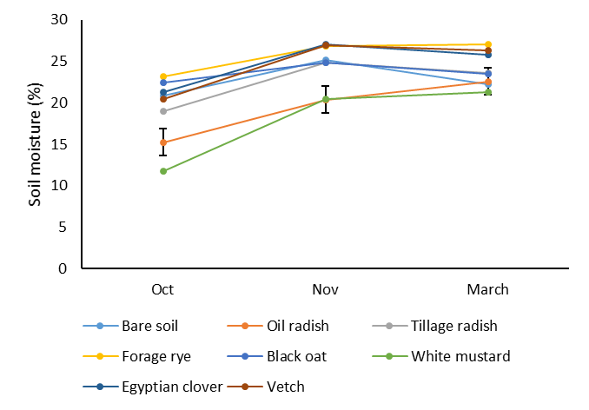

Figure 13. 2016/2017 Soil surface moisture over time. Differences present between treatment and sample date. Differences between treatments P<.001 d.f 31. Differences between dates P<.001. Error bars = LSD 1.948.

No differences of soil bulk density or shear strength in either year were measured showing that the cover crops had neither helped nor hindered the production of a sugar beet seedbed (data not shown). However, there was an exception in the second season of experiments as soil that had been ploughed in the autumn had a significantly lower shear strength which is likely as a result of the disturbance by the plough. This was also reflected in penetrometer data (Fig.15).

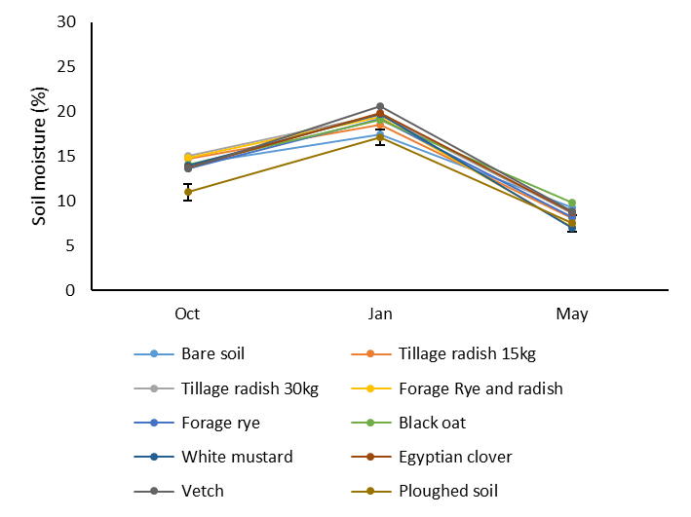

Figure 14. 2017/2018 soil surface moisture over time. Differences between treatments, sample date and an interaction between sample date and treatment. P<.001, P<.001, P=0.05 respectively. Error bars show combined treatment and sample date LSD 1.816

No differences in aggregation were measured at any point in either year which is likely due to the soil texture as the relatively low clay content means that the plasticity of the soil is not great enough to take on the relatively short term root effects of cover crops. In this time frame we would not expect to see the effect of changes in soil organic matter on soil aggregation as changes to organic matter are unlikely to occur unless the soil is undisturbed for a period of several years (Bellamy et al., 2005).

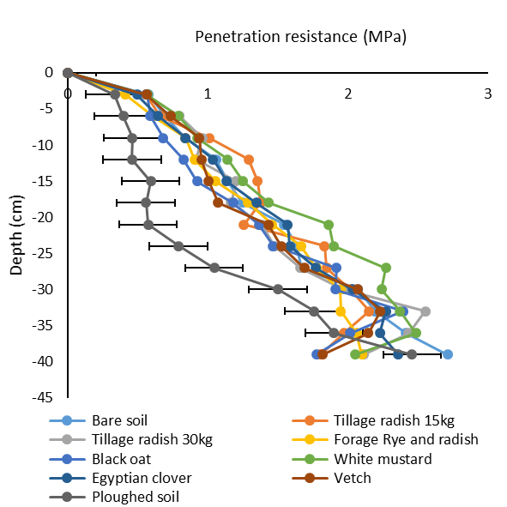

Figure 15. Penetration resistance from second field experiment in March 2018. Significant differences between treatments P<.001 d.f. 27. Error bars show LSD of 0.184.

In both years brassica cover crops produced the largest quantity of above ground biomass (Fig 16 & 17). The differences were lesser in the second season which is likely again to be as a result of the cool temperatures during the autumn. There also seemed to be a diminishing effect of doubling the tillage radish seed rate on above ground biomass production

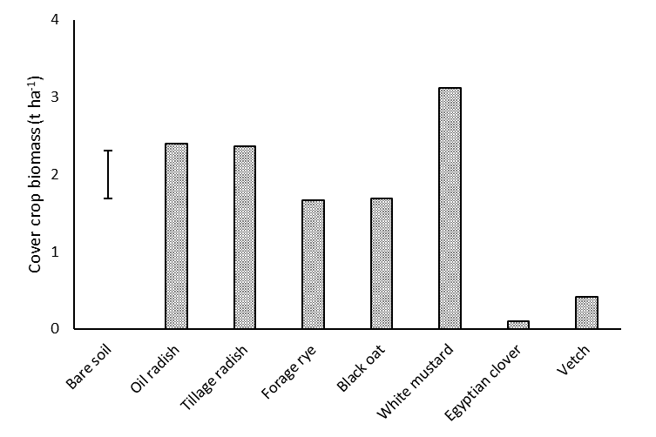

Figure 16. Cover crop above ground biomass from first experimental year. Significant differences between treatments P<.001 d.f 30 error bars showing LSD of 0.62.

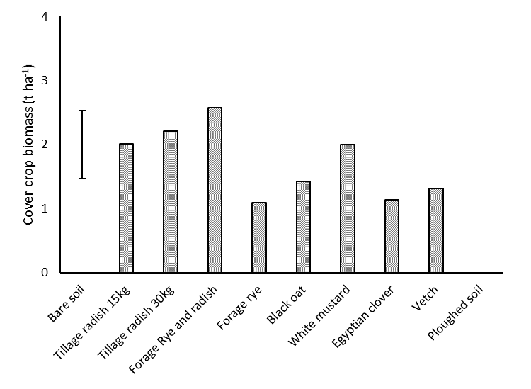

Figure 17. Cover crop above ground biomass from second experimental year. Near significant differences between treatments P=0.069 d.f. 30 error bars showing SED of 0.53.

As seen in the glasshouse experiment there was a linear relationship between above ground biomass and root length density (Fig.18) suggesting that a cover crop that has rapid autumn growth will produce the greatest root length. Furthermore, mustard produced significantly more above ground biomass than all other treatments including the combination of rye and tillage radish suggesting that as seen in the previous experiment cover crops should be chosen for rapid growth and vigour rather than complex mixes of species.

We found a positive relationship between cover crops and earthworm abundance. Where cover crops were present, as soil moisture (shown as conductivity) in the top 50 cm of soil increase so too did worm population (Fig.19). This shows that the presence of cover crops through the autumn is a useful food source for earthworms which are important for recycling decaying material and have been linked to increased macroporosity of the soil. The graph suggests when soil moisture is low the worm abundance will also be low which is likely due to earthworm behaviour tending to follow the moisture profile of the soil in this soil type. It may be a concern that large cover crops have been shown to dry the soil profile and thus reduce earthworm activity but this is unlikely to be a major problem due to the frequency of rainfall during a typical winter.

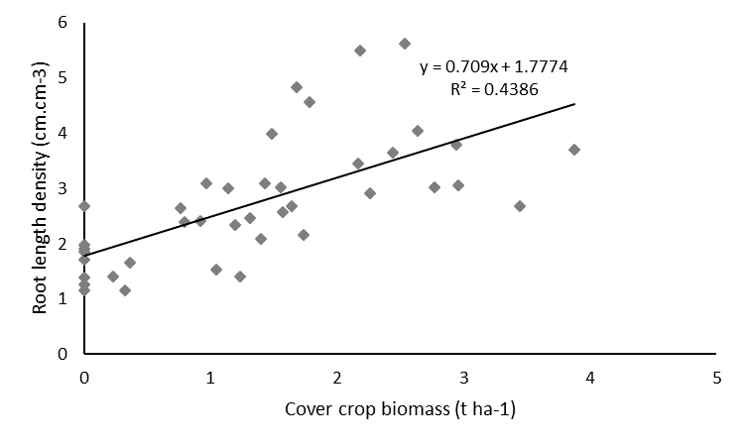

Figure 18. Significant relationship between cover crop root length density and cover crop above ground biomass production (P<.001. d.f. 39)

Sugar yield was not affected by cover crop/soil treatment in either year (Fig.20 & 21) however the second season had considerably lower sugar yield as a result of the later drilling date and the drought conditions of summer 2018. This differences may also be attributed to differences in plant population. In the first season sugar beet populations were the equivalent of 100,000 plants ha-1 whereas in the second season they were the equivalent of 60,000 plants ha-1.

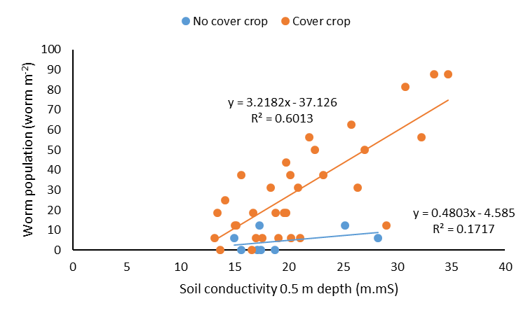

Figure 19. Significant interaction between soil conductivity in January and worm population in January and the inclusion of cover crops (P=0.036). Cover crop line shows all cover crop treatments combined, no cover crop line shows combined ploughed and bare soil treatment.

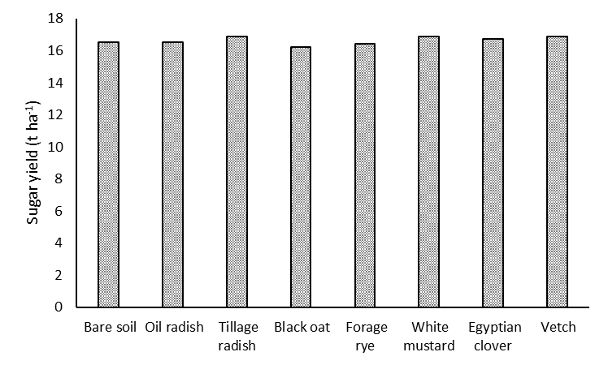

Figure 20. Sugar yield of first experimental year 2017. No significant differences between treatments*.*

Contrary to the lack of differences in sugar beet yield the sugar beet following the ploughed treatment in 2018 had significantly fewer beet that had become fanged. Fanging occurs as a result of impedance of the roots by strong soil. This has been seen previously as a result of compaction but is more likely to have occurred in 2018 as a result of the extreme temperatures and water scarcity resulting in extremely high soil resistance. The fanging of sugar beet storage roots is irreversible and can lead to loss of yield due to breakage of the root at harvest and financial penalties for the grower as a result of increased dirt tare between fanged roots (Koch, 2009). While this is only likely to be a problem in extreme years it is useful to highlight to growers the importance of removing soil restrictions and it suggests that in this case at least the inclusion of a cover crop has been of detriment to the sugar beet (Fig.22).

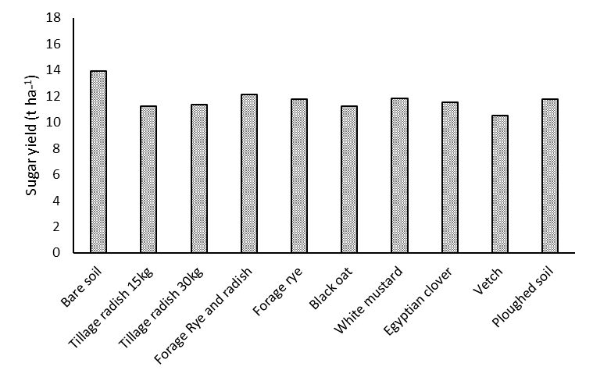

Figure 21. Sugar yield of second experimental year 2018. No significant differences between treatments*.*

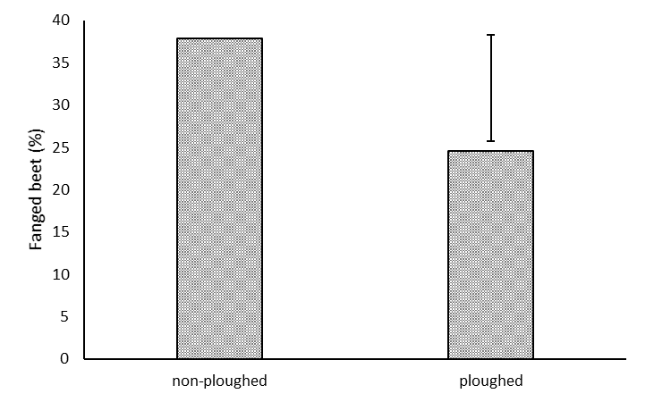

Figure 25. Percentage of roots that showed a high rate of fanging. Significant differences between ploughed treatment and all other treatments aggregated. P=0.037 d.f. 39. Error bars showing LSD of 12.57.

### Conclusions

* On this sandy loam soil cover crops did not have an effect on soil aggregation
* Cover crops were able to significantly influence the soil moisture during the autumn
* Cover crop growth and the effect on soil moisture is dependent on early growth
* Early establishment is key to good cover crop growth
* There was no benefit to cover crop combinations
* The greatest root growth occurs in the largest cover crops
* Earthworms were positively affected by cover crops
* Sugar beet growth and yield was not directly affected by the cover crops
* Ploughed soil produced fewer fanged beet when soil conditions became restrictive in the drought of 2018

## Findings from field experiments on commercial farms in Norfolk and Suffolk

### Introduction

In addition to the fully replicated experiments at Sutton Bonington Campus, we have been following two commercial farms over a number of years to understand how cover crops would be included in their rotations.

Holkham farms are based in North Norfolk on a light textured sandy loam soil. Measurements at Holkham were taken over two seasons from September 2015 (cover crop establishment) – October 2016 (sugar beet harvest) and September 2017 – October 2018. In both years the trials site was split into sections. In the first year half of the field had an overwintered cover crop established using a broadcast spreader on a min-till cultivator and the other half was over-wintered soil. In the second season this was repeated but there was an additional strip that had a grazed cover crop. After winter the entire field was cultivated with the same min-till cultivator to produce the seedbed for sugar beet.

The second farm was in Shimpling, Suffolk on a heavy clay soil in the Hanslope soil series. Here we conducted a replicated field experiment using tillage radish, rye, black oat, egyptian clover and bare soil. The trial ran from September 2017-October 2018. Prior to cover crop establishment the area was ploughed to a depth of 15 cm and the cover crops were established using a combi drill. In February 2018 the trial area was sprayed with glyphosate and a power harrow was used to create the sugar beet seedbed in March 2018.

In both trials measurements of soil structure and crop growth were taken throughout cover crop and sugar beet growth.

### Results and Discussion

#### Holkham 2015-2016

Initial differences were seen in penetration resistance which is likely to be due to the cultivation of the cover cropped soil compared to stubble. After 10cm depth no differences in penetration resistance were seen in either year suggesting that the cover crops had no effect on soil penetration resistance.

Following the cover crop, the sugar beet seedbed had a significantly lower shear strength in the first season (Fig.26). Sugar beet plant populations were slightly, but significantly higher following the cover crop. This might suggest that cover cropping or autumn cultivations are more favourable to even crop establishment than over-wintered stubble. However it is important to note that the plant population following stubble would not have been limiting.

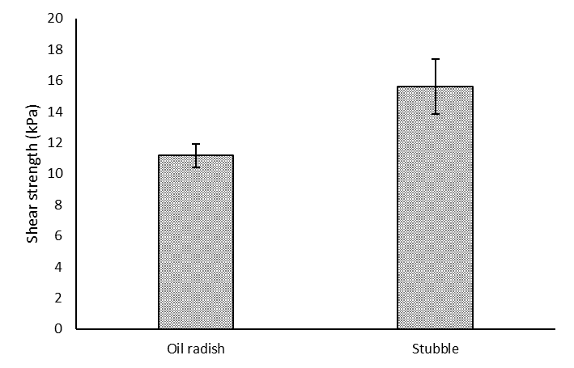

Figure 26. Shear strength of sugar beet seedbed in the first season. (*F<0.001*) error bars show standard error of means for each treatment.

Following the cover crops in 2016 the sugar beet had significantly larger canopies and NDVI throughout the growing season (Fig.27). This resulted in significantly higher sugar yield as a result of larger sugar beet (Fig.28). It is hypothesised in this year that this is as a result of less restrictive soil conditions which resulted in better access to water and nitrogen for canopy expansion.

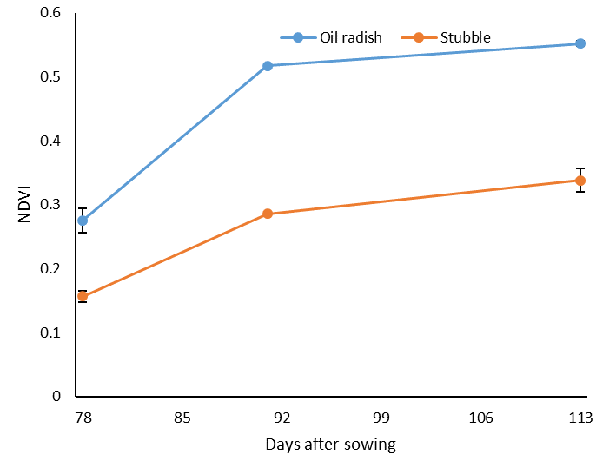

Figure 27. NDVI values for sugar beet over time. Error bars show standard error of means at each date.

#### Holkham 2017-2018

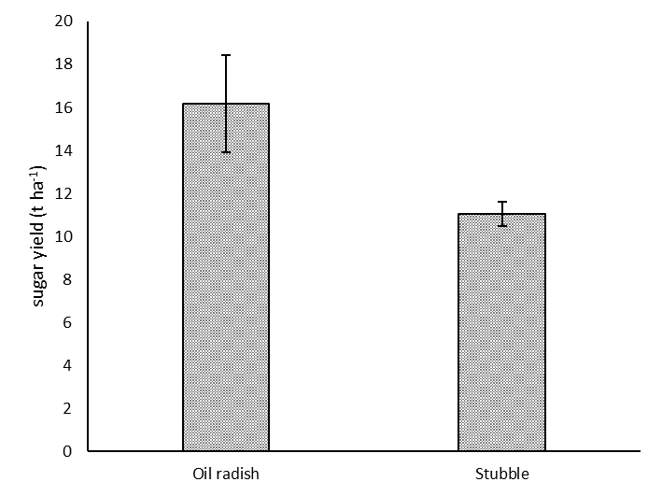

Figure 28. Sugar yield of treatments at harvest. (*F<0.001*) Error bars showing standard error of means

In 2018 no differences in soil structure were measured in any of the treatments throughout the autumn or in the seedbed. At sugar beet establishment there were no differences between treatments suggesting that the area that had been grazed had not been adversely affected and there was no negative effect of over-wintered stubble. It’s possible that this occurred as a result of a relatively dry winter which meant that the soil was at low risk of compaction when grazed. Sugar beet plant population was 108,000 plants ha-1.

Throughout the sugar beet growing season sugar beet that followed the cover crop had a larger canopy size (Fig.29). It became clear that this would be as a result of better access to water and or nitrogen. Work on radishes as nitrate catch crops has shown that they are effective at soaking up nitrogen in the autumn as a prevention of leaching to water courses (Cooper et al., 2017). However, there is evidence to suggest that nitrate released from a decomposing cover crop is not available early enough for a sugar beet crop (Sievers and Cook, 2018). It’s been seen that grazing by sheep may allow better nitrogen recycling following a cover crop (Duncan et al., 2016). Although there was a reduction in nitrogen content in sugar beet following stubble, we found that the sugar beet following stubble were not deficient in nitrogen suggesting that the differences in nitrogen availability were less important than water.

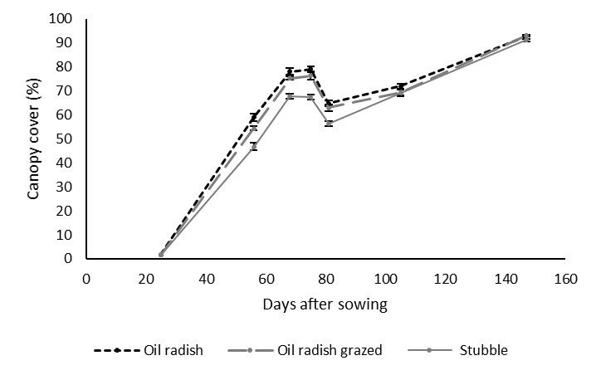

Figure 10. Canopy cover of Holkham field site over time. Error bars show SEM for each treatment at each date

Thermal camera images revealed that sugar beet following cover crops, regardless of grazing, were less water stressed during the drought suggesting better access to water which allowed greater transpiration (Fig.29). This theory was confirmed using X-ray CT scans which showed that the soil profile was significantly more porous following the cover crop which would have allowed for better sugar beet root growth (Fig.20).

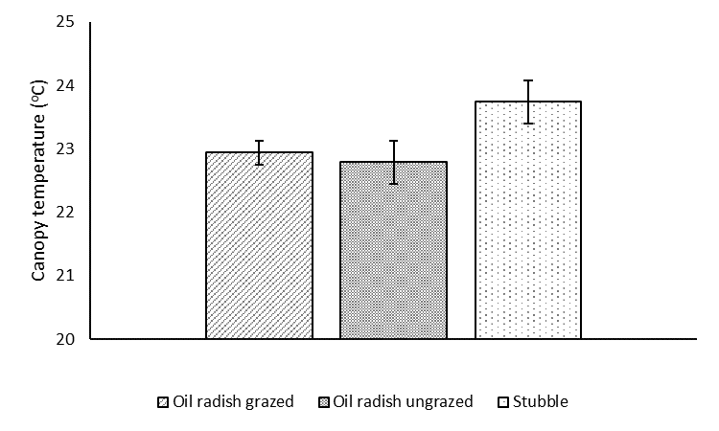

Figure 29. Sugar beet canopy temperature on June 28th 2018 at 10:30am. Error bars show SEM of each treatment. No differences between cover crop treatments. Oil radish grazed different to stubble (*P=0.05*), oil radish ungrazed different to stubble (*P=0.04*).

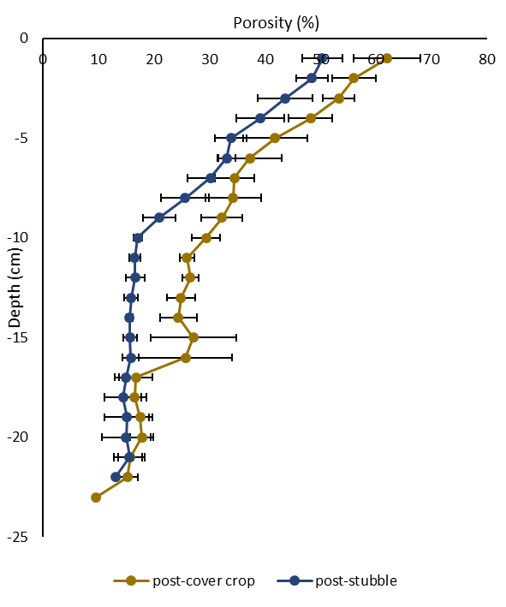

Figure 30. Soil porosity of soil treatments measured in October 2018. Significant differences measured between -9 and -16 cm. Error bars show SEM of each treatment at 1 cm increments.

Sugar beet following a cover crop had significantly higher yield than following the stubble treatment. It is highly likely that this is as a result of the larger canopy and better access to water. However, we would have expected to see larger differences in sugar yield having seen such large differences in the early season. It’s possible that the diminishing difference in sugar yield are as a result of later season growth where the differences in canopy size between treatments disappeared allowing for more even growth across the field (Fig.31)

It is possible that in years where there is less drought and heat stress this would be less important for the success of a sugar beet crop but does highlight the importance of unrestrictive soil conditions on sugar beet yield. It is possible that prolonged use of cover crops in the rotation may lead to better soil structure and better access to water for cash crops. This is likely to be of particular importance with potential climate change leading to hotter summers and the likelihood of reduced opportunity for irrigation.

Figure 31. Sugar yield at harvest. No significant difference between oil radish treatments. Oil radish grazed did not produce a different sugar yield to beet following stubble. Sugar beet following ungrazed oil radish produced a significantly greater sugar yield than stubble (*P=0.046*). Error bars show SEM

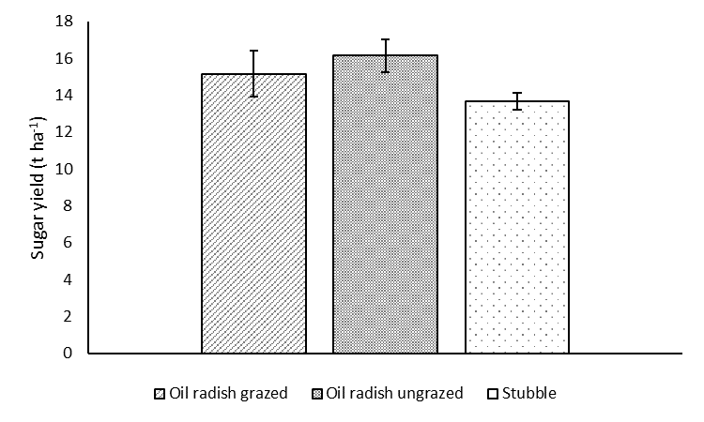

#### Shimpling 2016

No differences in penetration resistance was measured throughout the experiment suggesting that no treatments had a great effect on the soil strength. In the early spring, soil following rye and black oat had significantly more aggregates > 5mm in diameter. This suggests that the cereal cover crops had enmeshed the soil and had resulted in a more friable soil profile. However, the difference was only slight and after seedbed production using a power harrow the differences disappeared. This suggests that if growers were aiming to achieve long term changes to soil aggregation they may have to alter the secondary tillage practises of the farm.

At Shimpling the cereal cover crops produced significantly more biomass than radish or egyptian clover. This may explain the differences in aggregation as the cereal cover crops are more likely to have more root density to enmesh the soil particles and increase wetting & drying cycles.

Sugar beet canopy growth was significantly greater following bare soil and tillage radish than all other treatments (Fig.32). It’s possible that this is as a result of better access to nitrogen as cover crops such as rye, oat and egyptian clover have been linked to lock up of nitrogen fertiliser due to their relatively high carbon-nitrogen ratio (Wyland et al., 1995). However, no differences in nitrogen content of sugar beet leaves was recorded in any treatment. This suggests that the differences in sugar beet growth were as a result of restrictions in the soil which may have been lesser in tillage radish and bare soil treatments.

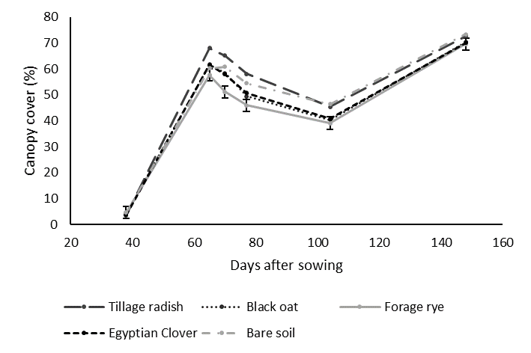

Figure 32. Sugar beet canopy cover over time at Shimpling field experiment. Differences between treatment and an interaction over time (*P=*0.002, *P=*0.031 respectively) error bars show SED of treatment and time.

During the heat wave canopy temperature was not significantly different between treatments and was higher than at Holkham. It is likely that this is a result of higher air temperatures in the area. In the period between June and August the air temperature was consistently 3oC higher in Shimpling than at Holkham which is close to the coast. It’s possible that this led to greater water stress.

D

C

Yield results showed that there were no differences between cover crop treatments (Fig.33). It is possible that there was a negative effect of having a large canopy during the heatwave in 2018 which may have led to a lower yield (Fig.34). Previous researchers have suggested that when plants experience extreme temperatures they can lose water through leaves without any effect on transpiration leading to no net benefit to sugar yield. It’s possible that the larger canopy seen after bare soil and tillage radish, on a normal year would have resulted in higher yield but due to the increased canopy growth they were inefficient with water during the heatwave.

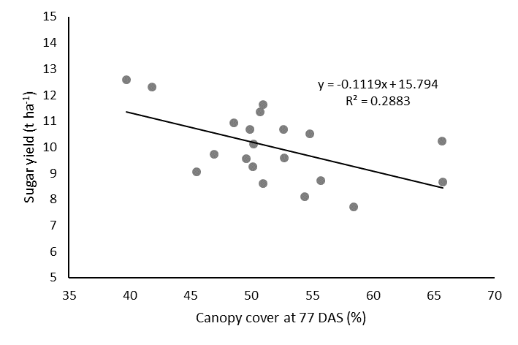

Figure 34. Significant negative relationship between canopy cover at 77DAS and sugar yield (*P=0.015*).

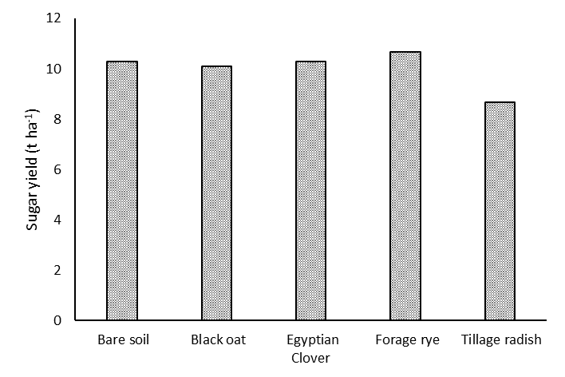

Figure 33. Sugar yield at harvest of experiment. No significant differences between treatment (*P>0.05*).

### Conclusions

* The inclusion of autumn sown cover crops resulted in greater soil porosity leading to greater sugar beet growth and yield on sandy loam
* Grazing of cover crops did not result in soil compaction and offered the opportunity to harness financial benefit to grazing and may have contributed to better nutrient availability to the following crop.
* On clay soil sugar beet growth appeared to be restricted after forage rye, black oat and egyptian clover which appeared to have a detrimental effect on nutrient availability and growth of the subsequent sugar beet crop in the early season.
* Where sugar beet were cultivated in extremely high temperatures there was a negative effect of a large canopy which appeared to lead to excess water use and lower sugar yield.

# Overall conclusions and useful points for sugar beet farmers

* Cover crops are able to improve soil aggregation
  + Unlikely on light textured soil
  + Related to root production and the effect of cover crops on wetting & drying cycles
  + May only result in small changes that are easily removed with tillage – changes to tillage regimes may need to be made
* The effect of cover crops on aggregation and soil moisture is greatly related to root growth which is directly related to above ground biomass production
* Root growth was not effected by combining species
  + Combinations are likely to be effective when spreading risk of establishment in the autumn
* Root density was highest in largest cover crops
* Brassica and cereal species tended to produce the largest cover crops
* The literature suggests cover crops should be destroyed well before sugar beet establishment to avoid nitrate lock up and adverse effects on seedbed moisture
* Cereal and legume cover crops are most likely to lock-up nitrogen fertiliser as their biomass tends to be ‘woody’ and have a higher carbon-nitrogen ratio
* Grazing did not have a negative effect on sugar beet growth but could cause compaction if grazed when soil is too wet
* Other studies have shown that manure deposited by sheep grazing is able to make nitrate more available from a cover crop which may reduce the risk of luck up following cereal species
  + Not sufficient evidence to change fertiliser recommendations
* Cover crops are able to increase soil porosity which can result in slight benefits to water uptake
  + This may only be the case when weather conditions are extreme

Following the project and speaking to sugar beet growers it has become clear that there is a disparity between what is achievable in trials and achievable on farm due to the many different types of cultivator on individual farms. From the experience of the project and wider literature it is important for cover crops to be destroyed long before production of a sugar beet seedbed as in some cases the soil can be too dry for optimum tillage conditions and in other situations cover crop residues can make the seedbed too wet leading to clod formation. The best results seen were when optimum seedbed production was prioritised rather than optimum cover crop growth.

## Selected References

ALLISON, M. F., ARMSTRONG, M. J., JAGGARD, K. W. & TODD, A. D. 1998. Integration of nitrate cover crops into sugarbeet (Beta vulgaris) rotations. II. Effect of cover crops on growth, yield and N requirement of sugarbeet. *Journal of Agricultural Science,* 130**,** 61-67.

ANGERS, D. A. & CHENU, C. 1998. Dynamics of Soil Aggregation and C Sequestration. *In:* LAL, R., KIMBLE, J. M., FOLLETT, R. F. & STEWART, B. A. (eds.) *Soil Processes and the Carbon Cycle.* London, UK: CRC Press.

BELLAMY, P. H., LOVELAND, P. J., BRADLEY, R. I., LARK, R. M. & KIRK, G. J. D. 2005. Carbon losses from all soils across England and Wales 1978–2003. *Nature,* 437**,** 245-248.

BONKOWSKI, M., VILLENAVE, C. & GRIFFITHS, B. 2009. Rhizosphere fauna: the functional and structural diversity of intimate interactions of soil fauna with plant roots. *Plant and Soil,* 321**,** 213-233.

COOPER, R. J., HAMA-AZIZ, Z., HISCOCK, K. M., LOVETT, A. A., DUGDALE, S. J., SUNNENBERG, G., NOBLE, L., BEAMISH, J. & HOVESEN, P. 2017. Assessing the farm-scale impacts of cover crops and non-inversion tillage regimes on nutrient losses from an arable catchment. *Agriculture Ecosystems & Environment,* 237**,** 181-193.

DEFRA 2018. Basic Payment Scheme: Rules for 2019. *In:* DEFRA (ed.). London: UK Government.

DUNCAN, A. J., BACHEWE, F., MEKONNEN, K., VALBUENA, D., RACHIER, G., LULE, D., BAHTA, M. & ERENSTEIN, O. 2016. Crop residue allocation to livestock feed, soil improvement and other uses along a productivity gradient in Eastern Africa. *Agriculture Ecosystems & Environment,* 228**,** 101-110.

GOSS, M. J. 1977. Effects of Mechanical Impedance on Root Growth in Barley (Hordeum vulgare L. ): I. EFFECTS ON THE ELONGATION AND BRANCHING OF SEMINAL ROOT AXES. *Journal of Experimental Botany,* 28**,** 96-111.

GYSSELS, G., POESEN, J., BOCHET, E. & LI, Y. 2005. Impact of plant roots on the resistance of soils to erosion by water: a review. *Progress in Physical Geography,* 29**,** 189-217.

KAY, B. D. 1998. Soil Structure and Organic Carbon: A Review. *In:* LAL, R., KIMBLE, J. M., FOLLETT, R. F. & STEWART, B. A. (eds.) *Soil Processes and the Carbon Cycle.* London, UK: CRC Press.

KELLER, T. & DEXTER, A. R. 2012. Plastic limits of agricultural soils as functions of soil texture and organic matter content. *Soil Research,* 50**,** 7-17.

KOCH, H. J. 2009. Relations between soil structural properties and sugar beet yield on

a Luvisol. *Pflanzenbauwissenschaften,* 13**,** 49-59.

LINSLER, D., KAISER, M., ANDRUSCHKEWITSCH, R., PIEGHOLDT, C. & LUDWIG, B. 2016. Effects of cover crop growth and decomposition on the distribution of aggregate size fractions and soil microbial carbon dynamics. *Soil Use and Management,* 32**,** 192-199.

OHNO, T., DOOLAN, K., ZIBILSKE, L. M., LIEBMAN, M., GALLANDT, E. R. & BERUBE, C. 2000. Phytotoxic effects of red clover amended soils on wild mustard seedling growth. *Agriculture Ecosystems & Environment,* 78**,** 187-192.

SIEVERS, T. & COOK, R. L. 2018. Aboveground and Root Decomposition of Cereal Rye and Hairy Vetch Cover Crops. *Soil Science Society of America Journal,* 82**,** 147-155.

WYLAND, L. J., JACKSON, L. E. & SCHULBACH, K. F. 1995. Soil-plant nitrogen dynamics following incorporation of a mature rye cover crop in a lettuce production system. *Journal of Agricultural Science,* 124**,** 17-25.