Report: Understanding water uptake in sugar beet

Background
It has been long known that sugar beet does not yield well under drought conditions. In the UK there is a 10% yield loss as a result of drought on average and in dry years this can increase to up to 25% yield loss (Jaggard et al. 1998). UK sugar beet is grown predominantly in East Anglia, on sandy loam soils, where annual rainfall is relatively low (>700 mm). This means there is low water availability during most of the growing season, and during the summer period drought often occurs (Brown and Biscoe 1985).

One way for plants to mitigate drought is by growing deep roots to reach water stored in deeper soil layers. Sugar beet are able to grow roots that exceed 1 m depth, however it seems that 80% of the water is taken up from the top 30 cm of the soil (Brereton et al. 1986). Possible reasons for the lack of water uptake from depth could be root physical restraints such as compaction. Roots tend to clump together into already existing pores when soil compaction is present. This would limit water uptake from those compacted layers, despite roots being able to reach those layers (Brown and Biscoe 1985). Another reason for the limited water uptake could be root physiological restraints such as immature root tissue (Varney and Canny 1993).

This project has focussed on root growth and water uptake from the soil to find ways to mitigate yield losses as a result of drought. Our aim was to identify limitation to water uptake. We started small in a glasshouse setting to assess root growth under varying watering regimes. After this we scaled up to large boxes in a polytunnel as well as field experiments. Our main questions were:
- Do sugar beet grow deep roots?
  - Do they take up water with those deep roots?
  - Are there any root physiological restraints?
- How does drought affect root growth?
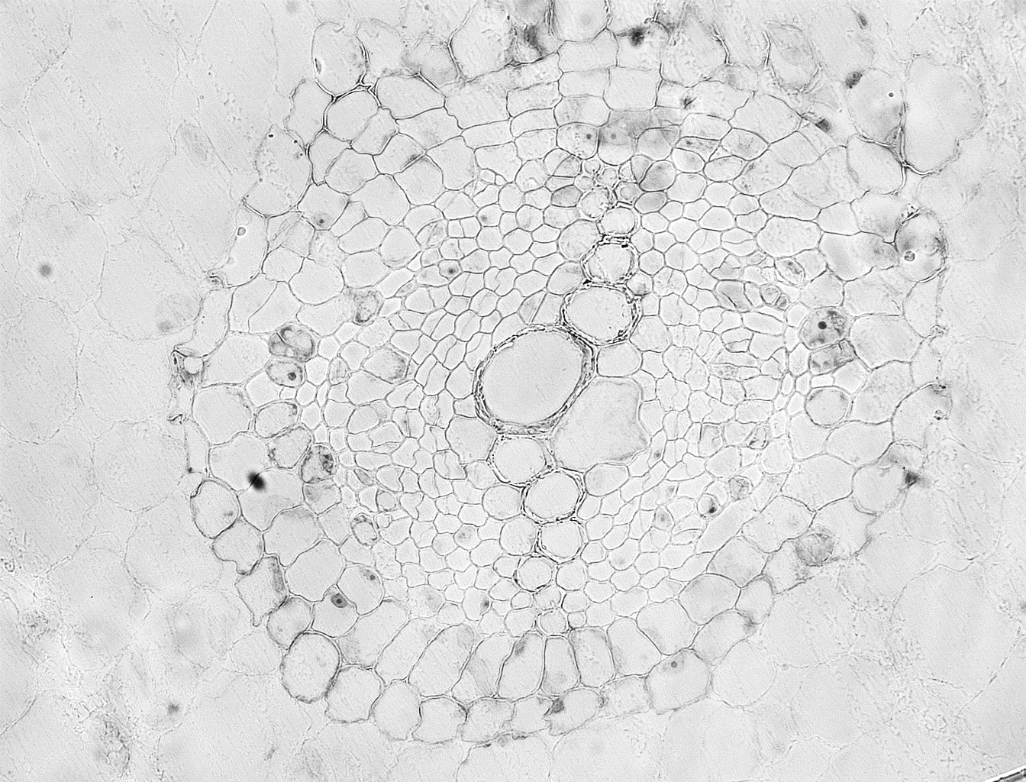
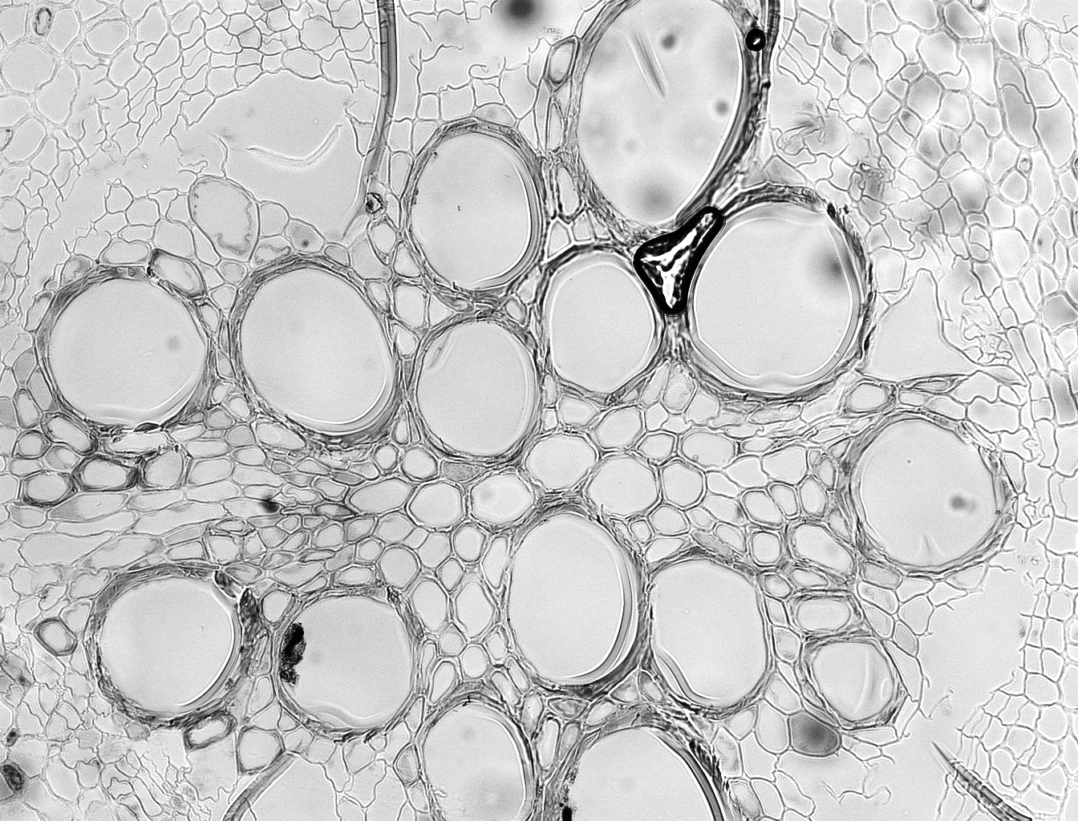
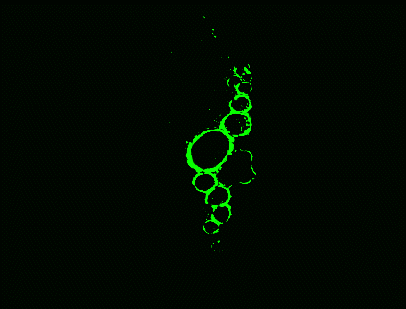
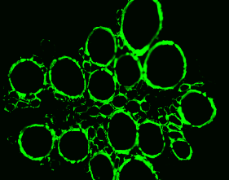
  - Does the timing of the drought change the plant response?
Mature xylem in green
Bright field Microscope
60 cm
90 cm
Figure 1 Different root maturities at different depths. The green shows mature xylem which is efficient at taking up water.
- Are there any varietal differences in root growth?

Findings
Our glasshouse experiment showed that roots could grow to 1 m depth when there were no soil restraints. Water uptake was also found from all depths indicating that water uptake from depth is possible. However, there was a few weeks delay in roots reaching depth and water being taken up. When we investigated this further, we found that when a root grows it takes a few more weeks for the xylem to mature until it can take up water most efficiently (Figure 1). This could explain why sometimes we find roots at a certain depth but there does not seem to be water uptake from that depth.

In our box experiments we could monitor root growth over time and see how root growth changes at different depths under different water availabilities. This taught us that sugar beet start proliferating roots at depth when drought occurs (Figure 2 and 3). Overall more roots grow under high water availability, but when drought occurs the plant invests in root growth at depth where there is often still water available. When we looked at differences between early and late drought, also in the boxes, we found that once the plants were established, drought early on was less damaging than late drought. However, sufficient rewatering after the drought period resulted in similar yields regardless of the timing of drought.
Figure 2 Root length at 119 DAS at different depths. The DR plants had not been watered for 62 days and had a higher root length at 110 cm depth than the fully irrigated control plants.

Once we established that sugar beet can grow deep roots and that they can take up water from depth we looked at their growth in a field setting (Figure 4). The first year, three varieties were used and the second year we used five varieties. Root growth was assessed twice during the growing season, once at canopy closure and once right before harvest time. During the first year we found that there were some varietal differences in root length density (RLD) at canopy closure. Variety Haydn had an overall higher RLD and this was mainly seen in the top layer (0-15 cm) and the deepest layer measured (60-84 cm). These significant differences had disappeared at harvest. The year after we added two varieties and looked at the root growth the same way. This time we found two varieties (Haydn and BTS 340) with an overall higher RLD and a higher RLD at depth at canopy closure. At harvest BTS 340 had proliferated its roots at depth even more.
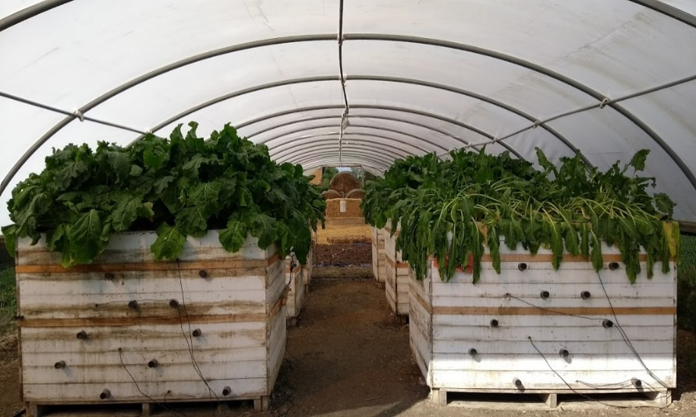
Figure 3 The box experiment with a fully irrigated box on the left and a droughted box on the right.

Conclusion
Overall, we found that sugar beet are capable of growing deep roots and water uptake from depth happens. However, there are some limitations to water uptake from depth such as immature root tissue and compaction resulting in root clumping. When drought occurs plants proliferate their roots more at depth. It also seems that plants recover more quickly from early drought than late drought. Our field experiments showed that there are varietal differences. This has also been noticed by one of the sugar beet breeders who have showed interest in the root research and the findings about the immature root tissue. They are funding a follow up project to look at the maturity of the root tissue and its effect on water uptake. All in all the project has given us a better insight into water uptake in sugar beet and it has given us more opportunities to look for improvement in the future.

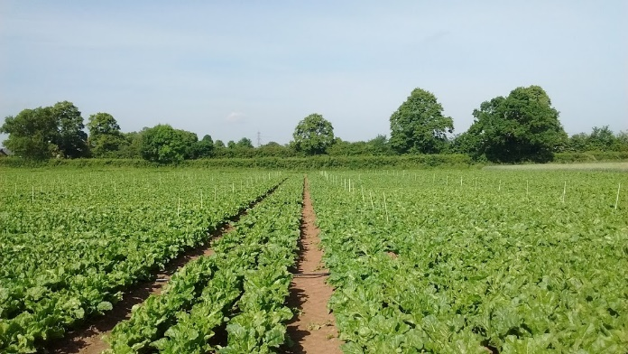
Figure 4 Field experiment looking at varietal differences in rooting as well as looking at sugar beet response to irrigation.

