BBRO PROJECT REPORT FORM
Please note the details on page 2 will be used to formulate the BBRO printed Annual Report.
Project Title:
Understanding Water Use Efficiency of Sugar Beet
BBRO project no:
Project sponsor: | BBRO
Interim report / Final report (delete as appropriate)

Project lead or student name: | Georgina Barratt
Project mentor or supervisors: | Debbie Sparkes  Erik Murchie  Mark Stevens
Report Date: | 18/07/2019
Reporting period covered:  (e.g. 1/1/16 - 31/12/16) | 01/04/18 – 01/10/19
Timeline (e.g. Year 1 of 4) | Year 3 of 4
BBRO use only | Date assessed:
Assessors comments
Action required

Project summary for BBRO Publication (no more than 300 words)
This project focuses on water use efficiency (WUE) in sugar beet, which examines the plant’s water use and the associated yields achieved. Sugar beet is often observed to wilt in the field even when soil water is freely available, resulting in lost yield potential. Sugar beet stomata, leaf pores through which water loss is controlled, are slow to respond to water stress. This response, and other traits of interest related to water regulation, are often inherited from its wild ancestor, Beta vulgaris ssp. maritima. The aim is to understand the behaviour of sugar beet under water stress, with a focus on the crop canopy, and the impact of a number of traits on WUE and whether they can be manipulated through management practices and/or breeding.
Short summary of key objectives
- To identify sugar beet traits linked to water conservation with a focus on leaf and canopy traits
- To understand if the traits identified can be explored to increase WUE
- To understand the impact of management practices on WUE

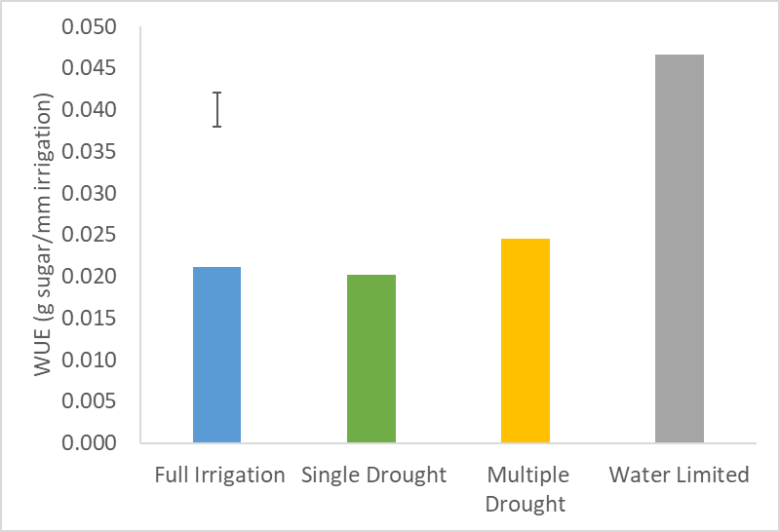  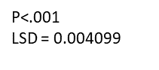  Fig 1. The sugar water use efficiency (WUE) of beet (shown as g of sugar per mm of irrigation) under four different irrigation regimes. | 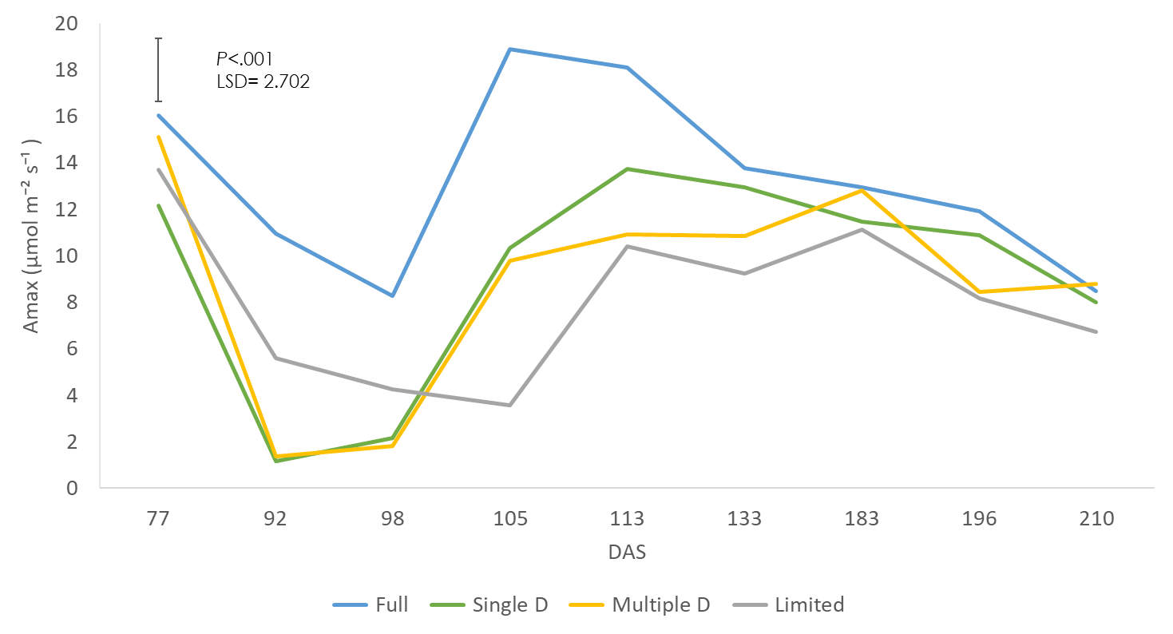  Fig 2. Maximum photosynthesis (Amax) of the sugar beet for the four irrigation treatments over the season
Outcomes/Key messages for growers and industry
In 2018 two sugar beet varieties were grown in 610L boxes in a polytunnel allowing for four different irrigation regimes. The four irrigation regimes were a fully irrigated control kept at field capacity, a continually water limited kept at approximately 50% field capacity, a single drought period at 65 – 96 DAS and a multiple drought period which was droughted at the same time as the single drought then re-watered and when recovered droughted again at 151 - 200 DAS. The results of this experiment are listed below under the research question they address:
- Are there differences in WUE between sugar beet varieties, and does WUE change over the growing season?
- Varietal differences such as stomatal number and leaf water content may help reduce water loss and therefore increase WUE on the hottest days
- WUE increases during the warmest months as the beet become stressed and the stomatal aperture is reduced, which reduces water loss more greatly than C0₂ uptake
- If the stress is not severe, and the stomata remain slightly open, it may lead to increased WUE without a yield penalty
- The greenness of the canopy may fluctuate more in some varieties than others under drought stress but this did not reflect any differences in stress and therefore WUE

- How is WUE affected by water availability, including multiple water stress, and the length of water deficit, including recovery?
- Beet have lower WUE when water is always freely available (Fig.1)
- Beet can recover after encountering severe drought stress as after the first drought photosynthesis recovered to levels comparable to the well-watered plants in 35 days (Fig. 2)
- The second drought was late in the season so the increase in WUE was not so great as that seen in the first drought: the beet were not as heat stressed so the stomata remained more open
- This water stress later in the season was not visible by observing the canopy but did reduce yield compared to the fully irrigated, as shown in Table 1 below.

Table 1. Average sugar %, root clean weight (kg) and sugar yield (kg) of 10 sugar beet grown under four different irrigation regimes in 610L boxes.

 | Sugar % | Clean Weight (kg) | Sugar yield (kg)
Full Irrigation | 17.11 | 11.47 | 1.952
Single Drought | 16.92 | 10.12 | 1.713
Multiple Drought | 17.35 | 8.96 | 1.556
Limited | 18.97 | 8.41 | 1.592
LSD | 0.67 | 1.20 | 0.18
P | <.001 | 0.001 | 0.003

Section 1: To be completed by Project Lead:
Other project objectives (not listed on previous page)

Milestones for current period
Note: mentors will be asked to comment on the status of this project (yellow column) using the scoring system in section 2.
- Finish analysis of 2018 polytunnel experiment data
- Plan and start the 2019 polytunnel experiment
- Set up pot experiment looking at drought and recovery in sugar beet vs sea beet
- Work with UCLA on sugar beet hydraulic conductivity
- Plan for and start booking process for 4th year experiment looking at sugar beet responses to fluctuating irradiance
- Plan thesis chapters and papers

Summary of results (including figures and tables)
For Project Annual Report: please provide a 2 page summary of key findings from the reporting year.
For Project Final Report: please provide a summary of project findings and outcomes with relevant supporting data.
Polytunnel box experiment 2019

The outcomes/Key messages for growers and industry section has focused on the results of the 2018 polytunnel experiment but we will now focus on the results gathered so far in the 2019 polytunnel experiment. This is a re run of 2018 with some minor changes, the most notable being the re skinned polytunnel transmitting 91% of light now compared to around 80% before making conditions more representative of the field.

This is a re-run of the 2018 box experiment aiming to address the following research questions:
- Are there differences in WUE between sugar beet varieties, and does WUE change over the growing season?
- How is WUE affected by water availability, including multiple water stress, and the length of water deficit, including recovery?

Experimental design:

2 varieties –
- Upright
- Prostrate
4 water treatments –
- Fully irrigated (kept a field capacity)
- Single drought (no watering from 73 – 91 DAS)
- Multiple drought (no watering from 73 – 91 DAS, re-watered and no water again from 129 – 147 DAS)
- Water limited (kept at approx. 50% field capacity)

A total of 32 boxes as each treatment was replicated 4 times.

Relative water content (RWC)

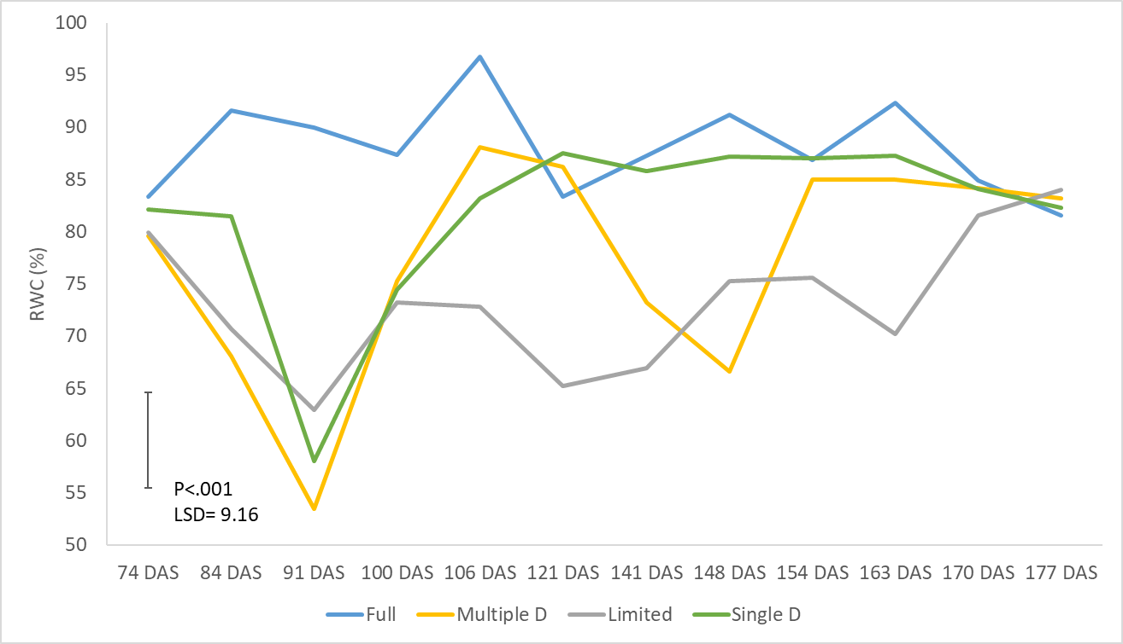
Fig 3. The relative water content (RWC) of sugar beet measured from 74 – 177 DAS grown under 4 different irrigation regimes.

The relative water content (RWC) gives the percentage water in the leaf relative to the total amount the leaf can hold. Under drought stress a decline in RWC is evident but recovery after re watering only takes around 20 days and reaches the same levels that were evident pre drought (Fig 3). This highlights the resilience of the crop to water stress which was also evident in 2018. In 2018, the second drought was later in the year when the temperatures were low and a decline in RWC was not evident. This year, the second drought was around 3 weeks earlier and the warmer temperatures resulted in a second decline in RWC and other parameters in the multiple drought so it will be interesting to see if yields are more greatly reduced at harvest compared to 2018, as shown in Table 1 earlier.

Maximum assimilation (A_{max})

Maximum assimilation (A_{max}) is the maximum rate of photosynthesis as measured by a portable photosynthesis system, in this case the Li6800.

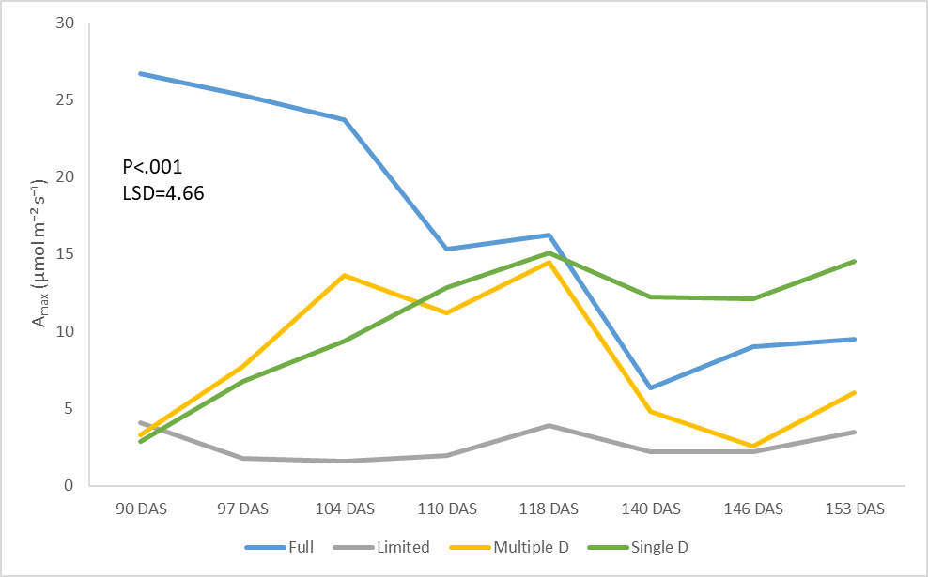
Fig 4. The A_{max} of a sugar beet leaf measured from 90 – 153 DAS grown under 4 different irrigation regimes.

Our results show that A_{max} is reduced under drought stress but that it recovers in around 20 days after re watering to levels similar to those seen in the fully watered control (Fig 4) which was also indicated by the RWC (Fig 3). The single drought is particularly interesting because A_{max} increases to a level above the control and maintains this for around 35 days after recovery. The stomatal impressions currently being processed may show an adaptation such as a change in stomatal density compared to the fully irrigated that enables this higher A_{max} and this data will be processed by the end of 2019.

Leaf level water use efficiency (WUEg)

Water use efficiency at the leaf level (WUEg) is A_{max} divided by stomatal conductance (gsw) to give a value of the amount of assimilation being achieved per amount of water lost through transpiration. This again is measured using the Li6800.

Under water stress, stomata begin to close. As the gradient driving water loss is greater than that driving C0₂ uptake, the WUEg increases as transpiration is reduced more than C0₂ uptake for assimilation, as evidenced in Fig 4 at 97 DAS in the three water stressed treatments. Due to this, the trend in WUEg is the reverse of that seen in A_{max} as can be seen when comparing Fig 4 and Fig 5.

As the weather gets cooler WUEg increases in the fully irrigated control as transpiration decreases in cooler temperatures. Even in these cooler conditions, the multiple drought treatment still shows an increase in WUEg under water stress at 146 DAS.
As already highlighted, last year the second drought was later so the increase in WUEg was not as great. We have managed to fit in the second drought earlier this year which will be interesting to compare to the data from 2018.

Overall, the results so far support those from 2018 and it will be interesting to see at harvest if crop level WUE (amount of yield/irrigation) is greater in the water stressed treatment, as was evident in 2018, especially in the multiple drought as the earlier drought imposed a greater level of stress on the beet.

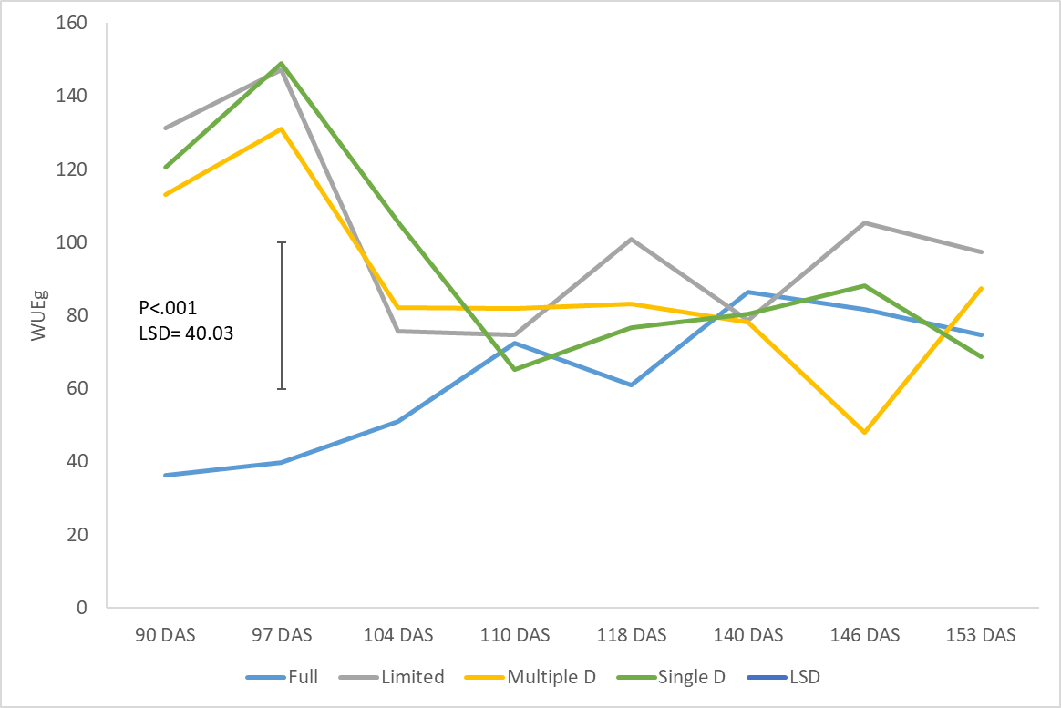
Fig 5. The WUE of a sugar beet leaf measured from 90 – 153 DAS grown under 4 different irrigation regimes.

Ongoing work: Polytunnel 2019

Varietal differences are still being assessed but early evidence shows differences between varieties and their response to stress are evident again in 2019. This data needs further analysis but will be ready to be presented at the winter technical events in early 2020.
The boxes are still to be harvested so the effect of the observations, including those presented here, on biomass and yield has not yet been assessed.
Carbon 13 isotope measurements will also be taken at harvest to give an integrated measure of WUE over the season. We can then assess if these results correlate with the photosynthesis measurements taken over the season to see whether they reflect the long term WUE of the beet.
Annual report: Key issues to be addressed next year:

Connecting wilting and light intensity
The second year stomatal response experiment (reported previously) highlighted that beet stomata can respond quickly to light but the next hypothesis that needs to be answered is:

Do stomatal responses to the light cycle of a typical summer day in the UK cause witling in sugar beet?

To explore this hypothesis a CER experiment which utilises a new state of the art CER will be undertaken. This room can simulate increases in light up to a midday maximum and the decrease back to night, as well as corresponding changes in humidity and temperature.

What can we gain from addressing this hypothesis?
If beet wilting is driven by light intensity when water is not limiting, it may not be detrimental to the crop, as this may be the crop maximising its use of the available light resource.
If wilting is not shown under changes in light intensity then wilting may be due to another factor. For example, the rapid uptake and transpiration of water by sugar beet may dry the zone around the root faster than water can move through the soil to replenish the available water.
Publication of results to date/planned publications:
PhD thesis to be written to consist of 3 papers as follows:
- Speed of stomatal response in sugar beet (Nov 2019 – Jan 2020)
- WUE in sugar beet between varieties, over the season and under water stress using data from the polytunnel experiments (Feb 2020 – May 2020)
- Wilting response on sugar beet using data from CER experiment to be undertaken in early 2020 (June 2020 – August 2020)
A literature review of sugar beet WUE will also be produced before thesis submission in September 2020.

Section 2: To be completed by project mentor
Status - Mentor’s scoring system for interim reports.
Red | “Major concern - escalate to the next level"  Slippage greater than 10% of remaining time or budget, or quality severely compromised. Corrective Action not in place, or not effective. Unlikely to deliver on time to budget or quality requirements.
Amber | "Minor concern – being actively managed”  Slippage less than 10% of remaining time or budget, or quality impact is minor. Remedial plan in place
Green | "Normal level of attention"  No material slippage. No additional attention needed
Milestone | Comments + action required | Status  R/A/G
Is the project on track to meet the stated objectives? (please comment in relation to milestones and the status score awarded in section 1).

Are conclusions scientifically robust? (please comment on data analysis/interpretation)
For final reports only:
How would you rate the project against the following criteria (please give a score out of 10, with 10 being highest)
1 ) The project met its original objectives:

2) Contribution to scientific knowledge:

3) Direct relevance to growers:

