BBRO PROJECT REPORT FORM
Please note the details on page 2 will be used to formulate the BBRO printed Annual Report.
Project Title:
INSPIRE project – understanding intra-field variation in yield (TMAF-funded)
BBRO project no:
Project sponsor:
Interim report / Final report (delete as appropriate)

Project lead or student name: | Dr Simon Bowen
Project mentor or supervisors:

Report Date: | 2019
Reporting period covered:  (e.g. 1/1/16 - 31/12/16) | 2018 crop year
Timeline (e.g. Year 1 of 4) | Year 1of5
BBRO use only | Date assessed:
Assessors comments
Action required

Project summary for BBRO Publication (no more than 300 words)
Crop performance of Middle Track and Landing Strip fields in 2018

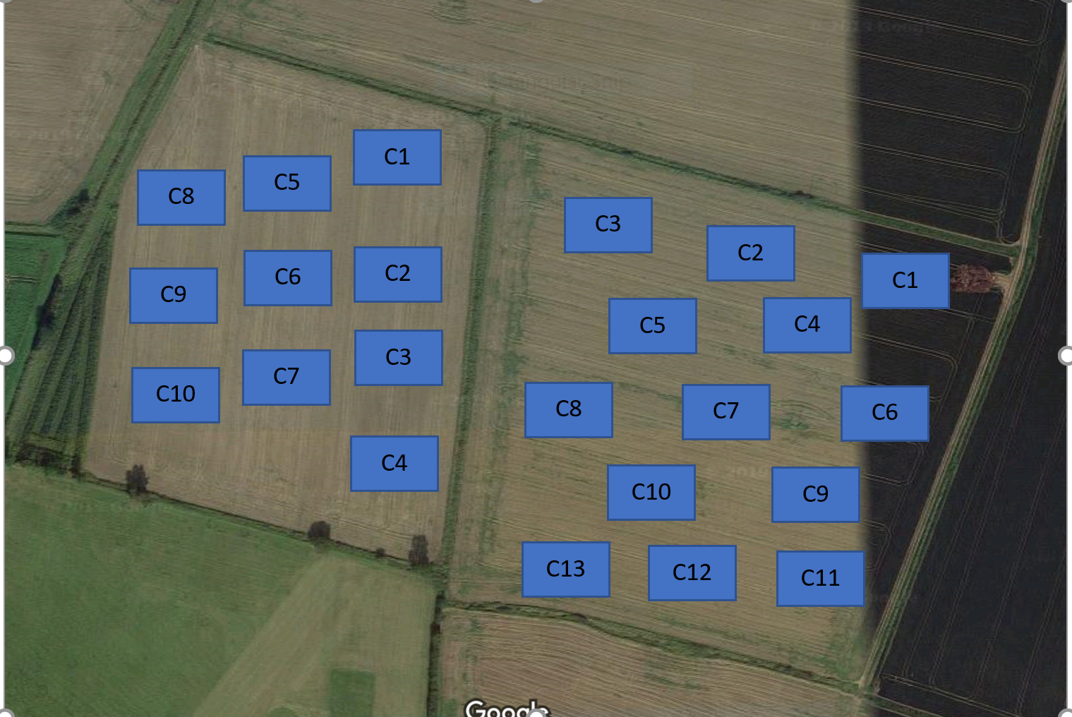

Sampling areas in Middle track (right) and Landing Strip (left)

Mean and CV% values for environmental and crop measurements made at the two fields.

 |  | Middle track |  |  | Landing strip
 |  | Mean | CV% |  | Mean | CV%
1 | Clay % | 7 | 4.9 |  | 9 | 12.8
2 | Sand % | 74 | 11.6 |  | 68 | 10.7
3 | Soil OM% | 3.5 | 14.2 |  | 3.2 | 15.6
4 | Soil pH | 7.2 | 4.6 |  | 7.1 | 5.7
5 | Soil CEC meq/100g | 17.3 | 12.3 |  | 20.4 | 22.7
6 | Soil moisture June % | 13.5 | 32.6 |  | 12.7 | 19.6
7 | Soil moisture July % | 11.3 | 18.3 |  | 17.1 | 22.6
8 | Soil moisture Aug % | 17.1 | 27.5 |  | 15.6 | 34.2
9 | Soil P mg/l | 15.8 | 45.2 |  | 14 | 32.5
10 | Soil K mg/l | 137 | 44.2 |  | 143 | 47.8
11 | Soil Mg mg/l | 58 | 32.1 |  | 43 | 66.2
12 | VESS assessment | 2 | 2.1 |  | 2 | 2.7
13 | Earthworms /pit | 8 | 46.1 |  | 11 | 77.2
14 | Soil respiration mg/kg | 135 | 86.2 |  | 126 | 65.3
15 | Weed density /m2 | >1 | 34.2 |  | >1 | 20.1
16 | Plant popN '000/ha | 92,500 | 13.2 |  | 96250 | 9.7
17 | Top fresh wt t/ha | 35 | 74 |  |  | 44.1
18 | Root yield t/ha | 111.2 | 15.3 |  | 105.3 | 36.8
19 | Sugar content % | 18.3 | 2.3 |  | 17.6 | 3.8
20 | Amino-N mg/100g | 25 | 6.3 |  | 36 | 18.5

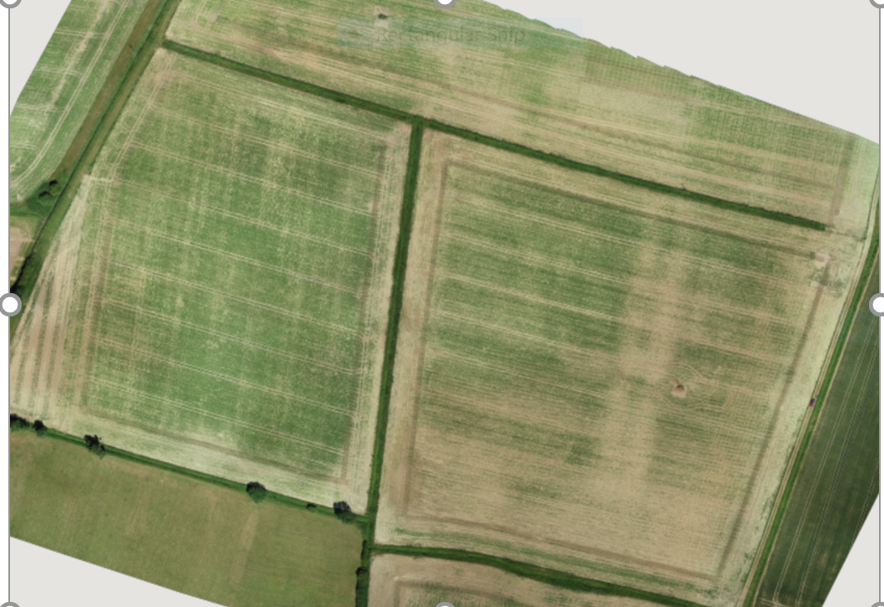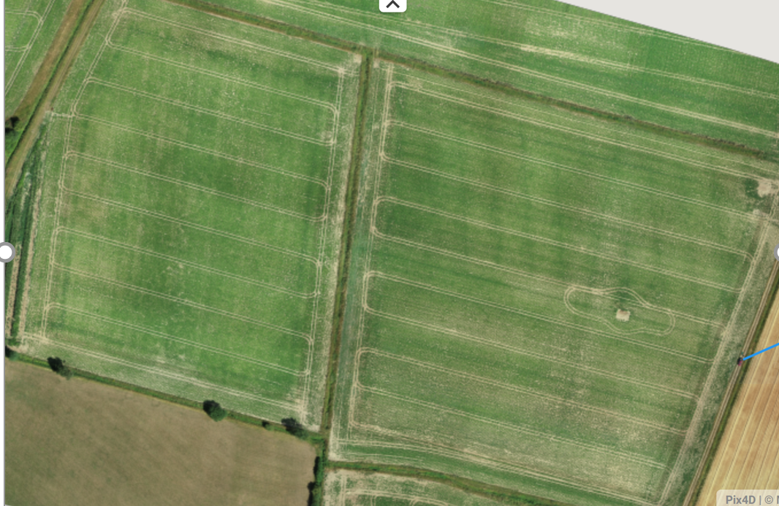

Aerial images of the two fields in June (left) and August (right) 2018

The considerable amount of data that has been collected on the two fields highlights the extent of variation in both environmental factors and crop performance and the challenges this presents to analysis and identifying key influencing factors. This is the first year of this project and the data will be used to inform both the data analysis process as well as future sampling protocols. It is anticipated that several years of data will be required to establish key correlations between crop yields and environmental factors. However, some key observational comments from the 2018 data set are as follows:

- Crop root yields varied considerably across both fields, ranging from 65t/ha to 122 t/ha.
- Top fresh weights varied across the two fields with a range of 26-57t/ha. Canopy assessments and the remote imagery also demonstrated the variance in crop canopy development, identifying both patches within field and clear geometric effects on canopy growth. Both establishment and canopy development rates varied considerably across the field.
- As the season progressed, some of the earlier variance in canopy developed was less visible and canopy development, especially from September onwards (post-drought) remained good and uniform through to harvests
- Sugar percent was more consistent (17.7-18.7) across both fields but top fresh weights varied
- Plant establishment was on average below the optimum of 100,000 plants/ha and again varied considerably across the two fields (range 88,600 -97, 400 plants per ha) It is anticipated that further analysis will link this to areas of lower yields within the fields
- Many of the measured environmental were found to have a large associated CV% and require further data processing and statistical analysis before examining relationships with crop performance.
- The very dry conditions were reflected in some low soil moisture levels. In general, the VESS assessments showed that soil structure was good across both fields.

Short summary of key objectives
- To investigate spatial variability of sugar beet yield and quality within fields and their correlation with key environmental variables. The study commenced with two sugar beet fields in in 2018. Preliminary soil analysis of a further two fields of winter wheat due for sugar beet in 2019 was also undertaken.

- To follow yield performance of a set of fields across rotations, to identify those environmental variables that may influence across the rotation.

- To assess how remote sensing can be used to identify intra-field variation and help to understand underlying factors.

- To identify potential factors that can be manged at a more precise level within field

Insert picture/graph | Insert picture/graph
Outcomes/Key messages for growers and industry
- This project is reporting on the first year of a long-term monitoring project which aims to explore intra-field variations in crop performance. Two fields were assessed in 2018, highlighting considerable variance in plant population and yield (65-122t/ha) within both fields
- Measurement of a range of environmental variables also highlighted how variable these were. This reinforced the need for greater data sets and statistical analysis to draw conclusions about how these relate to crop performance.
- The dry conditions in 2018 clearly affected plant establishment and early canopy development but late season canopy development following the rain resulted in good yields.
- A greater focus on measuring seedbed conditions in relation to environmental variables is likely to highlight key relationships but it is anticipated that improving moisture retentive properties will be a key area to reducing intra-field variance.

Section 1: To be completed by Project Lead:
Other project objectives (not listed on previous page)

Milestones for current period
Note: mentors will be asked to comment on the status of this project (yellow column) using the scoring system in section 2.

Summary of results (including figures and tables)
For Project Annual Report: please provide a 2 page summary of key findings from the reporting year.
For Project Final Report: please provide a summary of project findings and outcomes with relevant supporting data.
Annual report: Key issues to be addressed next year:

Publication of results to date/planned publications:

Section 2: To be completed by project mentor
Status - Mentor’s scoring system for interim reports.
Red | “Major concern - escalate to the next level"  Slippage greater than 10% of remaining time or budget, or quality severely compromised. Corrective Action not in place, or not effective. Unlikely to deliver on time to budget or quality requirements.
Amber | "Minor concern – being actively managed”  Slippage less than 10% of remaining time or budget, or quality impact is minor. Remedial plan in place
Green | "Normal level of attention"  No material slippage. No additional attention needed
Milestone | Comments + action required | Status  R/A/G
Is the project on track to meet the stated objectives? (please comment in relation to milestones and the status score awarded in section 1).

Are conclusions scientifically robust? (please comment on data analysis/interpretation)
For final reports only:
How would you rate the project against the following criteria (please give a score out of 10, with 10 being highest)
1 ) The project met its original objectives:

2) Contribution to scientific knowledge:

3) Direct relevance to growers:

