BBRO PROJECT REPORT FORM
Please note the details on page 2 will be used to formulate the BBRO printed Annual Report.
Project Title:
INSPIRE Project (Interpreting spatial heterogeneity in relation to the environment)

BBRO project no: | Project funded by TMAF (No BBRO funding)
Project sponsor: | Dr Simon Bowen
Interim report / Final report (delete as appropriate)

Project lead or student name: | Dr Simon Bowen
Project mentor or supervisors: | N/A
Report Date:
Reporting period covered:  (e.g. 1/1/16 - 31/12/16) | 2018-20
Timeline (e.g. Year 1 of 4) | 2/5 year rotational project
BBRO use only | Date assessed:
Assessors comments
Action required

Project summary for BBRO Publication (no more than 300 words)
The intra-field variation in sugar beet crop development and yield was measured and correlations with a suite of soil properties was examined. The potential basis for precision management of soils to improve lower yielding areas of fields is discussed.

Analysis of sugar beet crop development and yield in relationship to the suite of measured soil properties has indicated the following:

- The average difference between the highest and the lowest measured sugar beet yields in all four fields were 41.3t/ha. This represented a within field yield variance +/- 40%.

- Within-field yield was positively correlated with plant population and soil properties including soil organic matter content, microbial activity, and soil water content (June measurements). This indicates that the soil moisture properties and biological activity of the soil are key driver of yield variation within fields. Whilst the relationship between soil type, soil moisture and plant establishment is expected, the relationship with biological properties is novel and much less well understood.

- There were negative correlations with clay content, phosphorous (low) pH (low) and higher weed density. Clay content will influence seedbed soil particle size and moisture properties and therefore germination and establishment. Seedbed quality is key to achieving good plant populations. Low pH and soil phosphorus levels has also been linked to poor plant establishment.

- The Solvita test provides a measure of C0₂ released by soil microbial activity and therefore soil biological function. Applying this at the intra field level is a novel approach. Solvita results were found to be correlated with higher yields both within fields and between fields.

- Benchmarking of VESS assessment and earthworm against other soil health scorecards indicated that values were good. Values were relatively uniform across the sampling points.

- A mobile phone app (Canopeo) and drone-based aerial imagery to generate RGB, NDVI & NRDE values were used to assess variation in canopy development. An analysis of the top fresh weights of plants in mid-November showed considerable variation across fields with a range of 26-57t/ha (fresh weight) Carbon sequestration by the tops and net carbon return to the soil (after losses due to microbial decomposition) is being evaluated.

- Areas of wilting were not strongly associated with any measured properties and results show that canopy growth was weakly correlated with within field variations in yield.

Short summary of key objectives
- The project is investigating the spatial variability of sugar beet yield within fields and to establish any correlation with key soil properties. It is anticipated that this may provide a potential basis for more precision management of the soil. The study commenced with two sugar beet fields in 2018 and a further two field sugar beet fields were introduced in 2019. The project was planned to initially cover a period of 5 years.

- Between 8 and 13 geo-referenced sampling points (not including headlands) were established in each field (each representing approximately 0.5 ha block) A suite of 15 soil chemical, structural and biological measurements were made within a 5m radius of each sampling point.

- Sugar beet crop performance was assessed using a range of methods including aerial imagery and novel soil & crop assessment techniques. Yields were measured by undertaking three replicate test-digs at each sampling point.

Insert picture/graph  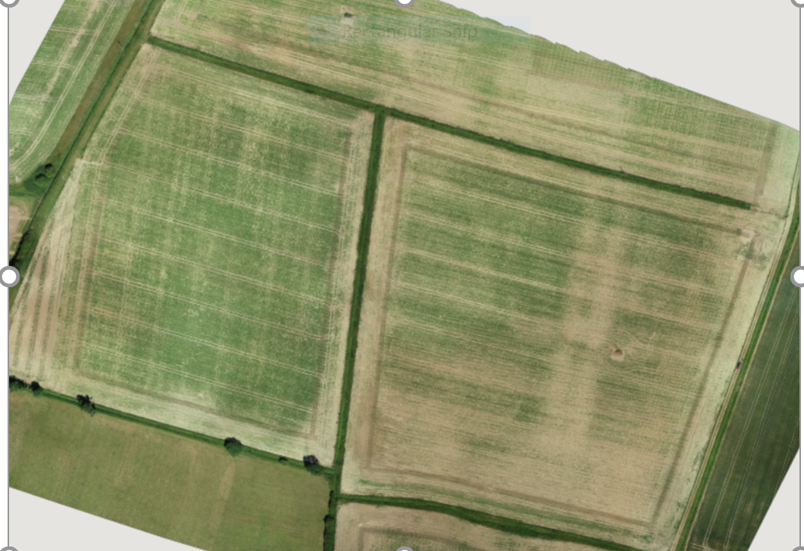  Use of drone imagery to assess intre-field variation | Insert picture/graph  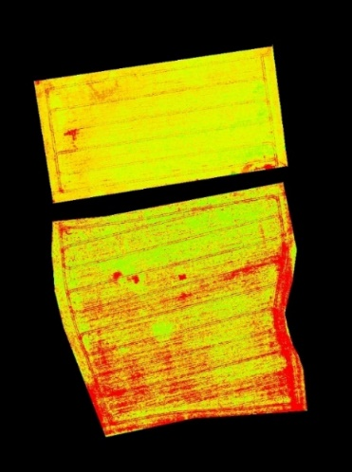  Use of vegetation indexes to assess intra-field variation
Outcomes/Key messages for growers and industry
- Intra-field in sugar beet yield is considerable. Variation in yields of +/- 40% were recorded within the four study fields.
- Soil moisture properties and biological activity levels of the soil have been initially identified as key drivers of yield variation within fields
- Precision management of soil biological activity using tools such as organic manures, cover crop species & tillage is worthy of further consideration.

- Plant population is a key driver of component of yielding areas of fields. The clay content of soil has been shown influence seedbed soil particle size and moisture properties and therefore germination and establishment, indicating precision cultivation and/or drilling approach are worth investigating.

- Assessments of canopy growth were weakly associated with yields and therefore of limited value in explaining intra-field yield variation. Quantitative assessment of plant population via aerial imagery is considered to be more relevant, but techniques are still being developed. Sugar beet vegetative growth patterns exhibits strong compensatory and autumn canopy growth potential which can mask early season impacts of poor plant population and drought.

Section 1: To be completed by Project Lead:
Other project objectives (not listed on previous page)

N/A

Milestones for current period
Note: mentors will be asked to comment on the status of this project (yellow column) using the scoring system in section 2.

N/A

Summary of results (including figures and tables)
For Project Annual Report: please provide a 2 page summary of key findings from the reporting year.
For Project Final Report: please provide a summary of project findings and outcomes with relevant supporting data.
N/A

Annual report: Key issues to be addressed next year:

N/A

Publication of results to date/planned publications:

Section 2: To be completed by project mentor
Status - Mentor’s scoring system for interim reports.
Red | “Major concern - escalate to the next level"  Slippage greater than 10% of remaining time or budget, or quality severely compromised. Corrective Action not in place, or not effective. Unlikely to deliver on time to budget or quality requirements.
Amber | "Minor concern – being actively managed”  Slippage less than 10% of remaining time or budget, or quality impact is minor. Remedial plan in place
Green | "Normal level of attention"  No material slippage. No additional attention needed
Milestone | Comments + action required | Status  R/A/G
Is the project on track to meet the stated objectives? (please comment in relation to milestones and the status score awarded in section 1).

Are conclusions scientifically robust? (please comment on data analysis/interpretation)
For final reports only:
How would you rate the project against the following criteria (please give a score out of 10, with 10 being highest)
1 ) The project met its original objectives:

2) Contribution to scientific knowledge:

3) Direct relevance to growers:

