Issued: 1st June 2022
- Aphid numbers remain high in a range of non-Cruiser treated crops BUT we are now beginning to see numbers build in some Cruiser-treated crops too.

- The persistence of foliar insecticides has varied due to a range of factors (size of crop, weather) and subsequent applications have been made where thresholds have been exceeded again. Check crops within a week of any application to ensure effective, efficient use of foliar insecticides.

- Crops are developing canopies quickly, but there is a range of growth stages depending on soil type and rainfall. More advanced crops are now at the 16-leaf stage plus and are beginning to meet across rows, but later drilled crops and/or those in dry soils are at the 6-8-leaf stage.

- Multi-crowning has been seen in crops, especially where early pest and bird feeding may have damaged the growing point. Crops will appear more ‘bushy’ but will continue to develop and produce a root. Symptoms of leaf discolouration, twisting and fusing are also reported and may be due to herbicides. In most cases, plants will grow away from such symptoms.

- As crops grow rapidly, don’t miss the opportunity to apply foliar nutrients to support leaf growth and progress to the 12-leaf stage. Apply manganese and magnesium as a priority from the 6-leaf stage onwards.

Aphid update
Aphid numbers are now building in some Cruiser treated crops, especially in crops that have been in the ground for more than 8-10 weeks. Actual aphid numbers vary considerably from field to field and from day to day. This will be influenced by variable weather conditions especially wind direction and strength. The number of beneficiaries such as ladybirds are also increasing in response to the higher aphid numbers. It is important to make decisions based on regular assessment of aphid numbers to ensure foliar insecticides are used most effectively. Remember, that at the 12-leaf stage, plants begin to become more resistant to the virus, but this is a gradual process up to about 16-18 leaves. The aphid threshold for triggering foliar insecticide application depends on the number of leaves. Where this is variable, use the lower estimate of growth stage in crops:
Up to 12 leaves – 1 green wingless aphid per 4 plants
More than 12 leaves – 1 green wingless aphid per plant
In some crops, particularly with small plants present, the persistence of foliar insecticides has been relatively shorter than anticipated and subsequent applications have been made where thresholds have been exceeded again. Check crops within a week of any application.
Check the aphid survey data and aphid distribution map on BBROPlus regularly for the latest update (https://plus.bbro.co.uk/on-farm/member-area/). Use this as a guide only and not a substitute for checking your own individual crops. Information is updated regularly throughout the week as data is collected. If the sites are grey (no data) it may be worth checking the previous week using the green arrows above the map or checking again later as the maps are regularly updated as information is received from the field.
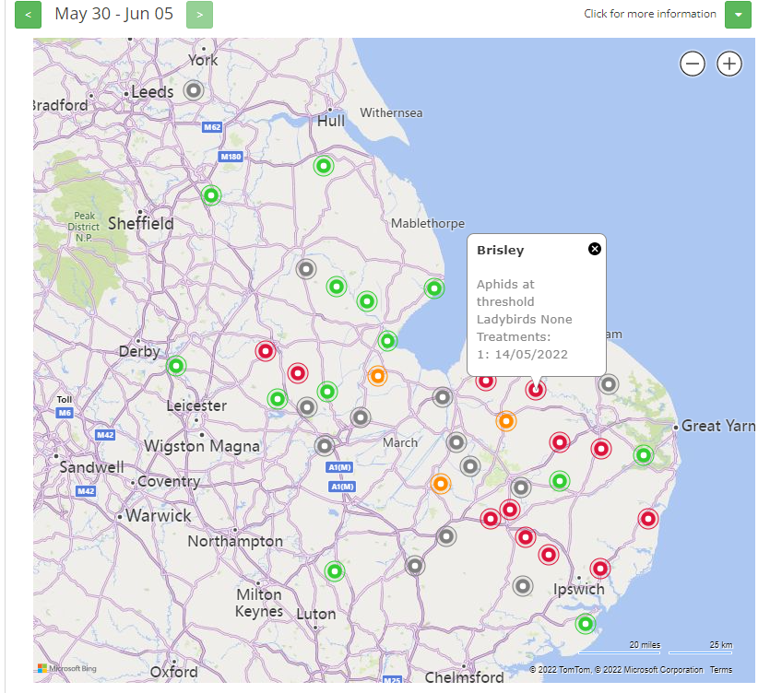
Fig 1: Aphid map as of 31st May 2022
For non-Cruiser treated crops, three sprays are now approved: flonicamid (Teppeki or Afinto) acetamiprid (Insyst) applied in any order and spirotetramat (Movento) as a third spray.
On Cruiser-treated crops you must start with flonicamid (Teppeki or Afinto). Only one spray of Teppeki or Afinto is permissible, not of one of each. If threshold is breached again a second spray is permissible but this must be acetamiprid (Insyst).
Do not reduce rates and ensure water volumes of foliar sprays follow the label recommendation to ensure good canopy cover and penetration, especially as canopies increase in size.
Herbicides – rain has activated many residual herbicides and they should now be providing good weed control. Where larger broad-leaved weeds and grass weeds have established these may need further treatment. Target post-emergence black-grass control at small plants (1-3 leaf stage). Control is reduced once black-grass plants have begun to tiller. Clethodim can provide useful control of black-grass.
Tank mixing - caution should be taken if considering tank mixing herbicides and foliar insecticides. BBRO generally advise against tank mixing foliar insecticides and herbicides as it is quite likely the efficacy of one or both partners will be compromised by not applying at the right time or conditions. Do not compromise on water volumes as these may be different and check on the compatibility of different partner products. Tank mixing of foliar insecticides and foliar nutrients is generally less problematic but always check compatibility of individual products.
Nutrition - Most plants are now ready for their first manganese and magnesium applications. Where plants are only growing slowly, and leaves are still small, these are best left longer to develop greater leaf area for foliar uptake. Leaf uptake can be highly effective, but it does depend on growing and weather conditions. Aim to apply to actively growing (not droughted) plants when temperatures are <20ºC and the humidity is high. Avoid hot, full sunlight conditions.
Managnese is key to supporting rapid leaf growth. Target a minimum of 1-2 applications during rapid canopy growth, repeating at 7-14 days. Target 1 kg of Mn/ha in normal growing conditions and 2 kg Mn/ha where there is a higher likelihood of deficiency, such as rapidly growing crops (all soil types) and/or organic and sandy soils, high pH, after liming and fluffy seedbeds. Remember symptoms can be transient depending on the growing conditions but don’t wait for severe symptoms to develop before applying. Magnesium is also key to supporting canopy growth and chloropyll production. Apply with managanese at similar rates.
Crops on dry, light or thin soils, or in low organic matter, may also benefit from foliar sulphur if not applied in the base dressing. Foliar boron may also be an option on light, low organic matter/calcareous soils and especially where the soil remains dry.
Multi-crowning - Reports of multi-crowing in crops are likely to be associated with earlier pest damage (such as flea beetle or thrips) or bird feeding which damaged the growing point on the plant. This stimulates lateral growing points to produce many leaves. This may be more common in non-Cruiser treated crops. As the photo from 2020 shows, plants tend to have a bushy appearance but do go on to form normal roots.
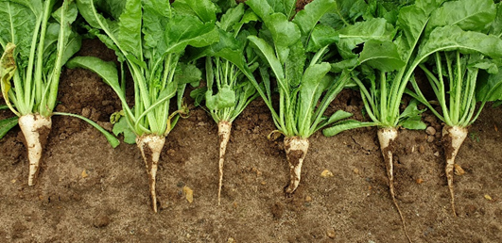
Fig 2: Multi- crowning seen in many crops.

Next event: BBRO will be attending the Morley Open Day 16th June https://tmaf.co.uk/morley-innovation-day-2022/

British Beet Research Organisation, Centrum, Norwich Research Park, Colney Lane, Norwich, NR4 7G
Prof Mark Stevens mark.stevens@bbro.co.uk 07712 822194
Dr Simon Bowen simon.bowen@bbro.co.uk 07718 422717
Stephen Aldis stephen.aldis@bbro.co.uk 07867 141705
General Enquiries info@bbro.co.uk

Two BASIS points in total (not per bulletin) have been allocated for the period between 01/06/21 and 31/05/22 reference CP/111958/2122/g. To claim these points please email cpd@basis-reg.co.uk
Two NRoSO points in total (not per bulletin) have been allocated between 01/06/2021 and 31/05/2022 reference NO469403f. To claim these points please email NRoSOCPD@cityandguilds.com

