**BBRO 10/04: Seed rates and optimal spatial arrangement of seeds for maximum yield and profitability.**

**By**

**E Burks, C Walters & G Milford**

Final Report

May 2011

**BBRO 10/04: Seed rates and optimal spatial arrangement of seeds for maximum yield and profitability**.

**Executive Summary**

1. An experiment was done in collaboration with a grower farming a Bunter sandstone soil in Nottinghamshire that yields only 50 t/ha when sugar beet is grown conventionally but is capable of producing over 100 t/ha of other root vegetable grown on beds.
2. The experiment compared the factorial combinations of beet grown at target populations of 90 or 140 thousand plants/ha on vegetable beds or conventional 50-cm rows.
3. Beet grown on the bed system yielded around 90 t/ha of adjusted clean beet at both plant population densities, almost 20% more than a conventional crop grown with 90,000 plants/ha on 50-cm rows. Increasing the number of plants on 50-cm rows to 140,000 plants/ha increased the yield to 95 t/ha suggesting that sugar-beet crops grown on the some light, relatively infertile soils may benefit from higher than currently-recommended plant population densities.
4. An analysis of British Sugar field survey data suggests that, whereas the currently-recommended plant population targets of 80 – 100,000 plants/ha may be appropriate for the majority of sand, loamy sand, and sandy and clay loam soils, they may not be sufficient on some of the more fertile silt and peat soils whose yields appear to continue to increase at plant populations up to 120 or 140,000/ha.
5. The finding that sugar-beet yields on certain soils, particularly some fertile silts, may benefit from higher than the currently-recommended plant population densities merits further study.

**BBRO 10/04: Seed rates and optimal spatial arrangement of seeds for maximum yield and profitability**.

**Introduction**

Recent BBRO-funded work re-examined the yield responses of sugar beet to plant population density in a small series of experiments on a restricted number of soils in which plant populations ranged from 40-170,000 plants/ha and yields from 40 to 90 adjusted t beet/ha[1]. The study confirmed the optimum plant population range required to achieve maximum yield in most situations to be 80-100,000 plants/ha. In a few experiments on sand and loamy sand soils, however, the largest yields were obtained with plant populations well above 100,000/ha, partly through increased plant numbers and partly because of fewer root-breakage losses during harvesting. Approximately 10% of UK sugar-beet is grown on such soils.

Some growers on particularly light soils who only achieve low yields with recommended plant populations on conventional 50-cm rows yet over 100 t/ha of root vegetables such as carrots and parsnips grown using bed system having much greater numbers of closer spaced plants, have circumstantial evidence that such bed systems may also improve their yields of sugar beet[2]. This was examined, in a collaborative experiment with a grower who had developed suitable drilling and harvesting systems for growing sugar beet in beds. The experiment was specifically designed to examine how far any extra yield from the bed system was due to a higher population of spatially-optimised plants, to a larger proportion of the crop being grown within a traffic-free growing medium, or to smaller harvesting losses.

**The experiment**

The experiment, done on a droughty Bunter sandstone soil at Clumber, Nottinghamshire in 2010, compared the productivity of sugar-beet crops grown on conventional 50-cm rows and on a vegetable-bed system. The beds contained five rows of beet spaced 24 cm apart on 1.2 m wide beds separated by 50-cm wheelings (Fig. 1*a*) with seed spaced 24 cm apart within the central three rows and 14 cm apart within the two outer rows (Fig. 1*b*). Each 5-m wide experimental plot on the bed system consisted of three such beds. They were compared with beet grown in 6-m wide plots on conventional 50-cm rows. The two factorially complementary treatments of 90,000 plants/ha on the beds and 140,000 plants/ha on the rows were included to test the extent to which yields were determined by plant numbers or the growing system. The experiment was laid out as a strip trial for ease of operation and management on a semi-commercial scale, with each strip divided into four replicate areas. The beds were drilled by the grower using his specially-constructed 5-m wide drill that drilled three beds at a time, and the row plots by British Sugar staff using a conventional drill.

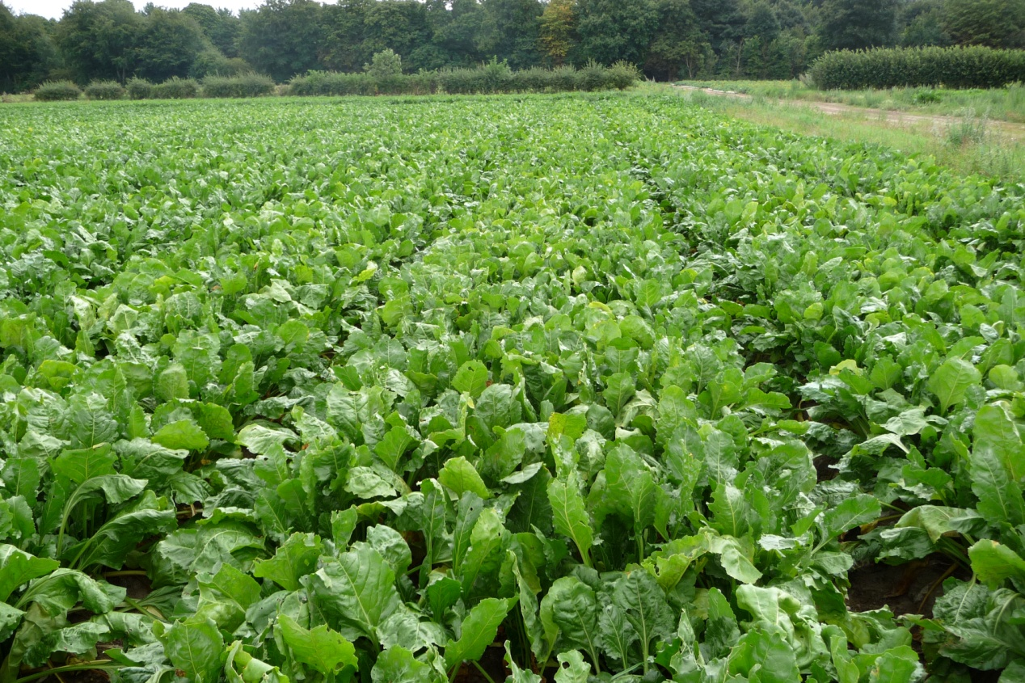

**(a)**

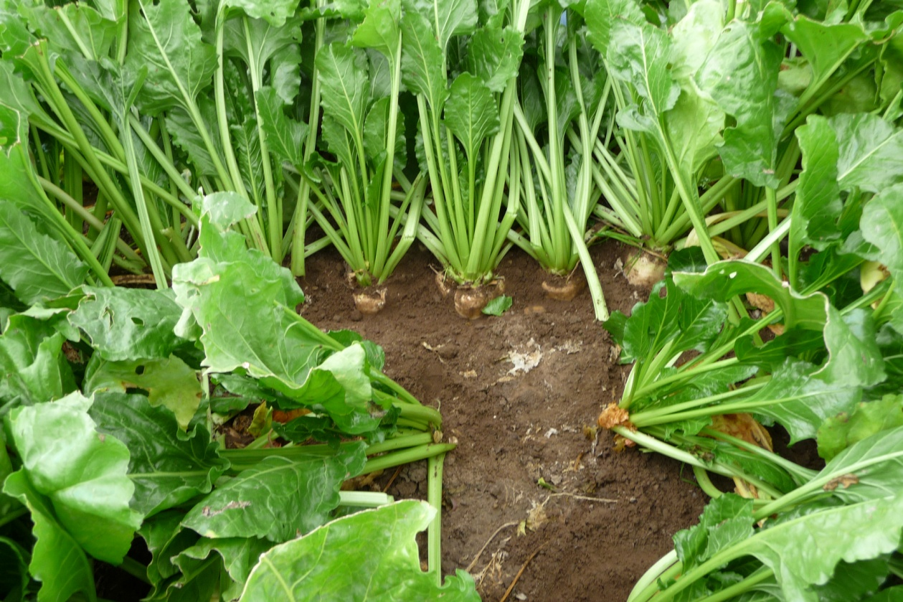

**(b)**

Fig. 1. *(a) General view of the bed system used to grow sugar-beet and (b) close-up view of plant spacing within the outer and inner rows.*

At harvest, a 10-m length of the central bed each plot in the bed-system was lifted using a modified potato harvester with attached shares, and a 10-m length was lifted from the three central rows of each row plot with a Garford 3-row plot harvester. The beet were lifted into pre-weighed trailers to obtain a dirty yield and samples taken for dirt, crown and beet quality measurements in the Wissington factory tarehouse; surface losses were also collected and weighed. The experiment received 40 mm of irrigation during its early growth.

**Results and Discussion**

The different drilling technologies used in two growing systems produced different plant population densities - the beds contained 94,000 and 133,000 plants/ha and the conventional 50-cm row plots 106,000 and 157,000/ha. To allow the relative effects of the different growing systems and plant populations to be meaningfully compared the yields were standardised to 90,000 and 140,000 plants/ha using the individual beet weight/ plant population relationship shown in Fig. 2, which was derived from the actual experimental data.

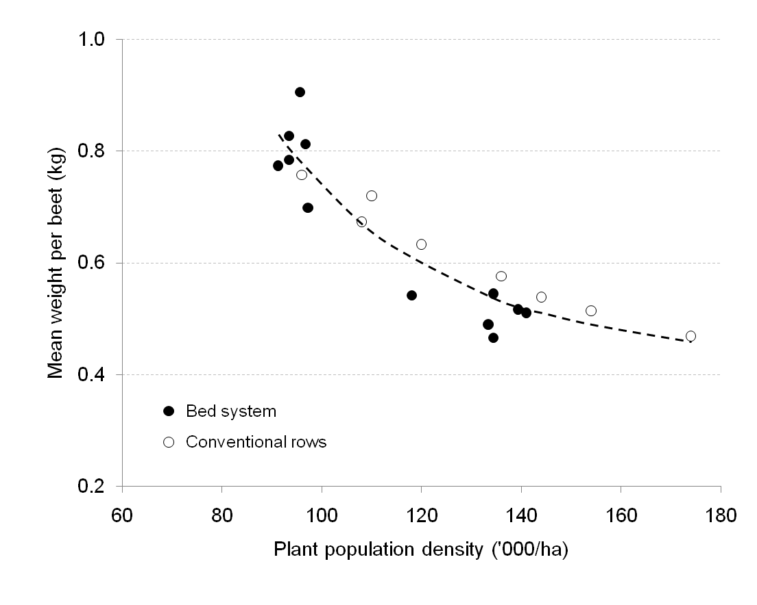

Fig. 2. *Relationship between the mean weight of individual beets and plant number used to standardise yields for differences in plant population density.*

The beds with 140,000 plants/ha yielded 90.7 t/ha of adjusted clean beet, This was similar to the 93.2 t/ha produced by beet grown on beds only 90,000 plants/ha but considerably more than the 79.7 t/ha produced by the standard agronomy of 90,000 plants/ha on conventional 50-cm rows previously used by the grower. However, the conventional row system with 140,000 plants/ha yielded 95.1 t/ha, *i.e.* 20% more than with the population of 90,000 plants/ha that would normally be recommended for the 50-cm row system, and 5% more than on beds containing 140,000 plants/ha (Fig. 3).

As in earlier plant population experiments, there was a general tendency for sugar concentration to increase and for sodium, potassium and amino N impurity concentrations to decrease with increased population density, although these trends were seldom significant. Surface harvesting losses were also larger at high plant populations - especially on the beds (Appendix Table 1).

Fig. 3. *The effect of plant population density on the adjusted yield of clean beet in the two growing systems.*

The 2010 experiment therefore:

1. confirmed the grower’s past, but not experimentally verified, experience that higher sugar-beet yields could be achieved on his droughty Bunter sandstone soil using a bed system containing 140,000 plants/ha than with the conventional agronomic practice of establishing 90,000 plants/ha on 50-cm rows;
2. showed that an equally yield could be produced on the bed system with 90,000 plants/ha as with 140,000 plants/ha, suggesting that savings could be made on the cost of seed; and
3. showed that, on this light, relatively-infertile soil, more than the recommended population of 80 - 100,000 plants/ha were needed to obtain maximum yield on 50-cm rows.

**Optimal plant population densities for different soil types**

French sugar-beet growers are the most productive Europe, achieving national average yields of 90-100 t/ha, and many on the fertile soils of the Paris basin, consistently achieve yields of 100-120 t/ha. UK study tours have frequently been remarked upon the agronomy practices underpinning these greater yields. Some of the main differences being a widespread use of irrigation, and much greater plant populations (110-120 thousand/ha) to which more nitrogen (150 kg/ha) is applied.

This led us to interrogate British Sugar’s field-survey database for evidence that larger sugar-beet yields might be achieved on some of the UK’s more fertile soils with higher than recommended plant populations.

Figure 4 shows the mean yields of adjusted clean achieved with incrementing deciles of plant population on each of the five major soil categories. The asymptotes of the yield curves of the sand, loamy sand, and sandy and clay loam soils confirm that the recommendation of 80 - 100,000/ha is generally appropriate for these soils (Figs 3*a*. 3*b* and 3*c*). On the other hand, yields continued to increase with plant populations rising to 120 to 140,000/ha on the silt and peat/organic soils, indicating that it could be profitable to aim for more than the currently-recommended number of plants on the more fertile of these soils (Figs 3*d*, 3*e*).

In most crops, the benefits of optimal plant populations would be expected to come from improved early leaf cover and radiation interception. But this is less likely in the crops grown on fertile silt and organic soils which tend to produce much larger, lusher leaf canopies. The benefits of greater plant numbers on these soils are more likely that come from changes in the proportions of crop dry matter partitioned to shoots and roots, and root dry matter to sugar - both of which are changed by an increased plant density. The comparison in an early BBRO study of crop productivity on a Broom’s Barn sandy loam and a fen peat at Ramsey provides a good illustration of this. Both crops produced close to 22 t of dry matter/ha but the more luxurious shoot growth and lower sugar concentration fen crop resulted in it yielding only 11 t sugar/ha compared to 15 t/ha at Broom’s Barn. Use of a higher plant population at the fen site to promote more a favourable distribution of dry matter might well have narrowed the difference in sugar yield.

This analysis of UK survey data and French experience suggest that optimal plant population densities for the more fertile silt and peat/organic soils would merit further consideration.

Fig. 4. *Relationships between the mean yields and plant population densities for different soil types derived from British Sugar field survey data.*

.



1. **BBRO Project 06/05:** ‘Seed rates for the new sugar regime’
2. **Limb R (2009**) Plant populations – time for a new perspective. *British Sugar Beet Review* **77** (2), 4-8.