**BBRO 09/22: Varietal differences in crown size and greater recovery of crown material at harvest**

**By**

**E Burks, C Walters & G Milford**

**Final Report: May 2011**

**Executive Summary**

1. Experiments were done on a sandy clay loam at Hibaldstow and a fen peat soil at Holme Fen in 2009 and 2010 to compare the yield and quality beet crops that were either conventionally-harvested or merely flailed to recover the whole of the crown.
2. Whole-crown recovery increased adjusted clean beet yields by 5% in the small-crowned variety Opta to over 10% in the larger crowned varieties, Dominika and Sophia. The gains were larger on the fertile fen peat soil where condition favoured greater shoot growth than at Hibaldstow, but not greatly affected by plant population or irregular spacing.
3. The gains in yield were achieved at little cost to beet quality.
4. Beet loads produced by flail-only harvesting did not contain unacceptable amounts of green material that would risk rejection at the factory.

**BBRO 09/22: Varietal differences in crown size and greater recovery of crown material at harvest**

**Final report**

**Introduction**

The UK sugar-beet industry has largely achieved its objective of increasing national average yields to 70 t/ha. The opportunities offered by recovering and processing the whole of the crown material are being explored to improve yields even further. Crowns contain significant amounts of sugar, but at low concentration and accompanied by high concentrations of impurities which have, in the past, impaired the extraction and crystallisation of sugar. Improved factory technologies and new opportunities for by-products now make the recovery of crown sugar a more attractive proposition.

Conventional harvesters generally operate a two-stage process for topping beet – using a forward-mounted flail to remove the bulk of the green top followed by scalper knife that removes the uppermost quarter to a third of the biological crown. This crown material is left in the field and does not contribute to recovered yield. Improved flail-only topping systems that remove only the leaves and petioles and so allow more of the crown material to be recovered are being tested on the continent and in the USA.

This project examined:

1. How much extra yield can be obtained by flail-only harvesting systems;
2. How far these yield gains are affected by varietal differences in crown size;
3. Whether flail-only systems allow more yield to be recovered from widely or irregularly spaced crops and whether they can cope with large, lush leaf canopies;
4. The effect of the extra crown material on the overall quality of the beet.

**The experiments**

Two experiments were done each year in 2009 and two in 2010, one on a sandy clay loam soil at Hibaldstow and other on a peat soil at Holme Fen. Each experiment compared the effectiveness of a flail-only harvesting system versus a conventional comb & scalper system on a small and a large-crowned variety grown at different seed spacings and regularity within the row.

The trials were laid out in randomised strips rather than small plots to simulate the commercial situation. Each experiment had a four-replicate, split plot design that factorially compared small- and large-crowned varieties grown at uniform densities of approximately 80 or 120 thousand plants/ha (*i.e.* at 17.0 and 12.5 cm spacing on 50 cm rows), or at a low, irregular density produced by substituting 25% of the seed at 80,000 plants/ha with blank pellets. Opta was grown as the small-crowned variety in both years and Dominika as the larger-crowned variety in 2009 and Sophia in 2010. The experiments at Hibaldstow were drilled on 25 March and 12 April, respectively in 2009 and 2010, and those at Holme Fen and on 29 March and 14 April. The respective harvest dates were 5 November, 4 November, 7 December and 26 November.

The variety x plant population density treatments were allocated to the main plots. These were 50-m long and six rows wide, and were sub-divided into two 3-row sub-plots at harvest, one of which was lifted using only front-mounted, metal turbine flails and the other using the conventional system of the same flails followed by a comb and scalper topping mechanism. Each sub-plot was lifted into a pre-weighed trailer which was then reweighed on electronic weighing cells to measure the yield of dirty beet. Two, standard factory-tarehouse bucket samples each containing *ca* 15 kg of beet were randomly dropped from the harvester in each sub-plot and collected for analysis at the Wissington factory. One sample was passed down a conventional tarehouse line in which the dirty and clean weights, crown tares and the sugar and impurity contents of the contractually-crowned beet were measured. The second was passed, uncrowned, down a separate line where the corresponding data were obtained for the whole of the lifted beet (*i.e.* root plus crown). Additional brei samples were taken from both lines and frozen for invert sugar analysis in British Sugar’s OSS laboratory. The data were analysed by ANOVA using the Genstat statistical program.

The results of the individual experiments are given in Appendix Tables I and II. The responses to the different topping and crowning systems were similar, in relative terms, in all four experiments, so the datasets were combined into an overall statistical analysis that included sites and seasons as additional factors. This is summarised in Table I. The report concentrates on the extra yield gained from the flail-only approach - which essentially delivers the whole of the crown - compared to the conventional comb and scalper harvesting system which, depending on how it is set up, delivers a variable fraction of the crown material.

***Yield and beet quality***

The mean yield of uncrowned, adjusted clean beet obtained using a flail-only approach (averaged over all varieties, spacings, sites and seasons) was about 8% larger than that obtained by conventional harvesting (*i.e.* 89.3 *cf.* 82.6 t/ha, LSD = 2.5 t/ha; Fig. 1). The main agronomic factors that affected the size of the yield gain



were varietal differences in biological crown size and soil fertility. The larger-crowned varieties, Dominika and Sophia, for instance, yielded 12% more adjusted clean beet using the flail-only as opposed to the conventional system, whereas the small-crowned variety, Opta yielded only 5% more. Similarly, the flail-only approach yielded 10% more adjusted clean beet than the conventional system on the nitrogen-rich fen peat soil at Holme Fen compared to only 7% on the sandy clay loam at Hibaldstow (Fig. 1*a*).

On the other hand, there was only a small difference in the percentage of extra yield gained from the flail-only system in the two growing seasons (8-9%) despite very large differences in absolute yield (86 t/ha in 2009 *cf.* 69 t/ha in 2010), and the gains were not greatly affected by changes in plant population density introduced by decreasing seed spacing within the row, and only slightly affected by the irregular spacings produced by the use of dead seed (Fig. 1*b*).

In most instances, the extra yield obtained from the recovery of more of the crown material was accompanied by a decrease in sugar percentage and an increase in total impurities (Table 1). These differences were, however, invariably small and not statistically significant. The overall concentrations of sugar in uncrowned beet, for example, averaged 18.43% in flailed beet compared to 18.48% in conventionally-harvested ones (LSD = 0.13), and those of total impurities were 3.290 and3.262 g/100g sugar, respectively (LSD = 0.131). Such small differences in beet quality are unlikely to greatly affect the processability of the beet.

***Recovered crown material***

Previous work[1] has shown that the principal factors that determine the amount of crown material present on delivered beet are the original size of the biological crown on the beet prior to harvest and the proportion that is removed and left in the field by the topping process. Biological crown size is primarily a varietal characteristic which is influenced, but not overridden, by agronomic factors and practices such soil fertility, the availability of nitrogen during early growth, and plant population density.

Fig. 1. *Gains in the average yields of adjusted clean beet from flail-only as compared to conventionally-harvested beet from (a) small- and large-crowned varieties on different soils at the two sites and (b) with different spatial arrangements and in the two growing seasons.*

Flailing removes only leaves and petiolar material from the shoot, leaving the crown more or less intact. The combined flail and topping mechanisms of conventional harvesters, on the other hand, remove both the foliage and part of the upper crown. Any gain in yield from uncrowned, flailed beet as opposed to uncrowned, conventionally-harvested beet therefore derives largely from differences in the biological crown sizes of the harvested beet. These biological crown sizes were not specifically measured in the present experiments, but were judged from the crown tares of the flailed beet. Depending on site and season, these ranged from 11 - 18% of the clean beet in Opta and from 15 - 25% in Dominika and Sophia (Appendix Tables I & II). They were generally larger in the lush crops grown on the nitrogen-rich, fen peat soil at Holme Fen than on the sandy clay loam at Hibaldstow, larger in 2010 than 2009, but slightly smaller in closely-spaced or irregular crops (Fig. 2). The differences in biological crown size can largely be attributed to enhanced shoot growth brought about by the crops having greater access to soil nitrogen and moisture during their early growth.

The flail-only harvesting system might be expected to produce loads containing unacceptable amounts of green material that risk rejection at the factory. There were no indications of this in the present experiments, even with the very lush leaf canopies of crops grown on fertile fen peat soils.

Fig. 2. *Differences in biological crown size due to variety, site, season and seed spacing.*

***Concluding remarks***

The general conclusion from these initial experiments is that a flail-only harvesting approach has the potential to deliver 5-10% extra adjusted clean beet yield over that delivered by conventional harvesting systems. Moreover, these significant gains in yield are achieved at little cost to beet quality. How much extra yield is obtained is largely determined by the initial biological size of the crown - this primarily being a varietal characteristic that may be enhanced by factors that favour shoot growth, principally the nitrogen and moisture status of the soil during early growth.

The yield gains in the present UK experiments were somewhat larger than the 2 - 5% increases obtained in recent German commercial trials reported by Wollenweber *et al*. (2010)[2], Wulkow *et al*. (2010)[3] and Hoffmann & Wulkow (2010)[4] and calculated from the data of Jaggard *et al.* (1999)[5]. Wulkow & Hoffmann (2010)[6] reported potential theoretical gains of 8-9% from studies on hand-harvested beets that are closer to those observed in our study. The commercial differences can be partly attributed to the different criteria used for topping beet in the two countries. The Germans consider the level of the lowest living leaf to be the optimal point of topping whereas, in the UK, beet may be topped anywhere between this point and that of lowest leaf scar - the contractual point for factory crowning - depending on how much crown tare UK growers wish to deliver. More of the crown will therefore be delivered by conventional harvesting systems in Germany than in the UK, and the potential gains from the flail-only as opposed to conventional harvesting would, conversely, normally be greater in the UK than Germany.

As would be expected, biological crown size was the main factor that influenced the yield gains obtained through flail-only harvesting. Crown size is a varietal characteristic and the most recent update of the biological crown size of the 58 varieties introduced onto the BBRO Recommended Lists since the early 1990s, shows that crown size, which ranges from 6% of the contractually-crowned root in varieties such as Alota, Saracen and Trinita to over 18% in Wildcat and Priscilla (Fig. 3) has, on average, tended to be smaller in more-recently introduced varieties (Fig. 4). If flail-only harvesting were to become more widely practiced the introduction of large-crowned varieties with their inherent yield advantage, may well reverse this trend - especially if the flail-only approach was also used to harvest BBRO Recommended List variety trials.

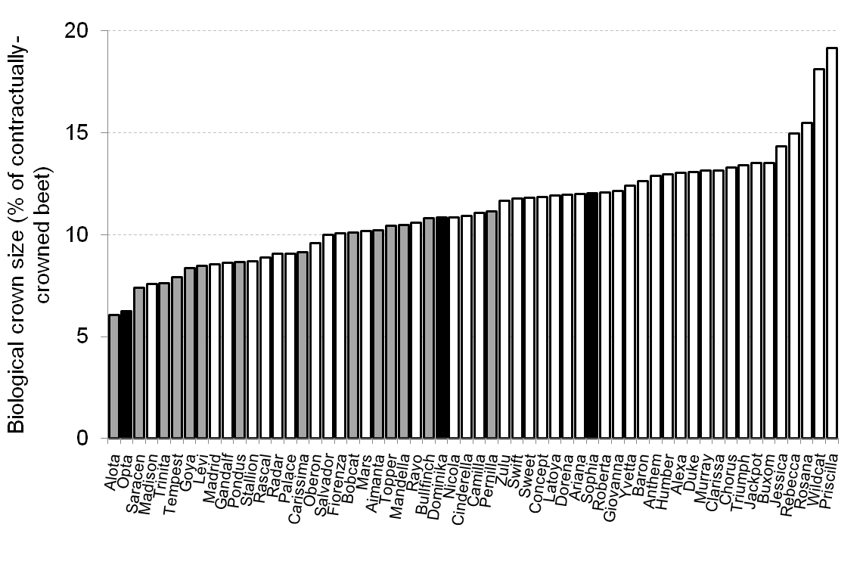

Fig. 3. *Biological crown sizes of the 58 varieties introduced onto BBRO Recommended Lists since the early 1990s.*

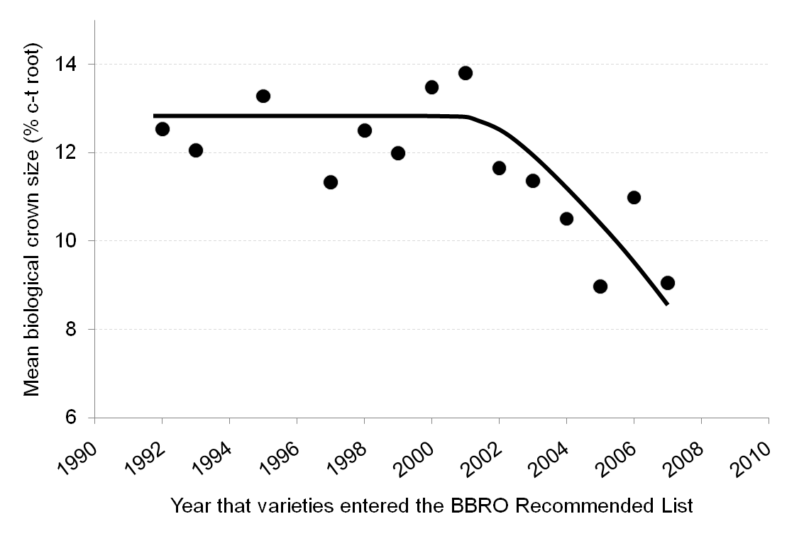

Fig. 4. *Trend in the mean biological crown size in sugar-beet varieties introduced since the early 1990s.*

These initial UK studies of flail-only harvesting were done using the conventional, metal turbine flails normally fitted to UK harvesters. Improved rubber flails that promise better performance - such as the Grimme system - are being developed and introduced and their practicality and benefits for full crown recovery now need to be commercially assessed. Hitherto, this would have meant following contractors with the appropriate flail technology from field to field and persuading them to participate in comparative trials. This has always been particularly successful. British Sugar’s Agricultural Research & Development Department have now acquired a Grimme flail capable of being fitted to their new Garfield plot harvester which should make flail-only *vs* conventional harvesting comparisons originally planned for 2010 but postponed to 1011 easier to do.





1. BBRO 04/15: *Factors influencing crown size and the implications for crown tare. (May. 2008).*
2. Wollenweber D, Töppe D & Schäfer B (2010). Ertrag und Qualität von geköpften und entblätterten Zuckerrűben. *Zuckerrűbe* **1**, 22-25 (2010).
3. Wulkow A, Coenen H, Michiels-Corsten, Leipertz H, Windt A, Bűrcky & Hoffmann C (2010). Defoliated and topped sugar beet – comparison of the harvesting systems in yield and quality. *Sugar beet Conference, Göttingen, 2010.*
4. Hoffmann C & Wulkow A (2010). Are there any differences in beet tops among varieties
5. Jaggard KW, Clark CJA & Draycott AP (1999). The weight and processing quality of components of the storage roots of sugar beet (*Beta vulgaris* L). *Journal of the Science of Food and Agriculture* 79, 1389-1398.
6. Wulkow A & Hoffmann C (2010). Yield and quality of topped and defoliated sugar beet: theoretical potential and practical importance. *Sugar beet Conference, Göttingen, 2010.*