Annual Project Report
Year 2

Project Details
Project Title | Testing insecticide resistance management strategies
BBRO Project Number
Project Lead &  Organisation | Dr Sacha White, ADAS
Collaborators | Dr Steve Foster, Rothamsted Research
Co-funders | AHDB, Corteva
Project Start Date | 01/08/2020
Project End Date | 31/07/2023
BBRO Funding £ | £60,000
Total Project Cost £ | £258,876

Annual Report

1. Industry challenge the project is addressing (300 words max)
In the last decade, multiple cases of insecticide resistance have bene reported in the UK. At the same time insecticides are subject to increasingly stringent regulatory requirements, further restricting the availability of effective chemical controls. For this reason, sustaining the efficacy of insecticides through effective insecticide resistance management (IRM) strategies will have substantial economic consequences across the industry.
Guidance for the management of insecticide resistance has long advocated that:
- Rotation (alternation) of modes of action is the most effective IRM strategy.
- Insecticides should be used at the full label dose.
- Mixtures of insecticides should include both mixture components at the doses used when applied solo – a ‘double dose’ mixture.
Mechanistic modelling studies (Helps et al., 2020) have shown that these strategies may be counter-productive and speed up the development of resistance.
For most plausible scenarios, relevant to a wide range of pest species on arable and horticultural crops, we have shown that:
- Mixtures are likely to result in longer effective lives for insecticide modes of action than alternation.
- Resistance is minimised by using the lowest dose at which robust control can be obtained.
- Adjusting the dose of mixture components to achieve the same combined efficacy as a solo product is a better IRM strategy. Such mixtures are more likely to be approved by regulators than ‘double dose’ mixtures.
These conclusions mean that the guidance for insecticides would no longer conflict with the guidance for fungicide resistance management. However, such substantial changes to longstanding guidance require a high level of proof. The industry is more likely to be convinced of the need for change if there is experimental evidence in a pest species of major cross-commodity importance. This project will provide such evidence, to prolong the effective life of existing chemistry and new active substances currently in the pipeline.
References:
Helps JC, Paveley ND, White S & van den Bosch, F (2020). Determinants of optimal insecticide resistance management strategies. Journal of Theoretical Biology, 503, 110383.
2. Key objectives of the project
Aim: Identify optimal insecticide resistance management (IRM) strategies.
1. Experimentally validate changes to resistance management guidance.
1.1 Test the effect of IRM strategies on the build-up of resistant populations.
1.2 Data analysis.
2. Reporting and KE.
3. Results summary (including relevant tables, graphs & photos)
- Four clones of Myzus persicae (peach-potato aphid), each containing different combinations of super-kdr (conferring high levels of resistance to pyrethroids) and MACE (conferring high levels of resistance to carbamates) resistance, sourced and cultures established. Three of these clones are visually identical so a biosecurity system was established to prevent cross-contamination of the cultures.
- Optimal starting populations and insecticide doses have been identified, and a sprayer has been built to achieve optimal insecticide application for use in the IRM cage experiments.
- Molecular assays to quantify the proportion of each resistance allele in a mixed sample of M. persicae have been designed, optimised and validated. This qPCR assays will allow samples collected from the IRM cage experiments to be analysed to monitor the change in resistance allele frequencies over time in response to the IRM strategies. The qPCR assay for MACE resistance has been optimised by testing shorter PCR primers. Five candidate primers were identified and tested. All showed an improvement on the previously used primer. Two candidate primers were taken forward for further testing, resulting in the identification of a primer that improved the accuracy and reproducibility of the assay. For the qPCR assay for super-kdr, new primers, probes and a range of annealing temperatures were tested but none showed an improvement over the assay developed in year one. Both qPCR assays were sufficiently accurate and reproducible for the purposes of the IRM experiments. They represent the first time quantitative assays has been developed to determine the proportion of resistant individuals in a sample of M. persicae. This presents the potential to develop these assays for wider uses, e.g. sampling aphids from a crop and determining the number of resistant individuals and the range of resistance mechanisms present. This is a substantial shift from currently available methods.
- First successful IRM cage experiment carried out (Fig. 1). This investigated the rate at which resistance builds up in cage populations of M. persicae. Each cage had a set starting population and ratio of resistant to susceptible aphid clones (Fig. 2). Three IRM strategies were compared; 1) rotation of mode of action (MoA) (each applied at their ‘label’ rate), 2) mixtures of two MoA (each mixed at their ‘label’ rate) and 3) reduced dose mixtures of two MoA (each mixed at lower than ‘label’ rate so that mixture itself provides a similar level of control to that in strategy 1). The experiment ran for 12 weeks, and six rounds of insecticides were applied (Fig. 3). There were no significant differences between the numbers of aphids under each IRM strategy throughout the course of the experiment. Differences in the build-up of resistant aphids was evident between the strategies (Fig. 4). Statistical analysis is yet to be completed. Results will be shared once further experiments are completed.

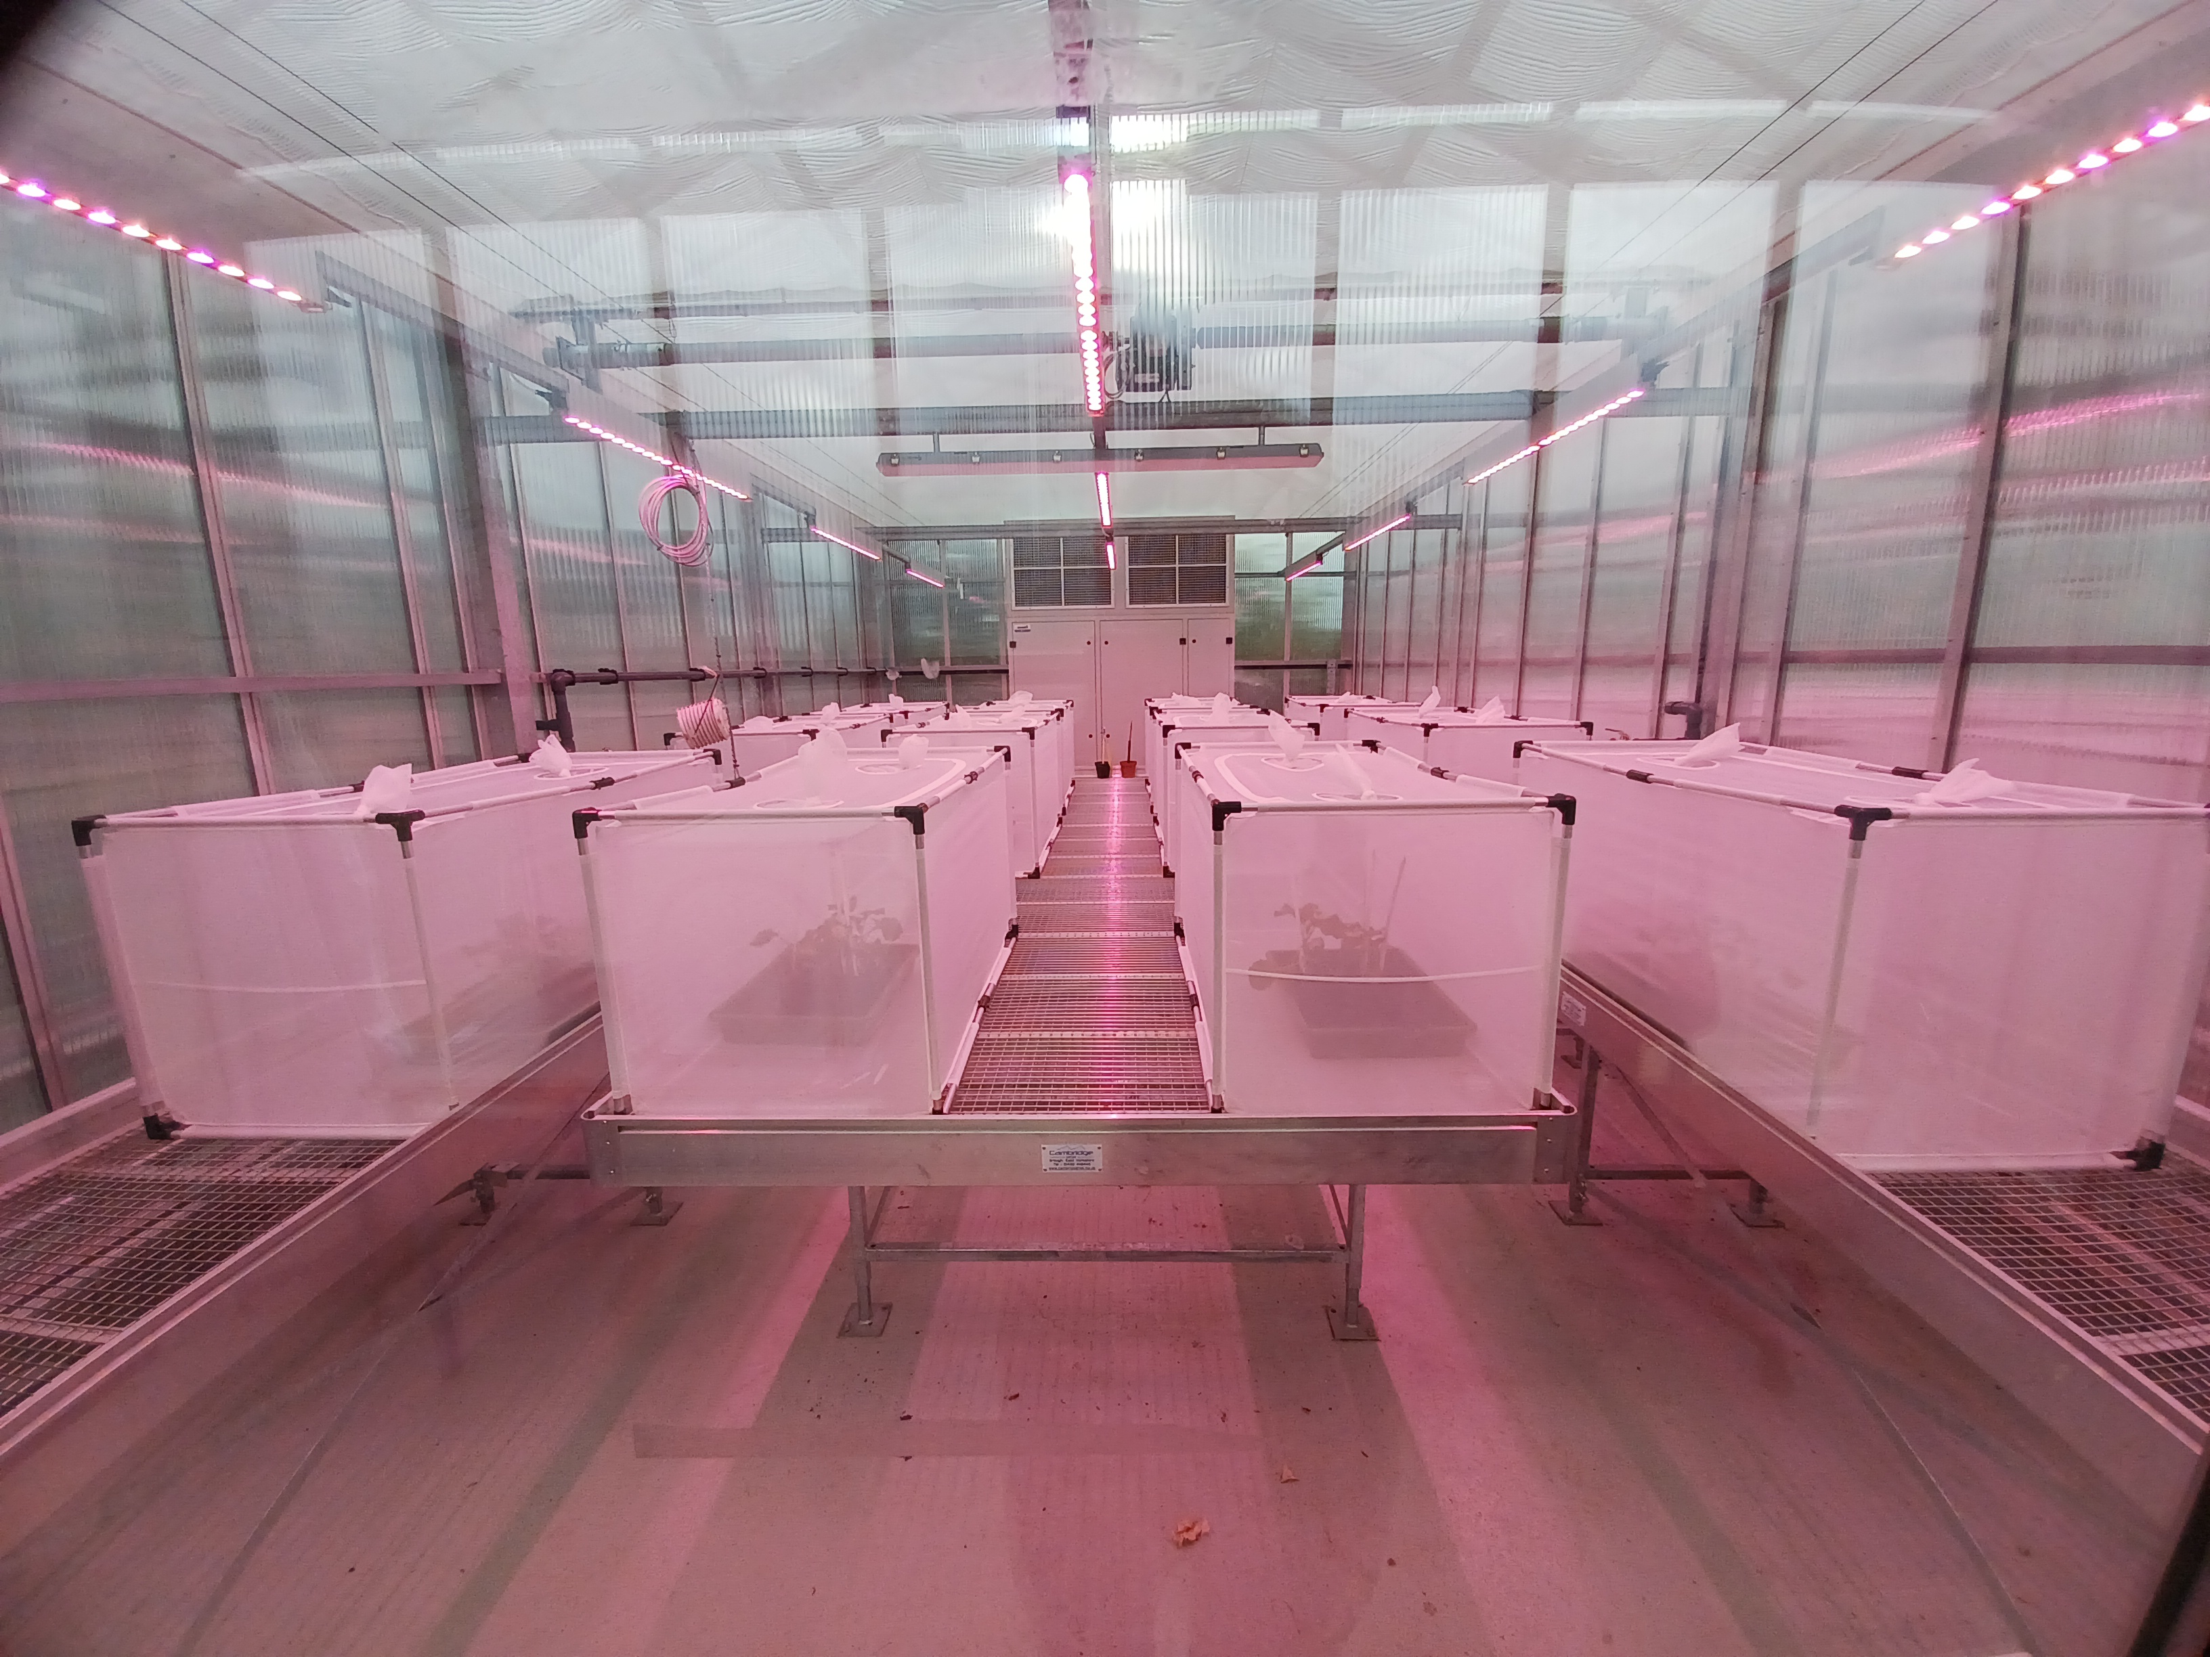
Figure 1. IRM cage experiment in a climate-controlled greenhouse at ADAS Boxworth.

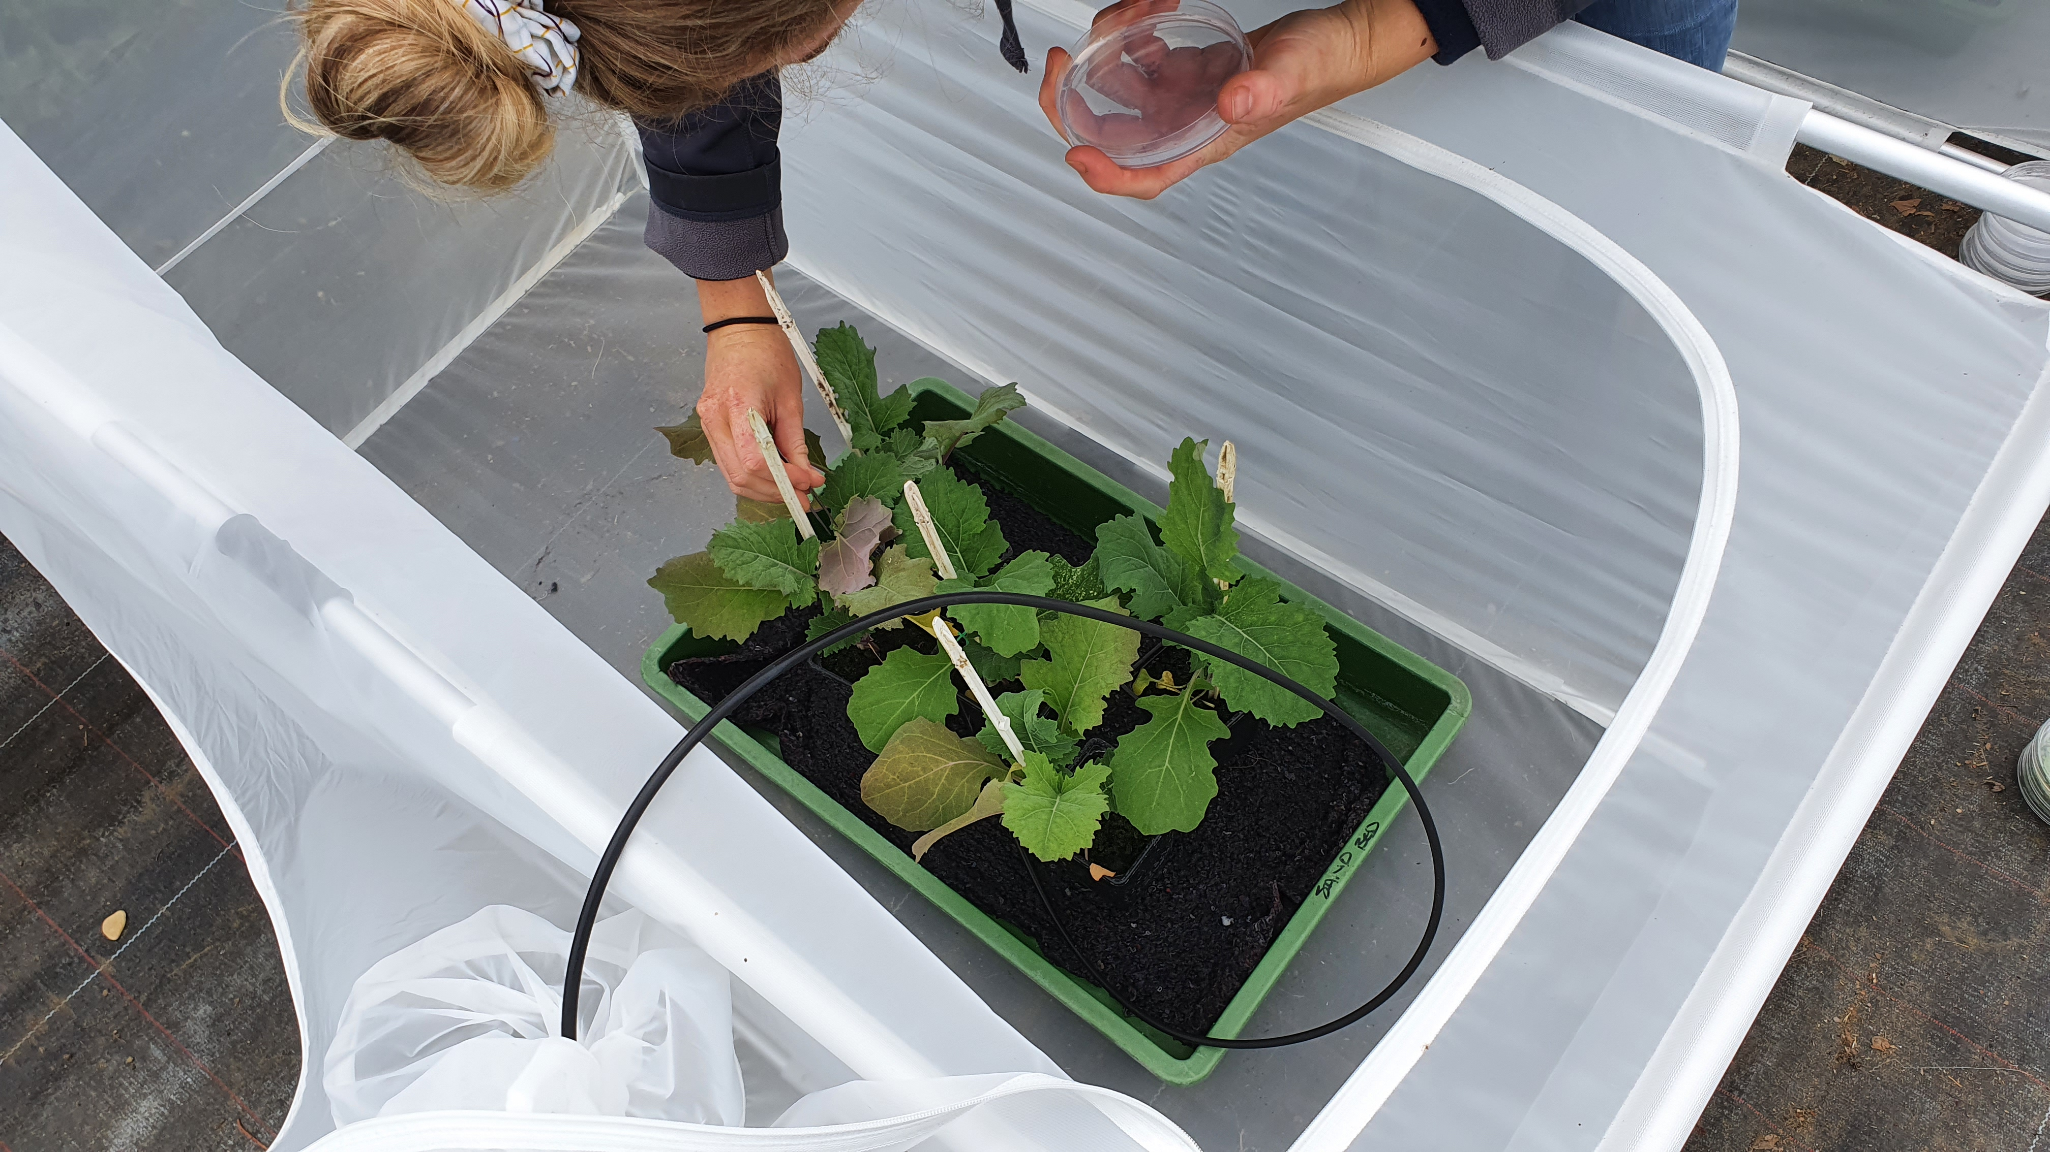

Figure 2. Aphid being introduced to the a cage in the IRM experiment.

Figure 3. Insecticide being applied to plants using a sprayer designed to achieve optimal coverage.

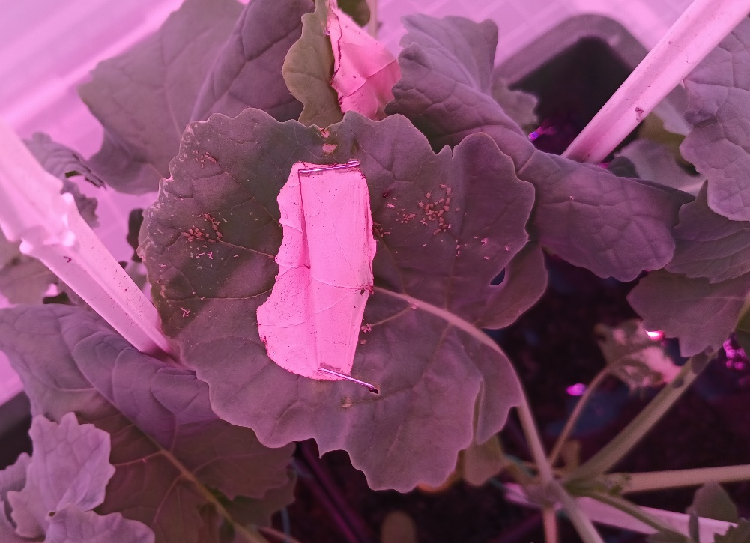
Figure 4. Aphid numbers increasing following several rounds of insecticide treatment, indicating selection for resistant clones.

4. Key grower findings to date (messages summarised)
- The quantitative PCR (qPCR) assays developed in the project have been optimised to allow accurate determination of the proportion of aphids with MACE and super-kdr resistance in a mixed sample.
- The first successful IRM experiment shows that the methodology works; the IRM strategies drove selection for resistance and the qPCR assays enabled selection to be measured for each strategy.
5. Knowledge exchange summary to date (press/events/papers/conferences etc.)
- Update to Insecticide Resistance Action Group (IRAG) – 16/11/20
- Insecticide resistance management factsheet – 29/01/21
- Update to IRAG – 14/04/21
- Update to IRAG – 9/11/21
- Update to IRAG – 27/4/22
- ‘From theory to field’ article in Crop Production Magazine – August 2022
6. Any issues identified that could affect delivery of the final project output
None.

