Annual Project Report
Year 2

Project Details
Project Title | Development of crop management strategies for the management of stubby root nematodes (Trichodorus and Paratrichodorus spp.) associated with docking disorder in sugar beet
BBRO Project Number
Project Lead &  Organisation | Nyambura Mwangi, Harper Adams University
Collaborators | BBRO
Co-funders | RAGT seeds, Joordens-Zaden and The Lugden Hill Charity
Project Start Date | 2nd November 2020
Project End Date | 1st November 2023
BBRO Funding £ | 37, 050
Total Project Cost £ | £96, 771

Annual Report

- Industry challenges the project is addressing
(300 words max)

Nematodes in the family Trichodoridae (Trichodorus and Paratrichodorus spp.) commonly known as stubby root nematodes (SRN), are known to cause damage to economically important crops by either feeding directly on the roots or indirectly through transmission of viruses belonging to the tobravirus group. In sugar beet Longidorus spp., Trichodorus and Paratrichodorus spp. attack young sugar beet seedlings causing a condition known as docking disorder, which leads to foliage appearing to be deficient in nitrogen or magnesium. In fields where the symptoms persist, roots yield 17.5 t /ha less and are more fangy than those from unaffected fields. A yield loss of up to 50 % has been recorded as a result of the fangy root symptoms. For many years, management strategies to minimise sugar beet yield losses caused by nematodes has been prophylactic use of pesticides i.e., use of soil fumigants. Vydate (Oxymyl), which has been the nematicide applied by the sugar beet growers in the recent past, was banned in UK in December 2020, leaving growers with no chemistry for the management of SRN. As the pressure to develop other active ingredients seems hard to execute., other cultural and crop management strategies need to be evaluated for recommendations to sugar beet growers. Cover crops such as brassicas have been successfully used in management of plant parasitic nematodes as they contain a class of thioglucoside secondary metabolites known as glucosinolates (GSLs) that are known to protect them from attack by pathogens. When brassica plants are macerated and incorporated into the soil in the process of biofumigation, the glucosinolates are involved in an enzymatic reaction producing bioactive compounds called isothiocyanates (ITCs), which have been shown in other studies to have nematicidal effects. This study also investigates the potential of cover crops from other families in suppression of SRN.

- Key objectives of the project
The objective of the current study was to
- Evaluate the efficacy of different cover crop species from diverse plant families in the suppression of stubby root nematodes under field conditions in Docking, Norfolk. Nematode densities were assessed before cover crop drilling (Pi), four weeks after planting (4WAP), before incorporation of cover crop residues (Bi) and six weeks post incorporation (Pf).
- Evaluate the sensitivity of stubby root nematodes to commercially available isothiocyanates associated with Brassica cover crops under laboratory conditions. An in vitro experiment was carried out using three pure commercially available ITCs i.e., Allyl (AITC), 2-phenylethyl (PEITC) and sulforaphane (SITC). The effect of ITC concentration i.e., 25, 50 and 100ppm and exposure time i.e., 24, 48 and 72hours on nematode mobility and mortality was evaluated.
- Assess the effect of plant extracts obtained from phacelia, opium poppy and endophyte grass on SRN mobility and mortality

- Results summary (including relevant tables, graphs & photos)

- Field experiment at Docking
The cover crops drilled in the field experiment are shown in Table 1. Results from the field experiment showed that different cover crops had different abilities to multiply nematodes during the growth cycle. Some cover crops such as opium poppy, phacelia, oilseed radish and endophyte grass had significantly lower reproduction factor compared to Indian mustard and Nil-endophyte grass which highly multiplied the nematodes (Fig.1). A sharp decrease in nematode densities was recorded as soon as the cover crop residues were incorporated into the soil except for the susceptible control Italian ryegrass and fallow control (Fig.2)
Species name | Common name | Variety | Seed rate
Festulolium loliaceum +U2 endophyte | Barrier festulolium | Green Solutions | 25 kg/ha
Brassica juncea | Brown mustard | Brons | 10 kg/ha
Papaver somniferum | Opium poppy | Marianne | 1.5 kg/ha
Raphanus sativus oleiferus | Oilseed radish | Terranova | 20 kg/ha
Phacelia tanacetifolia  Lolium multiflorium  Festulolium loliaceum -U2 endophyte | Phacelia  Italian ryegrass  Barrier festulolium | Factotum  Syntilla | 8 kg/ha  25 kg/ha  25 kg/ha
Fallow | Control | --------- | ----------
Sterile fallow | Control | --------- | ----------

Table1: Cover crop treatments used in field experiment at Docking, Norfolk

Fig 1: Average reproduction factor of different cover crops before incorporation, calculated as densities before incorporation (BI) / initial densities (PI), Vertical bars show the standard error of the mean
Fig 2: Trend in Average densities (±SE) of SRN in 200ml soil, at different sampling points, before planting (PI), 4 weeks after cover crop drilling (4W AP), before incorporation (BI) and final density (PF). Vertical bars show the standard error of the mean (n = 4).

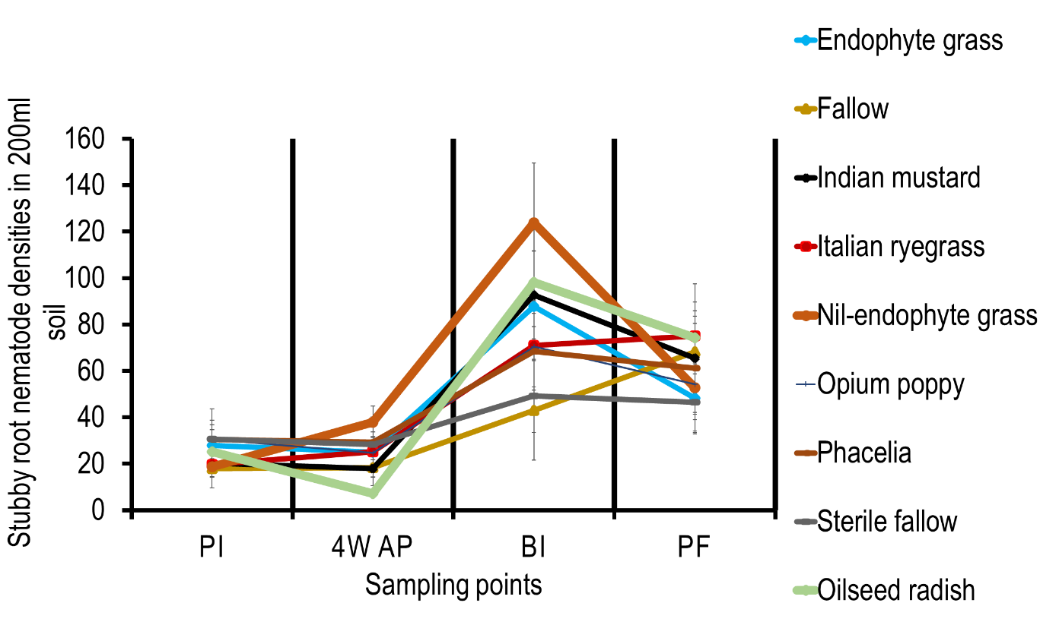

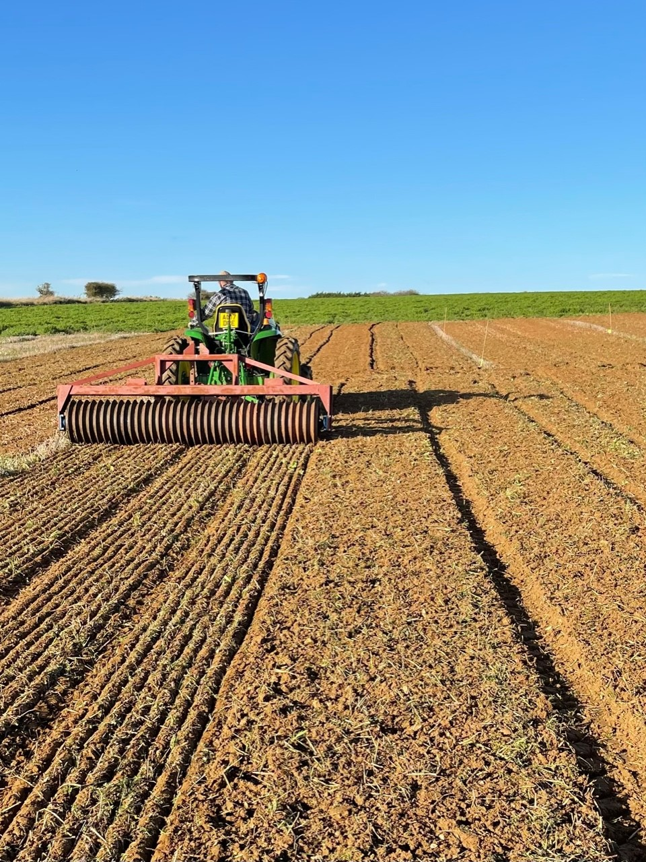
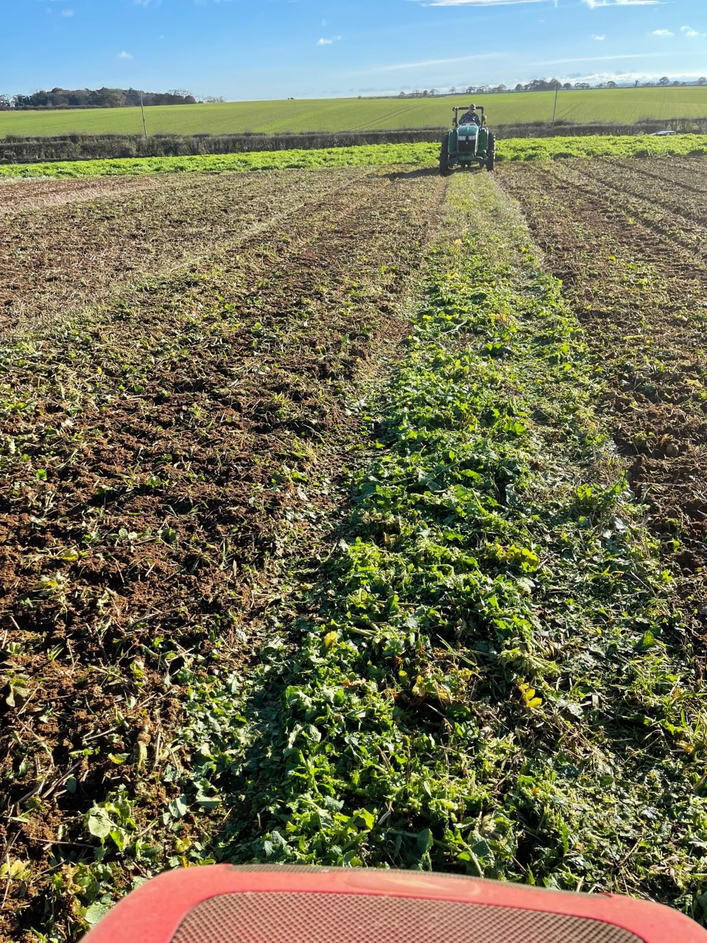
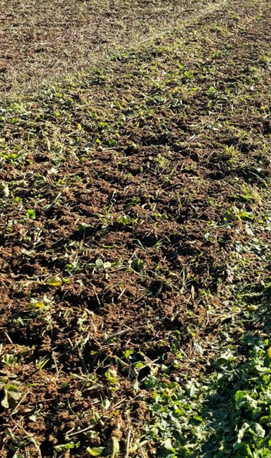
A
B
C

Fig.3: Field operations during field experiment at Docking, Norfolk: Flailing (A), incorporation of cover crop material into the soil (B) and rolling to seal the soil incorporated with brassica material using a roller (C). Nematode densities were assessed (1) before cover crop planting (Pi), (2) Four weeks after planting (4W AP), (3) before cover crop residue incorporation (Bi) and (4) 6 weeks post incorporation (Pf). Photographs by A. Wright

- In-vitro experiment with ITCs associated with brassica cover crops:

Results from this study showed that stubby root nematodes (SRN), are sensitive to isothiocyanates (ITCs). Allyl and sulforaphane were the most toxic ITC, causing 98% and 93% mortality respectively at the lowest dose of 25 ppm (Fig.4). A dose response was recorded for PEITC where significantly higher mortality of 98% (p<0.05) was recorded at 100 ppm compared to 5% and 30% mortality at 25 ppm and 50 ppm respectively. Nematode immobility was highest after 24h exposure time across all doses for allyl and sulforaphane except for 2-phenylethyl where nematode immobility was highest after 48h and 72h exposure time (Fig.5). These results indicate the potential use of brassica associated with the tested ITC in the process of biofumigation for SRN suppression.

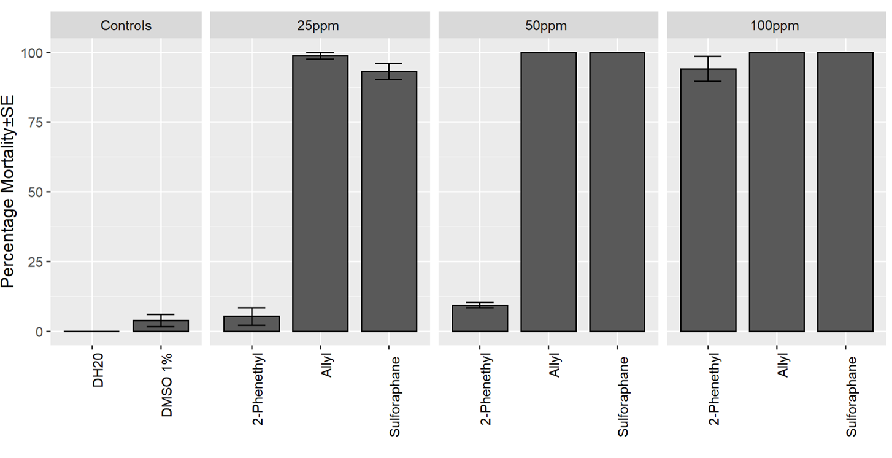
a
a
a
c
c
c
c
c
c
c
b

Fig 4: Mean mortality (%) of SRN (Trichodorus and Paratrichodorus spp.) following exposure to allyl (AITC), 2-phenylethyl (PEITC) and Sulforaphane (SITC) for 72 h and recovery in water for 48 h. Error bars represent the standard error. Significant differences (P<0.05) compared to the control are indicated by differences in compact letter display
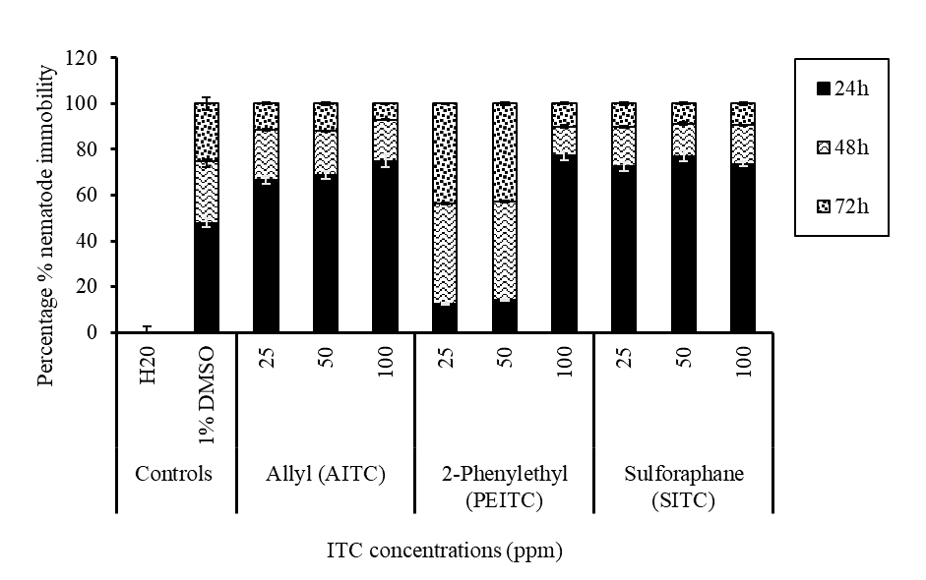
Fig 5: Mean percentage immobility of SRN (Trichodorus and Paratrichodorus spp.) at different exposure times of 24h,48h and 72h. Error bars represent the standard error.

- Invitro experiment with plant extracts
Results obtained from plant extracts from Phacelia, opium poppy, Barrier festulolium endophyte grass and Nil-barrier festulolium showed that the extracts crops had a nematostatic effect where SRN were immobile when exposed to the extracts as compared in the water control. SRN immobility was highest after 24h exposure period for all the plant extracts tested except for phacelia where the highest immobility was after 48h. (Fig.6). The nematodes recovered after 48h incubation in distilled water, hence confirming that their effect was nematostatic in this experiment. Only one concentration of the extract was used in this study, hence a wide range of concentrations need to be tested to confirm this effect.

48h
Plant extracts treatments

Fig.6 Mean percentage immobility of SRN (Trichodorus and Paratrichodorus spp.) at different exposure times of 24 and 48h. Error bars represent the standard error.

- Key grower findings to date (messages summarised)
The field experiment provides information on how stubby root nematodes (SRN) reproduce on different cover crops. Cover crops like Indian mustard appeared to increase stubby root nematode populations, but we observed a post incorporation effect where SRN decreased when the residues were incorporated into the soil. In this experiment, we were unable to achieve the recommended brassica biomass of 50t/ha fresh weight for successful biofumigation, where 20t/ha fresh weight was achieved for Indian mustard and 10t/ha for oilseed radish, hence this limited effective suppression of SRN. Lower SRN reproduction occurred in field plots where phacelia, opium poppy and endophyte grass were cultivated when compared with other cover crops indicating that they are poorer hosts for the nematodes. The laboratory experiment on isothiocyanates, helps support the post incorporation effect that we observed in the field; it confirms that SRN are indeed sensitive to the isothiocyanates that are produced when brassica residues are incorporated. The nematostatic effect recorded in the plant extracts experiment, validates the reduced reproduction of SRN observed in the field experiment. Results from these experiments show that cover crops can be successfully used in management of SRN, with more laboratory underpinning to investigate the different modes of action, effective concentrations of residues incorporated in the soil, so that these can be optimised under field conditions.

- Knowledge exchange summary to date
International congress of nematologists in Antibes, France- Poster presentation
IIRB conference, Belgium – Poster submitted online
Harper Adams University research conference – Poster presentation
6. Any issues identified that could affect delivery of the final project output

